Airport Elementary School
Code of Conduct

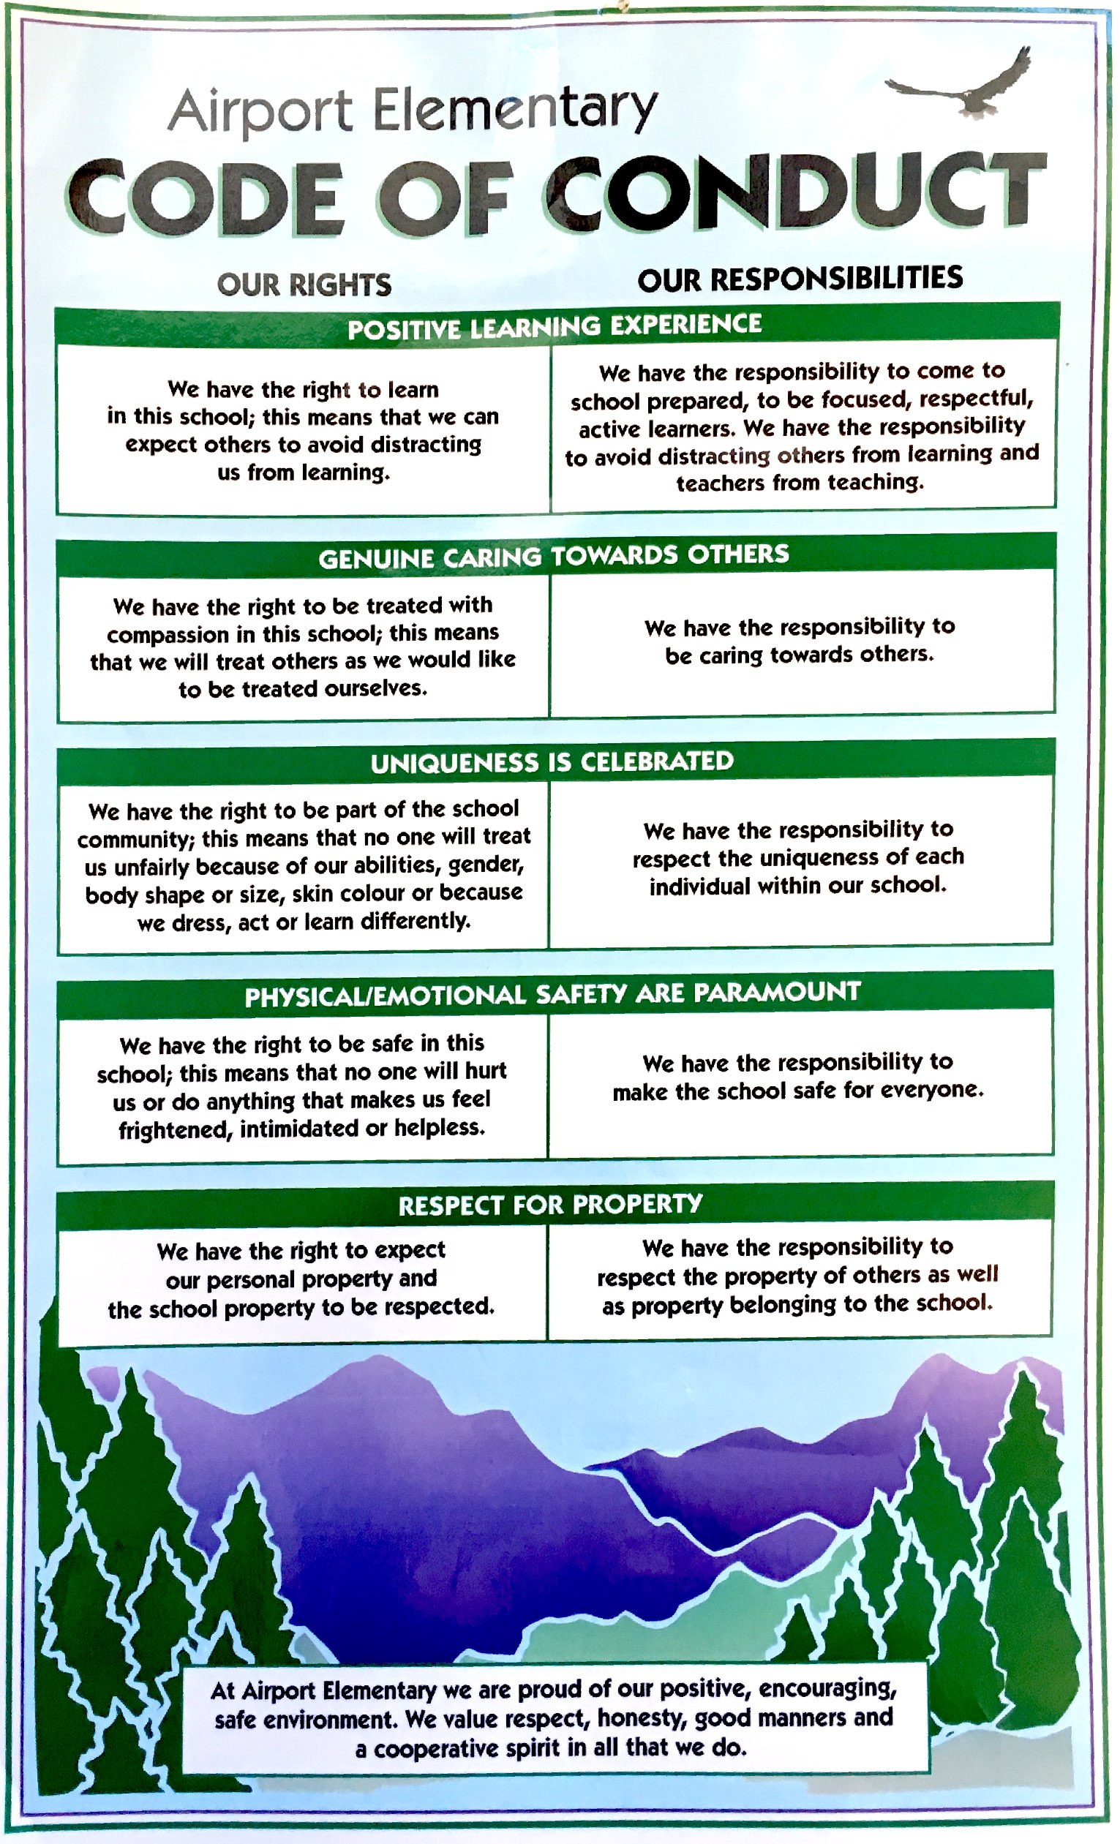

Statement of Purpose
At Airport Elementary School we strive to provide a safe, caring and educationally nurturing environment for all. Our school rules and policies are established for everyone’s protection, safety and well-being.

Conduct Expectations
The school code of conduct defines expected behaviour at school, while traveling to and from school and while attending school functions at any location. The code of conduct applies as much to the adults in and around the building as it does to the children in attendance.

Acceptable Conduct
Students are expected to do their best work and to respect others, their learning environment and personal and school property. They must follow the school and classroom rules and accept responsibility for their own choices and actions. Regular attendance and punctuality are mandated by the School Act. Students are expected to behave in a safe and pleasant manner and to inform adults in a timely manner of incidents of bullying, harassment and intimidation. The staff, with parent involvement, assists students in developing skills for resolving conflict, problem solving and decision making appropriate to their age.

Unacceptable Conduct
Behaviour that interferes with the learning of others or the orderly environment of the school, injures or threatens others or causes damage to property is deemed inappropriate. The following are examples, not an all-inclusive list, of behaviours that fall into this category:
- Acts of bullying, cyberbullying, harassment, intimidation, threatening or violent behaviours.
- Behaviours that interfere with the learning of others, interfere with an orderly environment or create unsafe conditions.
- Acts of discrimination including race, colour, ancestry, place of origin, religion, marital status, family status, physical or mental disability, sex, sexual orientation, gender identity or expression and age.
- Illegal acts such as possession, use or distribution of illegal or restricted substances, possession or use of a weapon (or using something as a weapon) or theft of or damage to property.

Rising Expectations
It is our expectation that as students mature and progress through the grades they will, in most cases, be capable of greater personal responsibility and self-discipline and therefore it is appropriate to have escalating consequences for inappropriate and repeated unacceptable behaviours.

Disciplinary Process
Consequences for misbehaviour will be applied in a fair and judicious manner and whenever possible the disciplinary action will be preventative and restorative. Depending on the severity or frequency of the behaviour and on the age and maturity level of the student, one or more of the following actions will be taken.
- Restitution – repair or replacement of objects. Some form of service to the offended party.
- Loss/limit or delay of access to school areas and/or equipment. Loss/limit or delay in participation in activities.
- Denial of interaction with other students (during recess and/or lunch) – “timed out”.
- In-school suspension – to be served in the office, another class or alternate safe place designated by the administration.
- Out of school suspension for a period of up to 5 days.
- Out of school suspension for a period exceeding five days. Follow up meeting with a representative of the Superintendent’s office.

Notification
The scope or severity of an incident may require us to advise other parties of serious breaches of the code of conduct. For example:
- Parents of the offender(s) and victim(s).
- School district official, police and other agencies – as required by law or policy.
- Other parents – when deemed to be important to reassure members of the school community that school officials are aware of a serious situation or incident and are taking appropriate actions.

Retaliation
All reasonable steps will be taken to prevent retaliation by a person against a student who has made a complaint of a breach of the code of conduct.
Airport Elementary School Expectations
Be Kind, Be Fair, Be Safe

Arrival and Departure
- Enter the building only after 8:30 a.m.
- Walk wheeled transportation on school grounds.
- Go directly home at the end of school dismissal.
- Cellphones, music players, electronics of all kinds are to be put in backpacks upon arriving at school and are not to be used until the end of the school day, unless the student has the permission of an Airport Elementary School staff member.

Playground
- Remain on the school grounds during school hours without written parent authorization and without signing out at the office.
- No fighting, including play fighting.
- Do not throw or carry dangerous objects (sticks, pinecones, rocks, etc.)
- Do not hang upside down on playground apparatus.

Buildings
- Staff permission is required for use of the phone.

Individual Classroom Expectations
Teachers at Airport Elementary chose the teaching profession because they want to help students achieve their goals, not because they want to police students in the classroom. In order to support their students’ learning, each teacher develops an appropriate climate according to the subject being studied and teaching practices. The teachers’ expectations, regulations and evaluation procedures are a crucial part of a tone that supports learning at school.

