M3 Lesson 2: Digital Footprints, Media Smarts and Safety Assignment
Core Competencies:

- Communication | - Thinking | - Personal & Social

Big Ideas:

- Cultivating networks and reciprocal relationships can support and broaden career-life awareness and options
Curricular Competencies:

- Examine the influences of personal and public profiles on career-life opportunities
- Identify risks and appreciate benefits associated with personal and public digital footprints
- Communicate with the intent to highlight personal strengths, talents, accomplishments and abilities
In this assignment, students will look at the concept of digital footprints, and how their personal and public profile can influence career life opportunities.
Assignment
In small groups in class or individually, answer the following questions:
1. Do you have any photos on Facebook, Instagram or Snapchat (or other social media outlets you may use) that you do not want your parents, your college/university admissions officer, a future employer, or a future significant other to see?
2. Have you ever checked out your page to see what it looks like to a stranger? Do you periodically check your privacy settings? Go ahead and check the privacy settings for at least one of your social media accounts and include a screenshot of the privacy settings in your reflection.
3. Why are these questions important?
**Note: If you do not use social media at all, please best reflect on the positives and negatives of social media from your point of view and include why you have made the choice to not use any forms of social media.
Extension: This is a good opportunity to link bullying on social media to self-harm and suicide if your classroom climate allows for it, particularly the case of Amanda Todd.
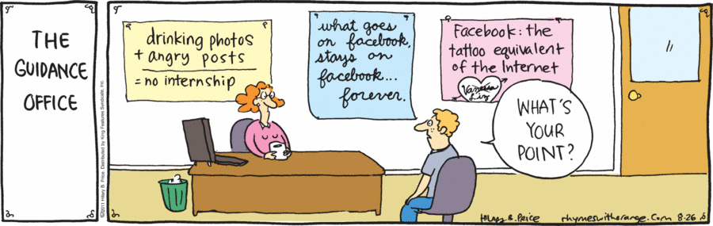
Assessment:

