M3 Lesson 3: Digital Citizenship
Core Competencies:

- Communication | - Thinking | - Personal & Social

Big Ideas:

- Cultivating networks and reciprocal relationships can support and broaden career-life awareness and options
Curricular Competencies:

- Examine the influences of personal and public profiles on career-life opportunities
- Identify risks and appreciate benefits associated with personal and public digital footprints
- Communicate with the intent to highlight personal strengths, talents, accomplishments and abilities
In this assignment, students will look at the concept of digital citizenship, and how good (and appropriate) digital citizenship contributes to positive mental health.
For Students:
What is Digital Citizenship?
Let's dig a little deeper into what digital citizenship is all about. Have a look at the images below. Do you agree that these are elements of digital citizenship? Are there elements you had not thought of before? Would you add anything? Take anything away?
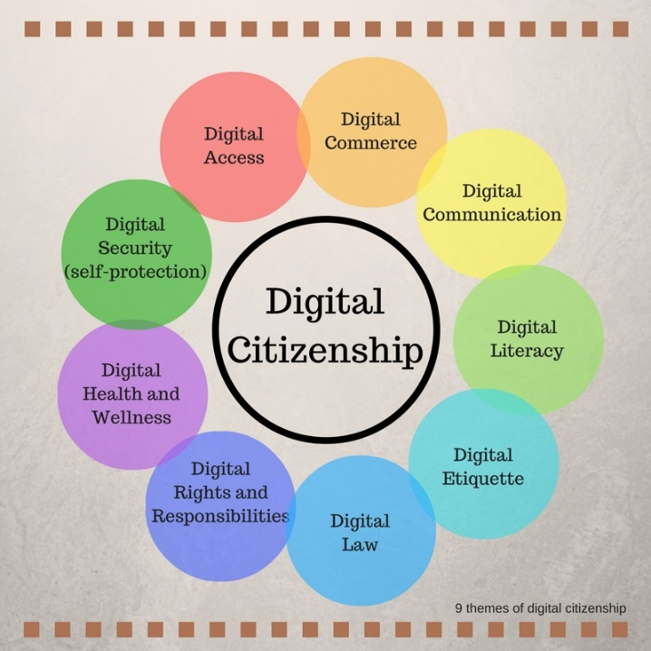

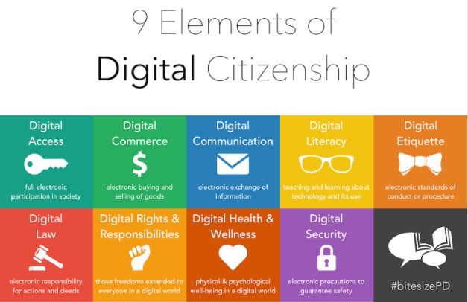
By now we are probably familiar with the different categories that fall under the umbrella term of "digital citizenship"...now, let's see if we can answer some questions about cellphones and digital citizenship. This is practice for the digital citizenship assignment that will follow and is beneficial as most of us will own a cell phone (if you don't already) at some point in our lives.
Watch this video, "Get Off The Phone" by Rhett & Link and consider the following questions:
- How does having a cell phone benefit us?
- How could having a cell phone negatively impact your life or the life of another?
- How does Rhett and Link use humour to get their point of view across to the viewer?
- How does the video influence your opinion on the appropriate use of cell phones?
Video - https://www.youtube.com/watch?v=nfUD0WhE264
Assignment:
Watch the video by Sherry Turkle, "Connected, but alone?" (https://www.youtube.com/watch?time_continue=2&v=t7Xr3AsBEK4)
Have students fill out the TEDTalk worksheet while watching the video.
While watching the video, think about some of the following statements, or discuss Ms. Turkle’s meaning in her talk. Do students agree or disagree with the statements?
- “The illusion of companionship without the demands of friendship.”
- “Being alone feels like a problem to be solved.”
- “We have everything we need to start. We have each other. And we have the greatest chance of success if we recognize our vulnerability.”
- “We all need to focus on the many many ways technology can lead us back to our real lives, our own bodies, our own communities, our own politics, our own planet. They need us.”
Assessment:

