M4 Lesson 1: Transferable Skills Assignment
Core Competencies:

- Communication | - Thinking | - Personal & Social

Big Ideas:

- Career-life decisions are influenced by internal and external factors, including local and global trends.
Curricular Competencies:

- Communicate with the intent to highlight personal strengths, talents, accomplishments and abilities
- Explore and reflect on career-life roles, personal growth, and initial planning for preferred career-life pathways
- Explore and connect experiential learning both inside and outside of school with possible and preferred career-life pathways.
In this assignment, students will think critically about their transferable skills, developing a list of their own transferable skills for their career life decisions.
Transferable skills essentially are those skills that you acquire in one experience that you can transfer into another. For example, if you have used time management skills as a soccer referee, you can transfer those skills in a retail position.
Activity
Have students take a look at the chart below of transferable skills. In small groups, have them discuss which skills they have, answering the questions below.
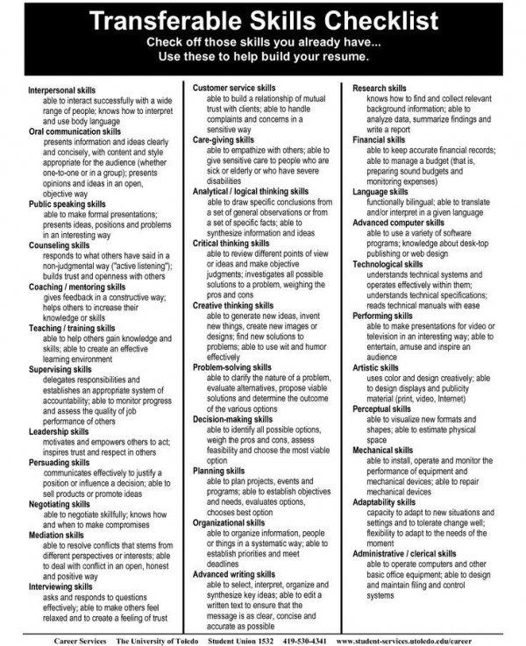
Questions:
Referring to the 'Transferable Skills Checklist' above answer the following questions.
1. Choose 3 skills from the checklist that you believe are your strongest skills.
2. How/where did you acquire these skills?
3. How can these skills be used in your ideal job? Why are these skills important?
4. What skills do you need to work on? How can they be improved?
Assignment
To better communicate transferable skills, students can now do the “Identifying Your Skills” questionnaire, found under attachments on the portal.
Assessment

