M4 Lesson 3: Writing a Resume
Core Competencies:

- Communication | - Thinking | - Personal & Social

Big Ideas:

- Career-life decisions are influenced by internal and external factors, including local and global trends.
Curricular Competencies:

- Communicate with the intent to highlight personal strengths, talents, accomplishments and abilities
- Explore and reflect on career-life roles, personal growth, and initial planning for preferred career-life pathways
- Identify career-life challenges and opportunities, and generate and apply strategies
In this assignment, students will learn the basics of writing a professional resume, and strategies to make their resumes stand out amongst the competition!
For Students:
Creating Resumes
A resume is the summary of your education, employment history, skills and accomplishments. It is the story of you. It is also a living document because it will change every time you acquire new knowledge, a new skill or a new job. The purpose of a resume is to give a prospective employer a snapshot of what you have done and what you have the ability to do. When combined with a cover letter, it becomes an effective marketing tool - one that is marketing you!
A resume should make a good first impression and make the employer want to know more about you. How can you accomplish this?
- Make it short: it should be no more than one or two pages.
- Organize it: the information should be coherent and presented in an attractive and tidy way.
- Focus it for the employer: show how your skills and accomplishments can benefit an employer.
- Have proof: be able to prove every statement about yourself with a specific, recent example.
There are three main types of resumes:
1. Chronological:
• Lists education, skills, and experience in reverse chronological order (the most recent experience first) with the focus on relevant experience.
2. Skills Based:
• Lists skills and talents in order of importance. This form is more suited to those with limited experience.
3. Combination:
• The most common format combines prominent skills and relevant experience with the most recent history presented first.
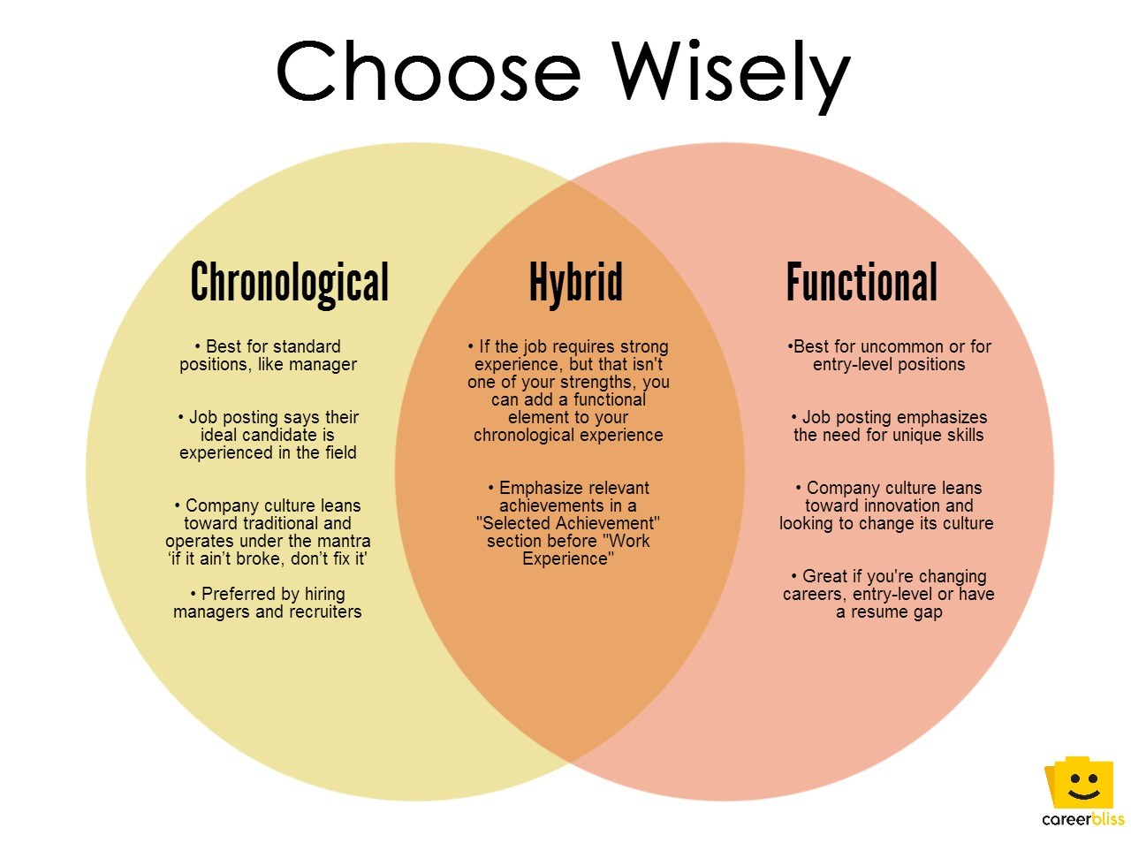
Resume Information
Employers who are looking for employees still in high school are not going to expect to see too much on a resume. The examples listed below, from sites around the world, show that lack of experience is common among most high school students:
Resume example from SD#71
My first resume from careerfaqs.com.au
Sample resume High School - from about.com
Two samples High School - from alec.co.uk
The idea that you need to keep in mind is that each year you are building on your experiences. Your resume should document your growing experiences, so keep a copy of it to adapt over time. Always remember the companies or organizations you have worked for or volunteered with, and the first and last names of those people you would like to use as references.
You can compare the difference between high school students and college students through these examples:
College resume sample 1 from the Senaca College, Ontario
College resume information from BCIT
Keeping track of your experiences will save you time when you start doing the work needed to complete your Capstone, required for graduation in British Columbia. A well documented resume can form the outline for some of your Capstone Project.
Act Ethically
You can be fired, even if it is years after being hired, if you make false claims (you lie) on your resume! The following link, titled Ethics 101 from gocollege.com, describes what happened to a coach in the United States when his falsehoods caught to him. Here is a bit of advice on ethics from about.com:
Act Safely:
Be careful about submitting online resumes or applications to .com or commercial sites. They may not be secure and someone could steal your identity, which will leave you with a big mess to clean up. Never put your birth date or social insurance number on your resume. If employers require these, they will ask for them after you are hired.
Email Addresses:
These final links, from Pongo and Lisa Vaas (two employment advisors), have sections dealing with appropriate email addresses. Read them through and consider making changes if you need to.
Most jobs require either an application, a resume, or both. Remember to list all of the different skills and experiences that you have. When times are tough, some employers get hundreds of applications for different jobs. They are looking for people that make a difference, so list everything reasonable. Don't just cover the big items because most other applications will have these and you won't stand out among the competition.
Application Forms:
Many employers want you to complete an application form. Your application form lets you make a first impression. Take two copies - one for a rough draft and one for a final copy, use blue or black ink and write neatly. Employers won't want to hire someone who makes a mess of an application form. The quality of the form sends a message to the employer about you and the effort that you will bring to the work.
Here are a few suggestions for application forms: Do's and Dont's.
Assignment – Making a resume using myBlueprint:
Last year in CLE 9 you started to develop a resume using the resume tool in myBlueprint. In today's assignment, you will adapt your resume to include any of the skills, experiences or knowledge you have gained over the past year. Don't worry if you never had a chance to start your resume last year, you can start one today!
You may feel as though you still don't have a lot of experience to put on a resume, but you probably have more than you think! Try to remember any of the paid or unpaid work or volunteer experience you have, any transferable skills you have gained through activities inside or outside of school, or any new or interesting classes you have taken. This is a good opportunity though to see where you may want to gain more experience in the next couple of years to round out your resume sections before you graduate!
Instructions:
1. Log into your myBlueprint account with your username and password.
2. On the left hand toolbar, choose "Resumes" under the "Work" heading if you are making a new resume. Then click “+ Add Resume” on the top right corner of your screen, and give your resume a title such as "Your Name Grade 10".
3. If you are just adapting your resume from last year, you will find it under "Home" then "Portfolios"
4. If you are making a resume from scratch, take the time to work through the resume sections to the best of your ability. Remember to highlight your best skills and experiences and use powerful verbs such as "organized" and "coordinated" instead of passive verbs such as "has" or "did".
5. If you are just adapting your resume from last year, add any new experiences, skills, classes you've taken and knowledge you've gained!
6. Experiment with the different features in myBlueprint such as layout and switching the order of your sections until you find one that you prefer.
7. Continually preview your resume by clicking “Preview Resume” at the bottom right hand side of your screen.
8. When your resume is finished, from the Preview Resume screen, click “Add to Portfolio” and “Export” to add your resume to your Grade 10 portfolio and export it to a .pdf for submission.
Assessment
