M4 Lesson 4: Writing a Cover Letter
Core Competencies:

- Communication | - Thinking | - Personal & Social

Big Ideas:

- Career-life decisions are influenced by internal and external factors, including local and global trends.
Curricular Competencies:

- Communicate with the intent to highlight personal strengths, talents, accomplishments and abilities
- Explore and reflect on career-life roles, personal growth, and initial planning for preferred career-life pathways
- Identify career-life challenges and opportunities, and generate and apply strategies
In this assignment, students will learn the basics of writing a cover letter, and strategies to make their cover letters stand out amongst the competition!
For Students:
Writing a Cover Letter
Many employers will expect you to write a cover letter to go with an application or resume.
A cover letter is a formal letter that accompanies your resume. Use your cover letter to introduce yourself, and to convince a potential employer that you are the right person for the job.

What should I include in my cover letter?
- Introduce yourself, identify the position that you are applying for, and explain how you learned about the position.
- Explain why you are qualified for the position, and why you would be a great fit for the job.
- Close your cover letter by thanking the employer for their consideration and request an interview to further discuss your qualifications.

Useful Cover Letter Tips
- Keep it brief – one page maximum
- Tailor the letter to match the requirements of the position
For example, “You mention that you are looking for people with Microsoft Office skills. Over the past summer I have worked extensively with MS PowerPoint, MS Word and MS Excel to draft professional documents.”
- Stress how you will add to the organization
- Be specific
- Focus on three qualities that distinguish who you are (e.g., hard worker, willing to learn, organized)
- Project confidence and be positive
- Personalize your letter to the hiring manager and ensure correct spelling of their name
- Check for spelling or grammatical errors
- Show your personality, curiosity, and interest in the field of work rather than repeating your resume word for word
- Research and learn about the company or organization you are applying to. If your cover letter is tailored to the company and job, you’ll show the employer that you can be a good fit.
A good place to start...Youth Canada has advice on writing a resume and lists many do's and don'ts that are applicable to cover letters as well.
Have a look at these sample resumes & cover letters. What do you notice is important information in each cover letter?
Cover letters can be the deciding factor between getting called for an interview or being passed up for another candidate who submitted something better. To make sure your cover letter helps you land the interview, keep these do's and don’ts in mind when you're writing:
- Do create a personalized cover letter for every company and position.
- Do take the time to find out the hiring manager's name and open the letter with a proper greeting.
- Do identify the position you're applying for, including the job code or reference number (if there is one).
- Do maintain a confident, enthusiastic tone.
- Do proofread repeatedly (typos and grammatical mistakes are a huge turn-off)!
- Do ask someone you trust to critique and proofread your cover letter.
- Do end with a statement of intent (ex: I will be in touch on Tuesday to discuss the possibility of an interview).
- Don't go beyond one page. In most cases, three or four paragraphs are enough to tell your story.
- Don't try to be cute. Humor is subjective; it can make you seem unprofessional rather than personable.
- Don't resort to clichés, exaggerations, or false flattery.
- Don’t assume spell check will catch all errors!
- Don't simply repeat claims you made in your resume. Instead, highlight the most impressive accomplishments from your resume and describe the story behind them.
- Don't forget to change the recipient's name and company name for each cover letter you write!
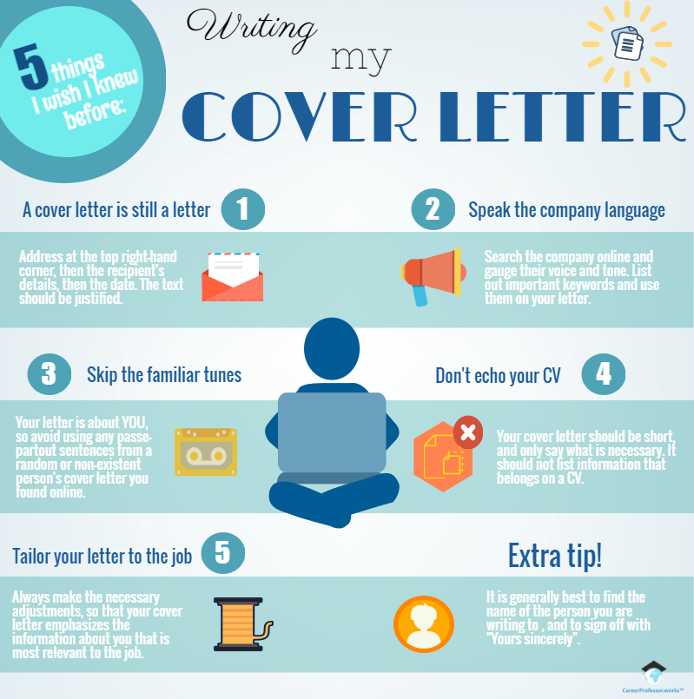
To take your cover letter to the next level, check out this Mclean's article on "How to Write Cover Letters That Stand Out"
Before beginning your own cover letter, it would be wise to do a simple Google search for cover letter examples and find one that you think would work best for you, your skills, and your field of interest. It can help to work from a template but make sure it is still formal and you are able to personalize it as need be. If you are looking for a general format to follow, please see the image below - it does an excellent job of providing a "jumping off point" for what each paragraph should include.
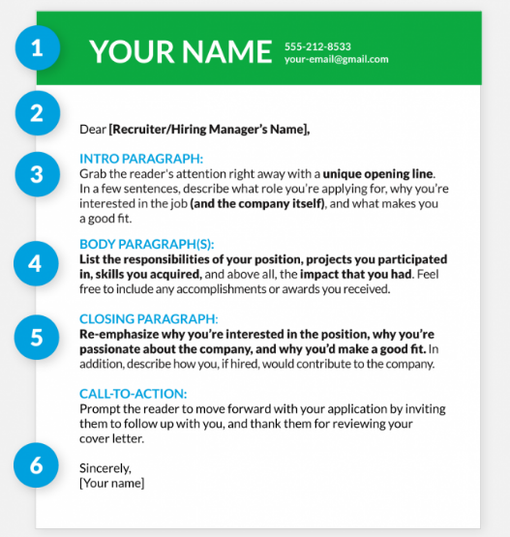
Assignment
Your task for this assignment is to write a cover letter that is linked to a part-time position or job of your choice that you have found in your community. Make sure you review some of the content on the previous page around cover letters and have a look at a few sample letters to help you get started. Use powerful language and give examples of how you have demonstrated the skills the employer is looking for in the position.
Instructions:
- Search online for a part-time position in your community that you meet the qualifications for. You are welcome to use your community newspaper, an online search, or perhaps the career centre at your school. myBlueprint also has a tool for finding available positions. Click "Work" on your dashboard and then "Job Search"
- Under the Job Search tool, choose "Entry Level" or "Volunteer", then the name of your city under "Where are you looking?" Use certain key words to help your search.
- Once you have found a position that you are going to write a cover letter for, search online to see if you can find the name of the hiring manager or contact person for the position. Look at the organization's website or try to find their LinkedIn profile. If you were planning on submitting your cover letter and can't find the name of the contact person, call the organization and ask who you should address the letter too. If not, you can just make up a name for this purpose!
- You are now ready to get started on your cover letter. myBlueprint has made it incredibly easy for you to format your letter. Under the "Work" heading, choose "Cover Letters". Then click “+ Add Cover Letter”
- Give your letter an appropriate title and complete the required sections. Please make sure that:
- Your information is complete (including your FULL address and telephone number)
- The employer information is complete (including their full address and job title - search online for the information)
- Your three paragraphs and closing are a reflection of how fantastic you are! A helpful hint is to have your resume next to you as you develop your cover letter BUT don't just restate your resume. Explain how the skills on your resume are transferable to the skills that the employer is looking for.
- Continuously preview your resume using the "Preview Cover Letter" button on the bottom right side of the screen
- When previewing your cover letter, choose a cover letter format that appeals to you.
- Download your cover letter to your myBlueprint Grade 10 eportfolio, as well as exporting it to a .pdf and submitting it here.
Congratulations! You just completed your first cover letter!
Assessment
(see below)
