M5 Lesson 7: Your Financial Planning Assignment
Core Competencies:

- Communication | - Thinking | - Personal & Social

Big Ideas:

- Lifelong learning fosters career-life opportunities.
Curricular Competencies:

- Practice effective strategies for healthy school/work/life balance
- Identify career-life challenges and opportunities, and generate and apply strategies

Assignment

Finance and You

Creating a Simple Budget
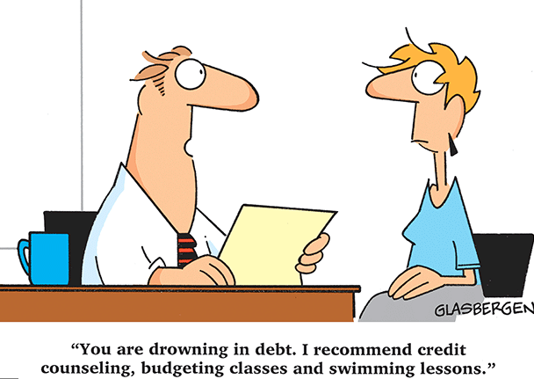
Log into myBlueprint and go to the 'Money' Section to get started with creating budgets.
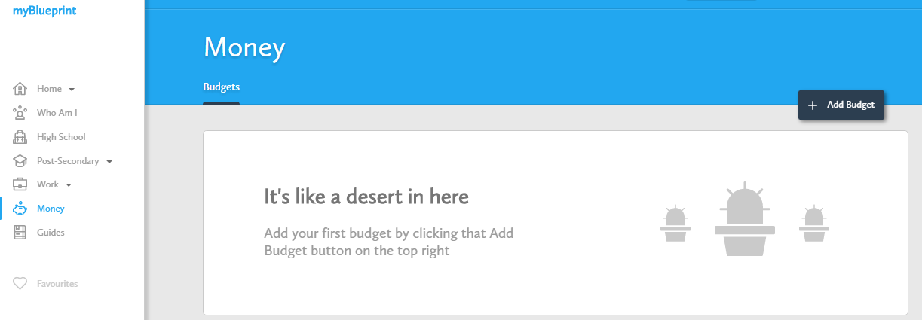

Now that you know what a budget is and why it is important to track your income and expenses, here are a few ways for you to use the Budgets tool in myBlueprint & below are your assignment instructions:
- Create multiple personal budgets. You can create your own personal budgets for many purposes, such as buying a new car or a new cell phone. For this assignment, you must create two personal budgets and add them to your ePortfolio as well as submitting them here.
- Create a budget for a post-secondary program. When you add a new budget, you can select the ‘Budget for Post-Secondary’ option from the ‘Need Ideas’ section and base your budget on the estimated expenses for one of your favourite post-secondary programs! For this assignment, you must create a budget for the post-secondary education program of your choice and add this to your ePortfolio as well as submit it here.
*Hint- use the Download Budget button in the top right-hand corner of the screen to download your budget to MS Excel for easy submission!
In total, you will be responsible for submitting 2 personal budgets and 1 post-secondary program budget. When you are finished your 3 budgets, submit them here and answer the following reflection questions:
1. Did you find the budgeting process useful? Why or why not?
2. Do you think budgeting will help you in your future? What will you be most likely to budget for?
3. Were there any surprises for you in creating these 3 budgets?
4. Did you notice any feelings that came up during or after you finished your budget? Where do these come from? How will you overcome them?
Before you start creating your personal budgets, explore the Paying for Post-Secondary Guide in myBlueprint to learn more about your financial aid options (where to access student loans, how to apply for scholarships, etc.), to help you plan your income and prepare a more accurate budget! Make sure you reflect back on your 'Career Cruising' assignment from Week 5 to help you choose your Post-Secondary Path.
Please check out the rubric before beginning your assignment.
Assessment
(see next page)
