M5 Lesson 7: Your Financial Planning
Core Competencies:

- Communication | - Thinking | - Personal & Social

Big Ideas:

- Lifelong learning fosters career-life opportunities.
Curricular Competencies:

- Practice effective strategies for healthy school/work/life balance
- Identify career-life challenges and opportunities, and generate and apply strategies

In this lesson, students will learn the basics about how to manage their finances, creating three budgets for themselves using the tools available in myBlueprint.

For students:
Whether you are saving for your post-secondary education, your first car, or a rainy day, there are a few things that you need to know about managing your money. The following overviews will provide you with the information that you need to smartly budget your money.
Why Budget?
Getting into the habit of budgeting early in your life will help you set up good habits in the long run! By budgeting carefully - tracking monthly income and expenses to monitor where your money is going - you can take ownership of your own finances and make sure that your money is being used wisely. If you don't take care of it, nobody will!
Managing Your Money
- Set financial goals - think about why you are saving and consider setting goals to help motivate you
- Make a list of your income and expenses, and then add it to the budgeting tool
- Watch your debt
- Save money
- Make good choices

Be a Money Savvy Student
- Decide how much you will spend before you go shopping
- Use coupons and online discounts whenever possible
- Shop alone - if you spend too much time in a shopping mall you are likely to spend more money
- Compare prices before you buy - sales do not always guarantee the lowest prices
- Bring a list when shopping for groceries and don't go shopping hungry
- When shopping online, be aware of hidden fees - make sure you consider shipping, taxes and customs costs for your cross-border purchases
- Always ask yourself...do I really need this item? Will I regret it tomorrow if I DON'T buy it?
Calculating your budget
- What money is coming in? Make a list of all your income each month and add them together to get a total.
- What money is being spent? Make a list of all your expenses each month and add them together to get a total.
- Calculate your budget. Deduct the total amount of money you spend each month from your monthly income.
- If you’re spending more money than your monthly income, then you may need to cut down on spending or try to increase your personal income to avoid debt.
- If you have money left over after paying your monthly expenses, put that amount into your savings.
Helpful Links
For more information on making a personal budget, budget tips, and expense examples, explore the following link:
- Credit Counselling Budgeting for Teens
Money Saving Strategies - here are some more strategies for taking control over your financial situation:
- Reduce your expenses. Don’t spend money on unnecessary items. Do you really need that new pair of jeans? Remember, the money you save now, you will have later when you may really need it.
- Make saving a habit. Whether your income is from a part-time job or an allowance, put aside something each week. You can ask your bank to make automatic transfers into a savings account to help you save.
- Get your money working for you. Did you know that banks actually pay you to deposit money into your savings account? This payment is called interest. In order to make interest, you have to leave your money in the account. That being said, don’t withdraw money unless it is absolutely necessary.
Some financial information to help you along the way...

What is a Savings Account?
An account held with a financial institution such as a bank or credit union
- Safe for short-term savings of any amount
- High liquidity (it is easy to access your money if needed)
- Protected

Helpful Websites
- Expense Calculator (Links to an external site.)
- Your Money (Links to an external site.)

Credit and Debt

What is Credit?
Credit simply means an arrangement to put off payment of a loan or purchase (i.e. an expense). There will be times in your life when it is necessary that you borrow money to pay for something. If credit is used wisely, it can be used to your advantage. However, borrowing more than you can pay back, or mismanaging what you borrow can get you into trouble. It is important that you have a plan on how you are going to pay back the money that you borrow. Creating a budget helps you manage your spending, and can help you pay off your loans sooner. Types of Credit:
- Student Loans
- Line of Credit
- Credit Cards
Getting your first credit card can be very exciting! Some people feel that they can buy whatever they want. Credit cards can be useful, but they can also wreak havoc on your budget if you spend more than you make. Here are a few helpful tools that you can use:
- Credit Card Selector Tool
- Credit Card Payment Calculator

What is Credit Fraud?
Credit card fraud is an act of theft involving a credit card, and can happen in several ways, such as losing your card or getting your card stolen. Your credit card may then be used to purchase goods and services without paying by someone other than yourself! Therefore, it pays to be vigilant in the use of your credit card. Here are some tips to help keep your identity and credit safe:
- Guard your social insurance number, PINs, passwords and account numbers, and don't leave them in an unsecure place.
- Keep your tablet, laptop, cell phone, and any other technology device in a safe and secure place. Do no leave them unattended.
- Do not leave your credit card unattended and avoid sharing your PIN with others.
- When making online purchases, make sure to verify that the website is secure (look for the "lock" symbol and a URL that begins https://).
- Keep copies of your statements and other important documents in a safe and secure location; shred personal documents before throwing them away.
- Cover your PIN and take your receipt when using an ATM or debit card machine.
- If available, use the chip technology for debit and credit cards to reduce your chances of credit fraud as the microchip is extremely difficult for criminals to duplicate!
- Visit the Financial Consumer Agency of Canada (Links to an external site.)Links to an external site. for more tips on how to protect yourself against credit fraud!

Shop Around!
Take the time to research where you will borrow money from. Even a difference of a few percentages in interest rates can make a huge difference in the long run!
Comparing Interest Rates
Financing a used car | at 12% | at 6%
cost | $6,000.00 | $6,000.00
you have | $2,000.00 | $2,000.00
you borrow | $4,000.00 | $4,000.00
your payments | $105.37 | $93.96
your interest | $1,057.76 | $510.08
Total cost: | $7,057,76 | $6,510.08
 | You Save: | $547.68
* Interest is compounded annually, over a period of 4 years (48 months)

What is Debt?
Debt typically refers to money that is owed after making a purchase that you cannot pay for (ie., you do not have the income). Individuals use debt as a method of borrowing money to pay for large expenses. Know how much money you owe and how much interest you are paying on your debts. Mismanaging your loans, or spending beyond your means, can cause your debt to get out of control. Debt comes as an expense! As mentioned, some debt is okay if it is a way to pay for your education, a needed car or a house. Try to avoid debt on credit cards for consumer items, as the interest can be very expensive!
Assignment

Finance and You

Creating a Simple Budget
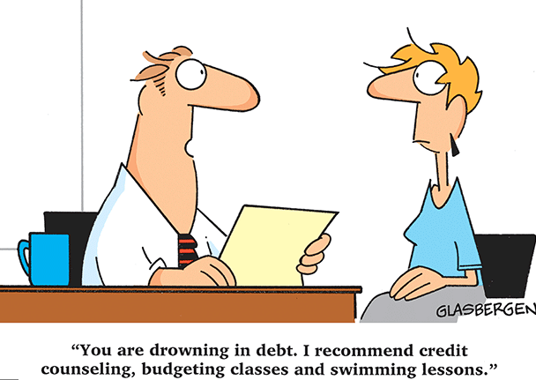
Log into myBlueprint and go to the 'Money' Section to get started with creating budgets.
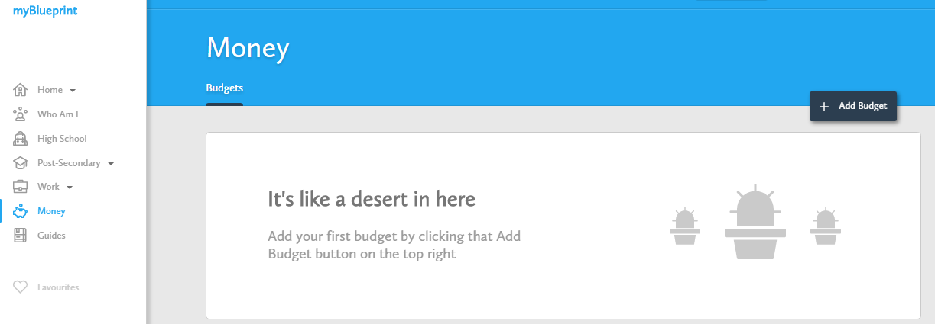

Now that you know what a budget is and why it is important to track your income and expenses, here are a few ways for you to use the Budgets tool in myBlueprint & below are your assignment instructions:
- Create multiple personal budgets. You can create your own personal budgets for many purposes, such as buying a new car or a new cell phone. For this assignment, you must create two personal budgets and add them to your ePortfolio as well as submitting them here.
- Create a budget for a post-secondary program. When you add a new budget, you can select the ‘Budget for Post-Secondary’ option from the ‘Need Ideas’ section and base your budget on the estimated expenses for one of your favourite post-secondary programs! For this assignment, you must create a budget for the post-secondary education program of your choice and add this to your ePortfolio as well as submit it here.
*Hint- use the Download Budget button in the top right-hand corner of the screen to download your budget to MS Excel for easy submission!
In total, you will be responsible for submitting 2 personal budgets and 1 post-secondary program budget. When you are finished your 3 budgets, submit them here and answer the following reflection questions:
1. Did you find the budgeting process useful? Why or why not?
2. Do you think budgeting will help you in your future? What will you be most likely to budget for?
3. Were there any surprises for you in creating these 3 budgets?
4. Did you notice any feelings that came up during or after you finished your budget? Where do these come from? How will you overcome them?
Before you start creating your personal budgets, explore the Paying for Post-Secondary Guide in myBlueprint to learn more about your financial aid options (where to access student loans, how to apply for scholarships, etc.), to help you plan your income and prepare a more accurate budget! Make sure you reflect back on your 'Career Cruising' assignment from Week 5 to help you choose your Post-Secondary Path.
Please check out the rubric before beginning your assignment.
Assessment
(see next page)
