Teacher Led |  | Requires Computer | X | Requires myBlueprint.ca | X
The apprenticeship and skilled trades is a pathway that students often overlook when planning their future. The aim of this lesson is to encourage students to explore this pathway, and spark interest in the skilled trades.

LEARNING OBJECTIVES:
- Students will explore and discover various skilled trades opportunities.
- Students will practice goal setting with a specific purpose in mind.
MATERIALS:
- Computer, tablet or mobile device
- Handout [A] - KWL chart
- Handout [B] - Activity worksheet
GETTING STARTED:
- Please visit www.myBlueprint.ca, and enter your email and password to log in.
- Forgot your password? Click on the “Forgot your password?” link in the green Existing User box.
- Forgotten email? As a teacher/counsellor, you can reset your students’ emails and passwords in your Student Manager or My Classes.
INSTRUCTIONS:
Before the lesson
- Class discussion: Pose the questions “What are your options after high school? What are the various pathways available to you?” to get an idea of what students already know about the 4 major pathways (apprenticeship, college, university and workplace).
- With a partner, have students fill out the K and W column from the KWL chart for skilled trades and apprenticeship programs (Handout [A]).
- Ask students to share the answers as a class. This is a good time to talk about the stereotypes people may have about skilled trades and break down those barriers!
During the lesson
- Give students Handout [B].
- Have students carefully read over the instructions for Handout [B] - Activity Worksheet
- Ask students to hand in a copy of their portfolio when they have completed Handout [B].
HANDOUT [A] - KWL CHART

KNOW | WOULD LIKE TO KNOW | LEARNED

HANDOUT [B] - ACTIVITY WORKSHEET
- From the navigation menu on the left hand side of your screen, select the Post-Secondary feature and click on Apprenticeship.
- Read over the Apprenticeship Guide found at the bottom right corner of the screen and answer the following questions:
In your own words, define …
An apprenticeship: ______________________________________________________________________________
______________________________________________________________________________
An Apprentice: ______________________________________________________________________________
______________________________________________________________________________
How many on-the-job training hours do most apprenticeships require? ______________________________________________________________________________
What is the percentage of in-class vs on-the-job training for apprenticeships? ______________________________________________________________________________
What is a Red Seal trade? ______________________________________________________________________________
______________________________________________________________________________
List one of the benefits of an apprenticeship: ______________________________________________________________________________
What are the 4 main sectors of skilled trades? List them in the order you’re most interested in to least interested in and explain why.
______________________________________________________________________________
______________________________________________________________________________
______________________________________________________________________________
______________________________________________________________________________

- Scroll back up to the top of the page and using the smart filters, filter the list to the industry sector you’re most interested in and explore the programs listed. From the programs you’ve explored, add 2 to your favourites list by clicking on the star beside it.
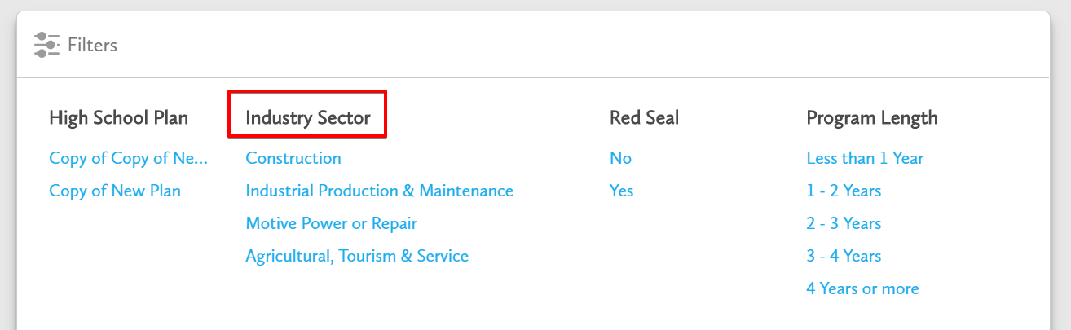

Which 2 apprenticeships did you add to your favourites?
- ___________________________________ 2. _____________________________________

- Click Home from the navigation menu and select Porfolios. Create a new portfolio titled ‘My Apprenticeships’ by clicking + Add Portfolio. Add the 2 apprenticeships as boxes to your portfolio under the left column.
- Go back to the Post-Secondary Planner and click Apprenticeship filter to the second industry sector on your list. Explore the options and add 2 to your favourites list.
Which 2 apprenticeships did you favourite?
1. ____________________________________ 2. _____________________________________

- Repeat step 4, but this time move the 2 latest apprenticeships to the middle column of your ‘My Apprenticeships’ portfolio.
- Repeat steps 3 and 4 for the 3rd industry sector on your list, and add the favourite apprenticeships to the column on the right in your ‘My Apprenticeships’ portfolio.
Which 2 apprenticeships did you favourite?
1. ____________________________________ 2. _____________________________________

- In your ‘My Apprenticeships’ portfolio, write a quick, but thoughtful reflection for each apprenticeship you’ve added explaining why you chose that apprenticeship.
- Download and print a copy of this portfolio to hand in to your teacher.
- Complete the L column from your Handout [A] - KWL chart.

- Answer the following reflection question:
Were you surprised at what types of apprenticeships are available? Explain.
__________________________________________________________________________________________________________________________________________________________________________________________________________________________________________
____________________________________________________________________________________________________________________________________________________________
Why do you think this pathway is often overlooked? Explain.
________________________________________________________________________________________________________________________________________________________________________________________________________________________________________________________________________________________________________________________
Now that you’ve done a bit more research, is this a pathway you would consider? Explain.
______________________________________________________________________________________________________________________________________________________________________________________________________________________________________________________________________________________________________________________________________________________________________________________________________

