Carpentry Station Cheat Sheet
Get the 2 totes from the Cupboard in the classroom & 3 drills with Robertson bits
Frame Layout | - YOU will have to have 3 different piles of wood (7 pieces each) prepped and ready to go. Each pile will consist of the 2x4 top & bottom plates and 5 2x4 studs the same length  - YOU grab 6 2x4s that are longer than 4ft but are the SAME length for the top and bottom plates. If there are too many nail holes, cut off 1 ½ inches on both ends with the mitre saw.  - Grab 15 matching studs for use by students to be divided into 3 groups of 5. If too many nail holes cut both ends off 1 ½ inches. These need to be the exact SAME length!!  - On the top and bottom plates layout where the studs go as per the video at 16” on centre.  - Each student in the group will nail ONE stud in place on the top and bottom.  - Show them how to nail properly and hold the 2x4 in place by standing on the pieces they will nail
Screw in blocking | - Get a premade frame from under the covered area if there is one OR make one yourself.  - You will need 15 blocks of wood for the day. Make sure they are ALL the SAME length.  - IF YOU HAVE TO MAKE A FRAME - The easiest way to assemble the frame with the correct stud spacing is to put 2 blocking pieces at the top/bottom then nail the stud into place, then remove the blocking  - You need #2 Robertson driver bits (Red ones) and 3inch screws  - Students will measure up from bottom plate on both sides  - Use speed square to draw a straight line  - Put 2 screws in from each side  - Do not sink screws in too far…use clutch on drill  EXPLAIN – You do this to keep spacing equal if 2x4s are warped
Nail hammering contest | - Nail 3 2x4s together that are 3ft long with 6 nails from each side. Install 2 more 12inch 2x4s 90 degrees to the 3ft ones with screws as “feet” to support the block of wood off the ground  - Have students do a “nail hammering contest” at the end before moving onto the next session.
Tools | Speed Square Framing Square  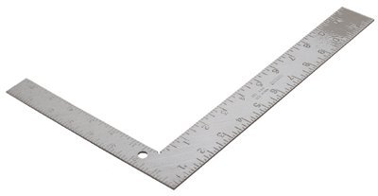  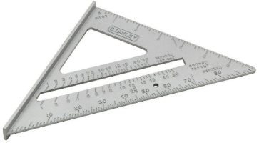  Claw Hammer Nail Puller  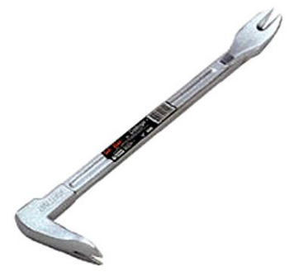  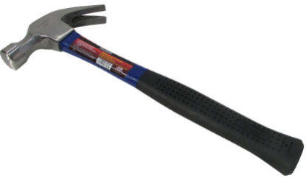  Tape Measure Tool Belt  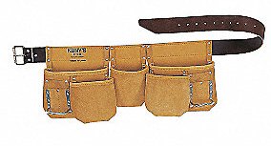  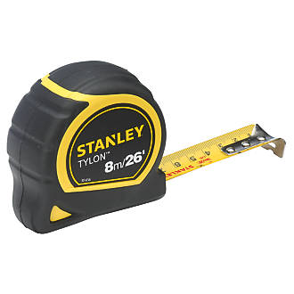  Cordless Drill or Driver Magnetic Sweeper  