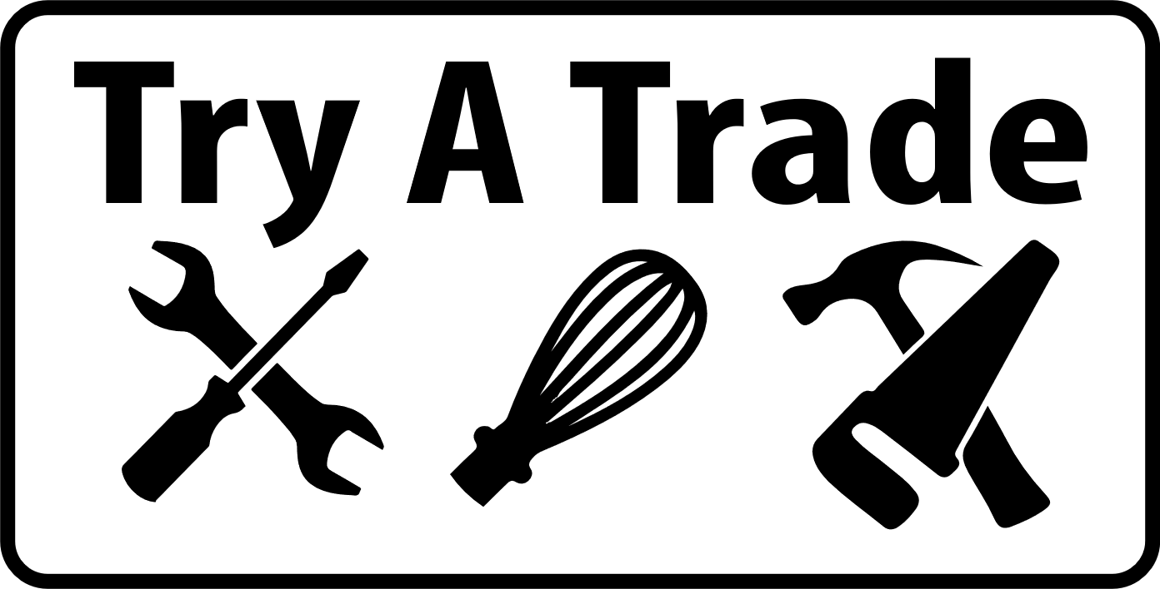
COOK Station Cheat Sheet
Get the 1 big tote from the Cupboard in the classroom AND the smaller dish/towel tote
Preparing | - Prep Food: Soak tomatoes, peppers, cilantro, green onions in warm water for 10min with soap. This will clean off dirt, germs, and pollution.  - Prep Tools: Wash 6 bowls, 6 pairing knives, 6 cutting boards, spatulas  - Have out: Take out boxes for food, plastic take away containers for the salsa, can opener, spoons, aprons, wash clothes and drying towels.  - Ingredients: All ingredients proportioned and ready to go. Enough for 15 students (5 kids x 3 times) plus yourself to use as a demo – SEE BELOW.
Ingredients and Notes to discuss with students as you go | - Fresh Roma tomatoes (15) – use the nice and red ones, avoid anything soft.  - Canned tomatoes (1) – I like to use canned in addition to fresh because it gives the salsa a better consistency.  - Fresh cilantro (1-2 sprigs x 15) – cilantro adds key flavor, don’t omit this!  - Jalapeno (optional) – this adds a nice kick. If you don’t like heat you can replace it with 1/4 cup chopped bell pepper, or omit.  - Red onion (1 makes 15 - ½ slices) – yellow onion can be used as well.  - Red/Yellow/Orange Pepper (3 cut into 1/6 each) – adds nice crunch and flavour  - Green onion (3 or 4 to make 15 x 1/5) – if you don’t want to buy both kinds of onions, omit the green onions and add a little more red onion.  - Garlic (1 clove x 15)– it may seem small but garlic packs a flavorful punch. Only use fresh garlic here for best flavor.  - Lime (4 limes cut into 1/4)– this really brightens up the salsa.  - Chili powder and cumin (in a small bowl) – a nice addition spice for flavouring.  - Sugar (in a small bowl) – just a touch balances out the acidity of the tomatoes and lime.  - Salt and pepper (in a small bowl) – the salsa would taste flat without the salt and the pepper adds a light kick.
Preparing the Salsa | *Remind students to chop fine or their salsa will be very chunky. If at home, they could blend it once all ingredients  Step 1: Tie back hair, put on apron, wash hands (warm water, soap, 20 seconds)  Step 2: Discuss the tools that they will be using.  Step 3: Demo how to use a pairing knife. Fingers down so cutting along nails not fingers etc.  Step 4: Introduce ingredients and recipe  Step 5: Let them start  - 1 Roma tomato- dice into bowl  - 1 Heaping tablespoon of diced canned tomatoes  - 1-2 sprigs of cilantro, leaves picked off and chopped finely  - 1/6 of a bell pepper finally chopped  - 1 slice of the red onion- students will then chop  - 1/6 of a green onion, chopped  - 1 clove of garlic- mince  - ¼ of a lime, squeeze in  - 1 pinch of chili powder  - 1 pinch of cumin  - 1 pinch of salt  - 1 pinch of pepper  Step 6: Wash knife, cutting board.  Step 7: Make box, scoop salsa into TWO plastic containers and put lids on them, place plastic containers in box and then add chips around salsa containers. PRINT names on each box and have students leave it with you till the end of the day  Step 8: Discard any extra salsa into a bowl for the teachers at the end. wash bowl, place apron on counter for next person.  Step 9: You clean and tidy and prep for next group.  **Make sure to always have a clean sink filled with warm water and soap so that students can do their own dishes, otherwise you may be stuck with them.

