Drywall Station Cheat Sheet
Get the 1 tote from the Cupboard in the classroom & 2 cordless drills from staff
Cut out Layout and setup | - YOU screw 4ft x 4ft Drywall to the frame using black drywall screws.  - You - Using the templates provided layout the holes to be cut out by students making sure you do NOT put a cut out hole overtop of a stud!!  - You will need to layout 20 cuts for the day  - YOU lock the units together with a block of wood at the top using 3” screws and a 2 x 4  - YOU use a drywall saw and cut out 5 holes yourself  - YOU use a 2 x 4 and install it behind the 5 holes you just cut out using 3” screws at the top and bottom, THEN use drywall screws between each hole you cut to secure it firmly.
Cutting holes  (students) | - Have students use a drywall saw to cut out a hole as a rectangle making sure they cut on the lines as the piece will be used over again  - Next have kids move their piece over to a spot that has a hole already cut out and the backing 2x4 block installed.
Patching | - Use a rasp to clean up any bad edges if their piece doesn’t fit  - Once nicely fitting, screw in with TWO drywall screws to hold in place. Do NOT get too close to the edge or the drywall will break.  - Carefully have them place tape over all the gaps.  - Place a small amount of mud into the Mud Pan. Do NOT put excess back into the bucket.  - Have kids mud over the piece with a puddy knife covering everything. Use a larger plastic trowel to smooth it out  - Explain that it is a multiple layer process that is sanded between each coat.  - They will not be able to sand as the mud would have to dry.  Make sure you wash EVERYTHING OFF at the end!!
Tools | Drywall Saw Mud Pan  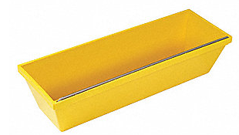  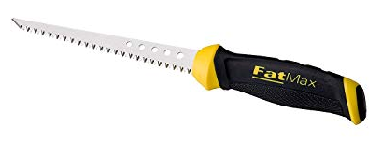  Puddy Knives Drywall Rasp  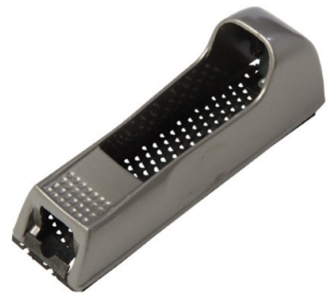  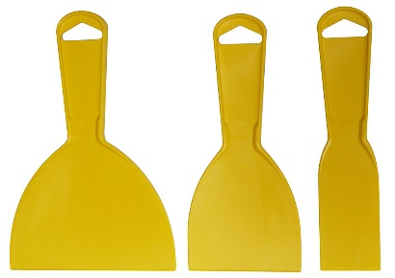  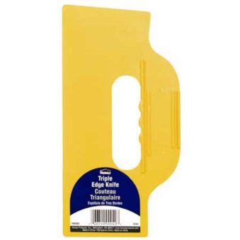  Drywall Tape Triple Edge Knife  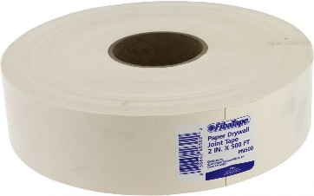  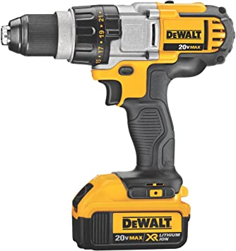  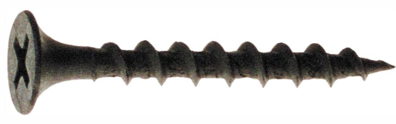  Drywall Screw Cordless Drill

