Electrical Station Cheat Sheet
Get the 2 totes from the Cupboard in the classroom AND 2 Walls from the Shop
Framed Walls  Installing a receptacle | - YOU install 6 device boxes to the frame with screws (The 6th one could be your demo one to show the kids what they are going to do)  - YOU make sure each of the 5 device boxes have wire sticking out at least 6-8 inches and the sheathing is removed to expose black, white, bare wires AND tightened at the back so the wire does not move!!  - You may need to replace the wire at some point with a new 24 inch piece.  - YOU make sure the bare wires are snipped from the previous group so the new group must strip the wires themselves!  - Students will install receptacle into the device box to get practise  Black (Hot) wire to Brass screw  White (Neutral) wire to Silver Screw  Bare wire (Ground) to the device box at the back and green screw  - YOU remove plug (receptacle) once finished and cut off exposed copper wire ready for next group
Wall Unit Installing a Switch & Receptacle | - Cut previously exposed wired bits off and pull wire out so there is 6-8 inches for next group  - Look behind unit to make sure there is enough wire to be able to pull through. You are doing this 3 times in the day  - Kids will install 3 light switches and 3 receptacles and a light fixture  - Installing the light switch  - the two black (hot) wires go to the switch, the two white wires get connected using a marette (orange)  - Install the receptacles  - Black (Hot) wire to Brass screw  - White (Neutral) wire to Silver Screw  - Bare wire (Ground) to the device box at the back and green screw  - Installing the light  - Black (Hot) wire to Brass screw, White (Neutral) wire to Silver Screw
Testing | - Do NOT plug in. Test first with multimeter…. See Claassen if unsure  - Plug unit it, 1 switch is connected to the light, 2 switches are connected to receptacles like in a living room or master bedroom. Use floor lamp for the receptacles to test
Common Electrical Tools | Linesman Pliers Needle Nose Pliers  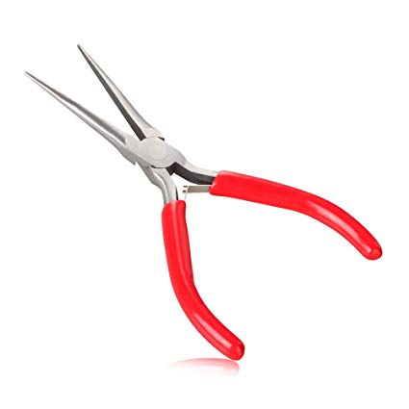  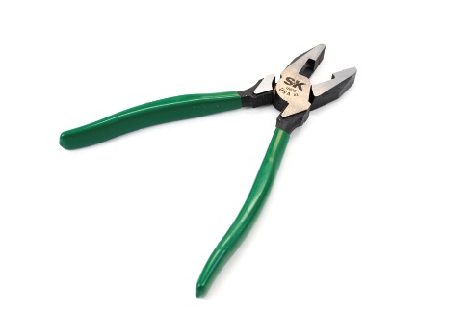  Wire Rippers Screw Driver  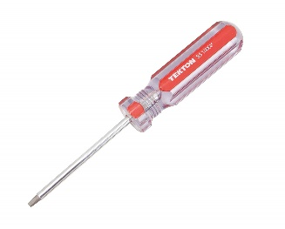  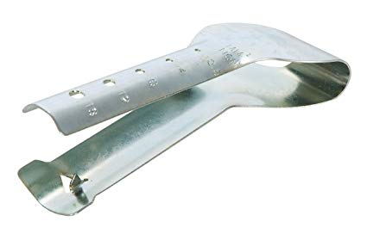  Wire Strippers  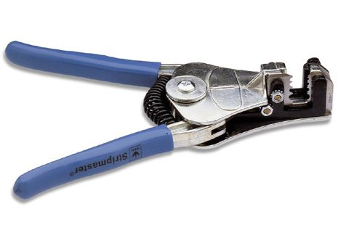  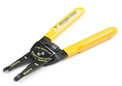  Receptacles Switches Marette  