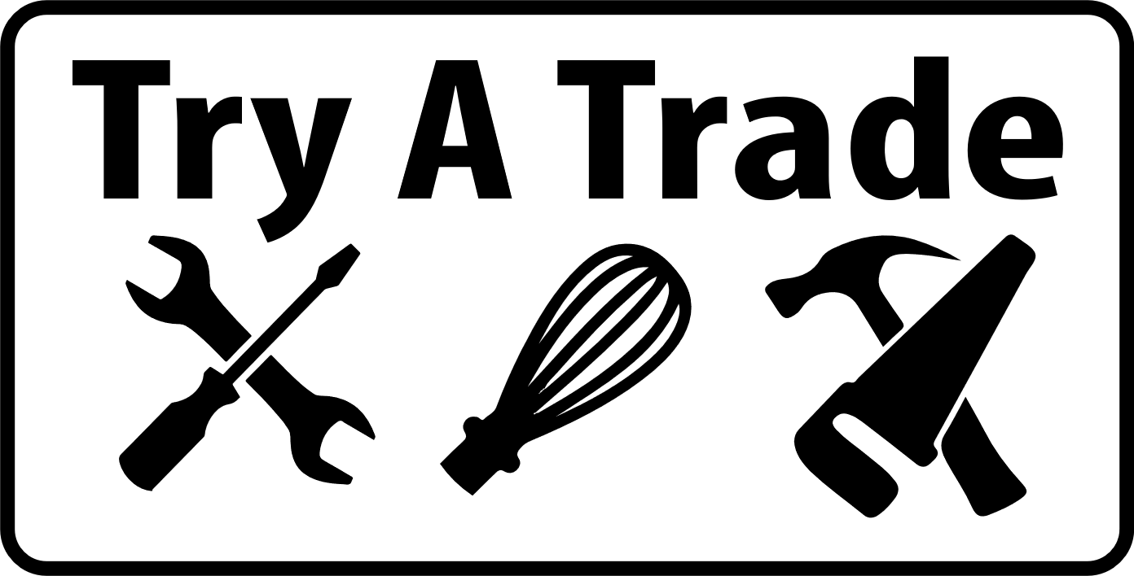
Mechanics Station Cheat Sheet
Get the 1 tote from the Cupboard in the classroom AND 3 engines from front of class
Tire Change  Tire PSI, Jacking up Car | - Remove a bit of air pressure before group gets there (around 30psi)  - Students use pressure gauge to check tire pressure, split group up  - Using “Tidy Tank” or air compressor, add air to inflate to 32psi  - Using a lug wrench, loosen the lug nuts BEFORE raising the tire  - Jack up car so the tire is about 1 inch off the ground  - Block up the car with Jack Stands or blocks of wood (Explain for Safety)  - Take the lug nuts off with lug nut wrench or by hand (remember to reinforce that right is tight, left is loose) and remove the tire.  - Change tire, then in reverse order, put new tire on, hand tighten lug nuts, lower tire so there is grip on the floor  - USE a torque wrench and set to 70lbs. Tighten lug nuts one at a time opposite of each other  - Lower car the rest of the way
Engine #1  Oil Check | - Students check oil (make sure you have a rag)  - Check dipstick, if oil is low and at the line (it should be) – explain that you add 1 litre of oil  - DO NOT remove oil filter or oil pan from this engine. There is oil in it!!
Engine #2  Change Oil Filter | - Use the oil filter wrench or oil filter socket to remove the existing oil filter. Remember, right is tight, left is loose!  - Once removed, use a bit of oil from the engine dipstick and add a small amount to the seal  - USE YOUR HANDS to re-install the new filter. Turn ONLY ¼ turn after contact is made
Engine #3  Bolt removal and install plus engine part explanation | - Students take a few bolts off to expose the cylinders  - Timing belt will already be exposed  - Have kids use a socket wrench and sockets to loosen and remove some bolts. Make sure you explain right is tight and left is loose.  - Make sure to explain cross threading, metal bolts, aluminum engine block. Stripping bolts in BAD!!
Tools | Oil Filter Socket Oil Filter Wrench  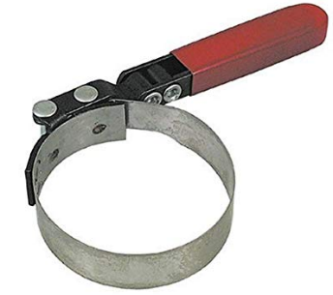  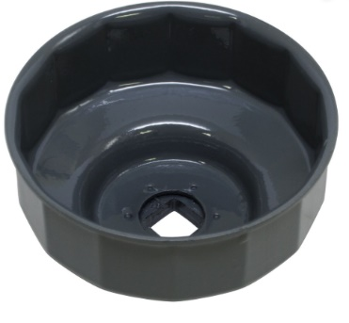  Torque Wrenches Scissor Jack  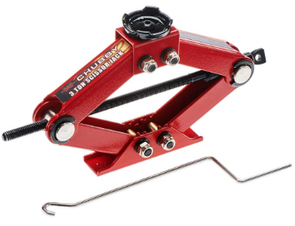  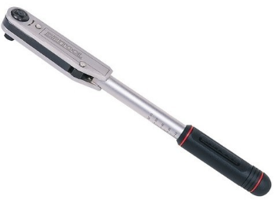  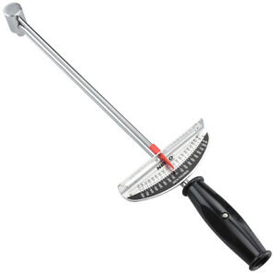  Lug Wrenches  