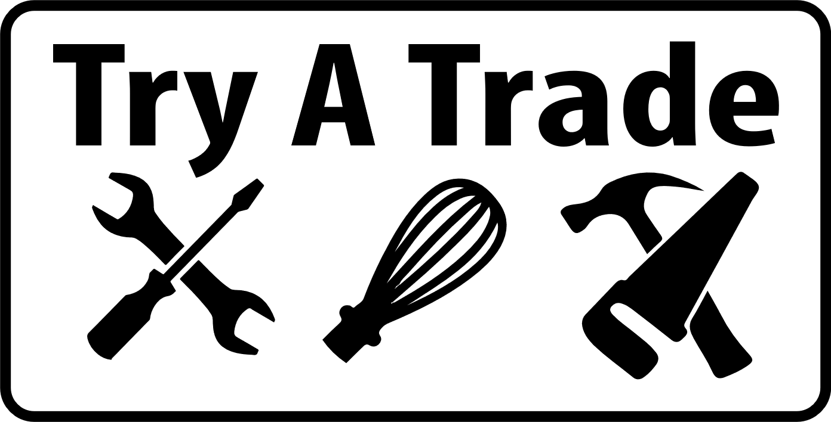
Plumbing Station Cheat Sheet
Get the 4 totes from the Cupboard in the classroom

Soldering Copper | - Use larger vises mounted on 2x6 board (in the shop) for cutting the copper pipe, use portable vices to clamp to table for soldering pipe  - Using tubing cutter (spin around pipe and turn knob as you go) cut a 2 inch piece, deburr the inside of pipe, sand outside with emory cloth or use pipe cleaners (solder doesn’t flow properly otherwise)  - Sand/clean inside of copper fittings (elbow) as well  - Flux both pieces – only need a tiny bit then join the 2 pieces together  - Roll out solder about 8in then bend the end 1/2inch to 1 inch. Don’t need much solder (kids will keep going) and solder will drip – WRONG!!  - Heat the joint, when solder flows freely remove the solder and heat  - Use a damp wet rag to cool once done and remove drip at the bottom
PEX Pipe | - Prepare station by cutting off ONE SIDE of the completed PEX piping at the corner of the unit and leaving the other side completely in tacked for students to follow  - Students measure and then cut PEX pipe to length for path it will follow  - Put rings over pipe THEN insert fittings into pipe  - Use PEX crimping tool to crimp rings in place. Use Go, No Go gauge to check the crimp is good.  DO NOT TEST UNTIL DRAIN PIPE SECTION IS COMPLETED!!!
Drain Pipe | - Using a hacksaw, have each student cut a 1/2inch piece of ABS pipe off (teach 1 stroke per second and cutting happens on the forward stroke)  - Using the tote of ABS pipe and the tote of ABS fittings have the students fit pieces together to complete the drain system from the sink to the hole in the floor. DO NOT use Vaseline like video says.  - Make sure water drain tote is under the unit to capture the water!!
Plumbing System Test | - Connect water hose to the tap installed on the back of the unit making sure the tap is turned off! Make sure sink taps are turned off!  - Turn main water on by Overhead doors outside of building  - Now open the tap located on the back side of the unit. The system will pressurize and hopefully not blow apart and soak everyone  - Turn sink tap on inside the unit and the system should work and drain all the way to the drain bucket that is STILL under the unit!!
Tools | 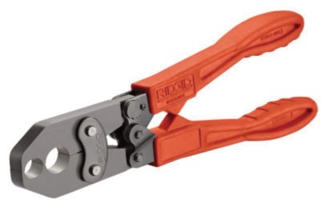  PEX Crimp Tool PEX Ring Removal Tool  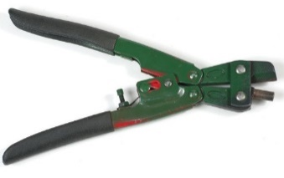  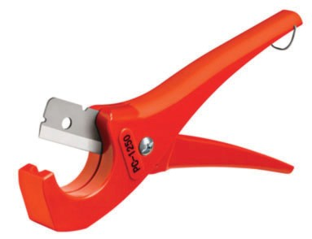  PEX Pipe Cutter Go, No Go Gauge  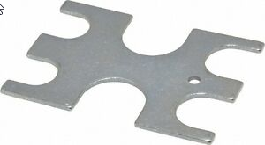  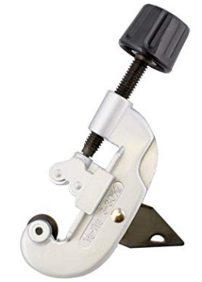  Tubing Cutter Solder  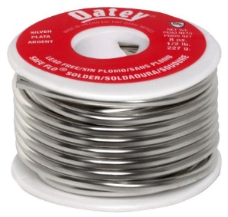  Copper Pipe Cleaner Copper Pipe Cleaner  Outside Inside  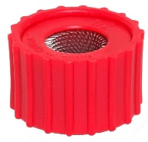  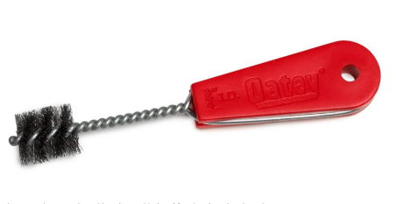  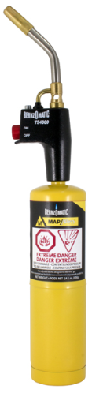  Bernzomatic Automatic Torch

