Roofing Station Cheat Sheet
Get the 1 totes from the Cupboard in the classroom AND the harnesses from staff
Prepping Kids in Hardness | - Give out the harnesses to the students and have them try and get into it themselves.  - Have Oliver help you get kids properly into Harnesses  - Kids will be clipped into Harness and attached to the wall facing down the slope  - Give students a tool belt
Roofing | - You will have to CUT SHINGLES TO MAKE THIS WORK!!!  - Row 1 – YOU Install first row on shingles upside down, use 2-3 nails per shingle  - Row 2 will start with a ½ shingle to offset the gap in Row one  - All subsequent rows stagger ½ shingle, full shingle to offset the gap  - Only 2-3 nails per shingle!!
Shingle removal | - Have each student use a nail puller to remove a shingle without wrecking the shingle!!  - Leave the bottom row
Tools | 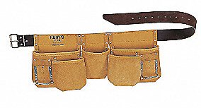  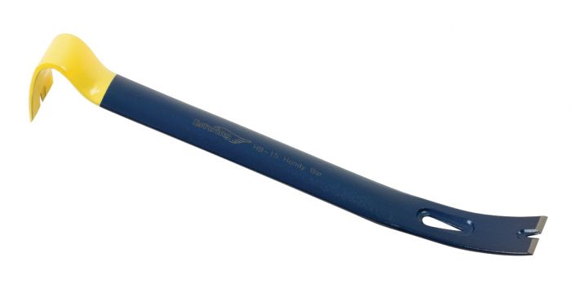  Nail Puller Tool Belt  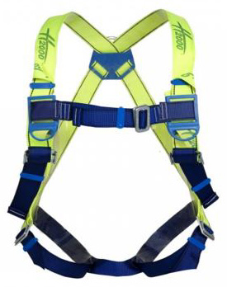  Claw Hammer Safety Harness  