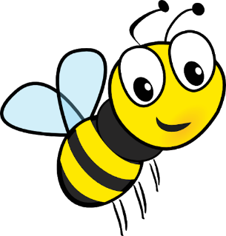
What do we know so far?

Mason Bees
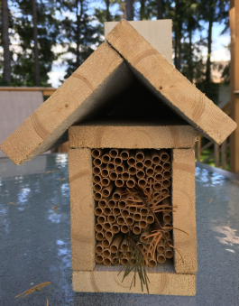

Everything you need to know before keeping Mason Bees.
How far off the ground should their home be? ________________________
Which way should it face? ______________________________________
Why do we want the morning sun? _________________________________
We’ve used cardboard straws for our bees’ nesting tubes. Why do you think this is good/ convenient for the end of the season?
___________________________________________________________
___________________________________________________________
What nesting materials will your bees need for their homes?
___________________________________________________________
What is the bees’ foraging radius? _________________________________
Where can we get the bees? _____________________________________
How do we get started with the bees? i.e. When do we put the cocoons out and where would be a good place?
___________________________________________________________
___________________________________________________________
What’s the difference between male and female bees?
___________________________________________________________
When does the season usually end? ________________________________
Why is it important to clean and harvest the new cocoons?
___________________________________________________________
How do you harvest the cocoons? Give step by step instructions.
___________________________________________________________
___________________________________________________________
___________________________________________________________
What type of cocoon should be removed? ____________________________
NOTE: Shake the cocoons in a colander. If there are any small cocoons, discard. Any cocoons that are soft and silky should also be separated and discarded. Keep an eye out for cocoons with small holes. These may have been parasitized by wasps and should remain separate from the healthy bees.
How do you store the cocoons until next season?
____________________________________________________________________________________________________________________________________________________________________________________________________________________________________________

In SUMMARY
Increasing native bee populations is one of the best ways to support local ecosystems and increase your garden and fruit tree yields. Keeping mason and leafcutter bees and attracting other native pollinators by providing habitat and forage is an easily attainable and super rewarding experience! Go forth and bee!
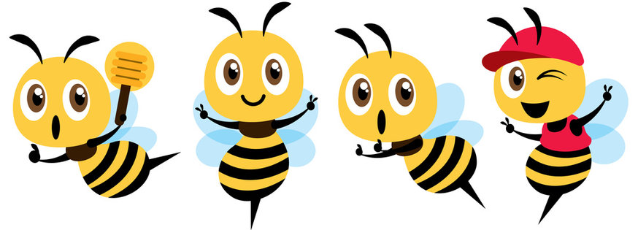
Bee Happy!

