Design Thinking Criteria and Reflection
ADST Grade 6 | 1 emerging | 2 developing | 3 proficient | 4 extending
I can identify key features or potential users and their requirements.
I can generate ideas and add to others’ ideas.

I can develop a plan that identifies key stages and resources.

I can make changes, troubleshoot, and test again.

The process/part of the project that I enjoyed the most was: ___________________________________
_____________________________________________________________________________________
The biggest challenge I faced when designing and building was: _________________________________
_____________________________________________________________________________________
Goal for my next design project: __________________________________________________________
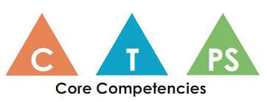
Core Competency Reflection
CRITICAL THINKING
A critical thinker can do the following things:
- experiment with different ways of doing things
- monitor their progress and adjust their actions to make sure they achieve their goal
Explain how you used one or more of these competencies during the Design Thinking project. Give specific examples.
_____________________________________________________________________________________
_____________________________________________________________________________________
_____________________________________________________________________________________
Proficiency Scale
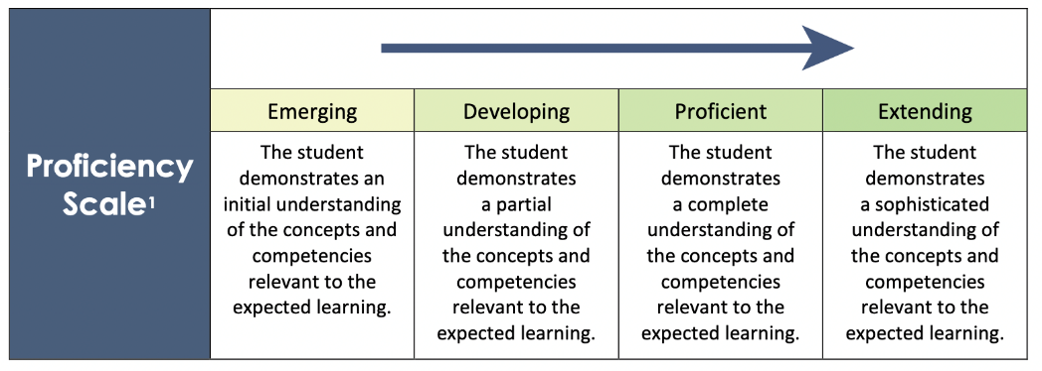
You can use this to help guide your self-reflection above.

