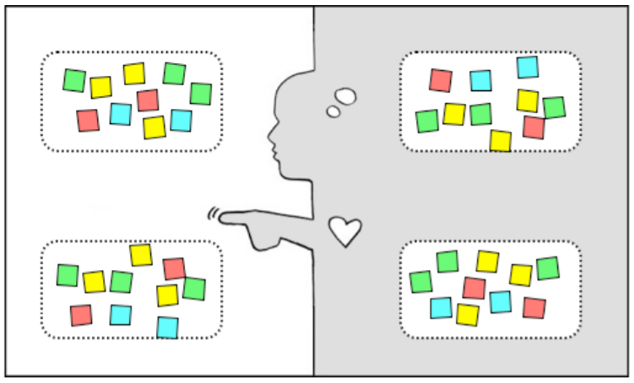
Empathy Map
WHY use an empathy map? Good design is grounded in a deep understanding of the person for whom you are designing. Designers have many techniques for developing this sort of empathy. An Empathy Map is one tool to help you synthesize your observations and draw out unexpected insights.
HOW to use an empathy map? UNPACK: Create a four quadrant layout on paper or a whiteboard. Populate the map by taking note of the following four traits of your user as you review your notes, audio, and video from your fieldwork:
SAY: What are some quotes and defining words your user said?
DO: What actions and behaviors did you notice?
THINK: What might your user be thinking? What does this tell you about his or her beliefs?
FEEL: What emotions might your subject be feeling?

Note that thoughts/beliefs and feelings/emotions cannot be observed directly. They must be inferred by paying careful attention to various clues. Pay attention to body language, tone, and choice of words.
IDENTIFY NEEDS: “Needs” are human emotional or physical necessities. Needs help define your design challenge. Remember: Needs are verbs (activities and desires with which your user could use help), not nouns (solutions). Identify needs directly out of the user traits you noted, or from contradictions between two traits – such as a disconnect between what she says and what she does. Write down needs on the side of your Empathy Map. IDENTIFY INSIGHTS: An “Insight” is a remarkable realization that you could leverage to better respond to a design challenge. Insights often grow from contradictions between two user attributes (either within a quadrant or from two different quadrants) or from asking yourself “Why?” when you notice strange behavior. Write down potential insights on the side of your Empathy Map. One way to identify the seeds of insights is to capture “tensions”, “contradictions”, and “surprises” as you work.

Empathy Map
Say | Think
Do | Feel

