Grade 6: Supporting Those in Need - Careers, ADST and English Language Arts

Materials Needed: Community Presenter List, Cycle Image Design Thinking, Gradual Release sheet (for teacher reference), SDG flip cards, LRC Kits/Books from your library, Empathy handout, 1 x 4 wood, nails, wool, school toolbox/Maker Cart, reflection sheet, Design Thinking Project Sheet, Sustainability Resources: https://www.comoxvalleyschools.ca/career-programs/sustainability-teacher-resources/

Guiding Question: How can we as community leaders support poverty and those in need? | Grade: 6
Big Idea:  English Language Arts- Language and text can be a source of creativity and joy.  Careers- Leadership represents good planning, goal setting, and collaboration.  ADST- Design can be responsive to identified needs. | First Peoples Principles: Learning involves recognizing the consequences of one’s actions.
Learning Path

Students will learn how to build a loom, weaving a scarf and then donate their items to a local shelter or cause (EDAS). Their donation should include a written piece around hope, caring, or the season. Presenters are encouraged to come in and speak with a class around the needs in their community.

Lesson Plan:
Get Ready!
Introduce Design Thinking to your students. You can use the Design Thinking hand-outs, Cycle Image Design Thinking, Cycle of Design Thinking, and the Design Thinking Project Sheet (Careers website).

Introduce the UN Sustainability Goals (SDG): https://sdgs.un.org/goals #1 relates to this so you may want to highlight it.
You can also use the SDG flip cards- #1
Video to show SDG’s in action, https://www.youtube.com/watch?v=lUjYMrGreRw

*If you would like the students to know about their personal interests and passions around the SDG’s you will want to do the “Pre-Loading” Lesson located on our website (https://www.comoxvalleyschools.ca/career-programs/sustainability-teacher-resources/ ).

Students will also need to learn about writing a poem or short story within a theme: Hope, the Season, Caring.
Consider additional supports:
Your Teacher Librarian
Your District Learning Resource Centre resource

Jump In- Putting it all together!
- The class will all pull out their copy of the Design Thinking Project Sheet. The teacher will need to walk the students through the project as a class, especially if this is their first time doing a Design Based Learning Project. The teacher will let them know that they will all be writing a piece and will need to build a loom. The teacher could let the students know about Gradual Release regarding Design Thinking – if they plan on doing more.
- Step 1: Empathize- Make use of the Empathize Guide Sheet to help students consider all aspects. Who needs what? Bring in a presenter to talk about the needs of local people (SD71 has a presenter portal). Bring in EDAS to talk about their cause and what they could do.
- Step 2: Use the Framing the Question Sheet to help students draft their question and narrow in on their focus. The teacher can write the guiding question on the board if they are creating a class question.
- Step 3: Ideate – mind map, brainstorm…the teacher will need to support students in thinking about all aspects of the problem. Students will know that they are focusing on a written piece and building a loom Ex. What could be made with a loom, how do you make a loom, nail type, writing styles, themes… Students write and draw their ideas out, considering all that they have learned. Students will need to share their ideas; the teacher should consider what they hear and if they can modify what they have planned. The teacher will then need to share the intended plan with the class and ask for feedback.
- Step 4: Prototype - For this step, the teacher will need to make sure all safety lessons have been taught for tool use, including the safety quiz. The class will review the project build (all details in Teacher build book).
They will want to write them on the board.
Once the build is done, students will need to create their written artifact with the goal of brightening someone’s day. These artifacts could look very different. The teacher may want some examples available.
- Step 5: Test - Students model, run events, test their project… students will make sure that their scarves fit, they can test these on members from around the school. They could also read their artifact to another class or a buddy class to make sure the message comes across strong.
Community: Students will then take their scarves and written pieces and donate them to a shelter or EDAS. EDAS will place once of each item in a bag along with some food and personal health items. These will then be distributed to community. If the students can, it would be ideal for them to support the cause and distribute them with EDAS.
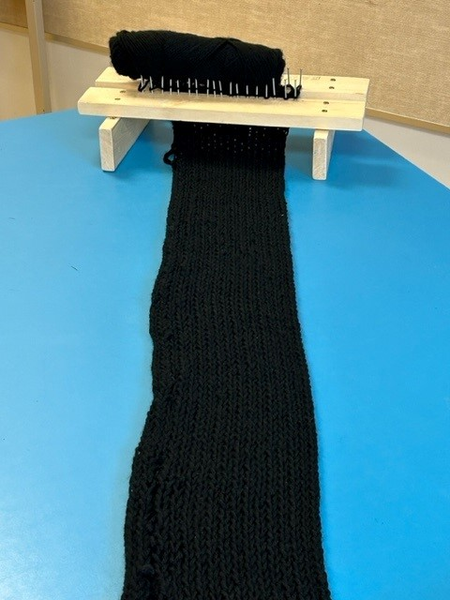
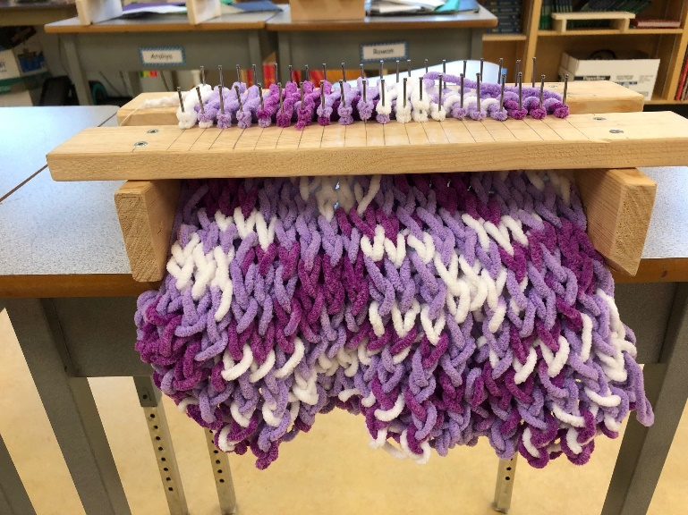
- Step 6: Assess- Reflect. Go back ideate more and/or prototype again the next year or the following month. What do we need to reconsider? Do we to grow this or work with other classes. How can we spread the word to other community members.

Community Extension:
- Students could organize an EDAS drive where they collect additional items to go into the EDAS bags from their home communities or school. Students could connect with the local paper and share the project and how they are contributing.

