Grade 7: Water Filtration Unit Plan - Cross Curricular

Materials Needed: science journal (use what you have to make one), PH test paper (optional, but good for testing results), materials as outlined in the water filtration guide (see below), Design Thinking Planning Sheet, LRC Kits (for SD71 teachers)

Guiding Question: How can we as environmental stewards ensure clean water for all species?

Big Idea:  Science- Earth and its climate have changed over geological time  Careers- New experiences, both within and outside of school, expand our career skill set and options  ADST- Design can be responsive to identified needs. | First Peoples Principles:  Learning is holistic, reflective, reflexive, experiential, and relational.
Competencies  Science- meets most competencies of the Grade 7 curriculum  Careers- Examine the importance of service learning and the responsibility of individuals to contribute to the community and the world (others fit as well)  ADST- meets most competencies of the Grade 7 curriculum  *Design-thinking framework (ADST placemat) | Content:  Science- Survival Needs: all organisms need space, food, water, and access to resources in order to survive  Careers- problem-solving and decision-making strategies  ADST- Locally developed module: Water filtration system

Learning Path

Note: Students may need to ‘create’ a science journal before embarking on their learning journey. Students will watch two videos to engage their thinking. After reflection and class discussion, UN Sustainability Goals 6 and 13 will be shared. Students will then ideate to create a water filtration system. Extension activities to stretch their thinking (and yours!) follow.

Lesson Plan
Get Ready!
Watch Where We Get Our Fresh Water
Reflect: In your science journal, answer these questions:
- What is the most interesting bit you learned?
- What is one question you have since watching the video? You may have more than one question.
Watch Are We Running Out of Clean Water?
Reflect: In your science journal, answer these questions:
- What is the most interesting bit you learned?
- What is one question you have now? You may have more than one question.
Consider UN Sustainability Goals (SDG’s) as you watch:
Ken Robinson and Emma Watson: The World's Largest Lesson
It is our job as community members, and people on earth, to support the welfare of our earth all that encompasses it. By taking part in this learning, students will be exploring two of the SDG’s.
Please take a moment to look over these and discuss how we can continue to support the SDG’s outside of school. Are there other Daily Actions your students can think of? Add them to their science journals!
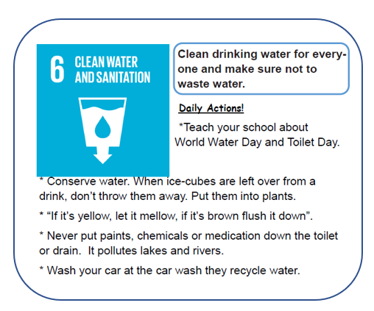
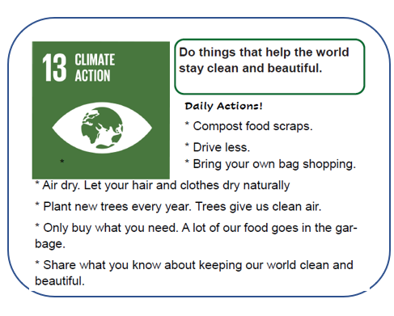

*Want a copy of all 17 SDGs in a printable infographic card format?
Access a downloadable PDF on the SD71 Comox Valley Careers Department under Elementary → Sustainability: Teacher Resources → SDG Cards Primary

Exit slip:Why is clean water so important? Who needs it?
A mind map, paragraph, drawing, or other is a great way to share their thinking.
*This may also be a good question to send home with students to discuss with their families and prepare something to share for next class*
Jump In!
- Build your own water filter with the NASA Jet Propulsion Laboratory.
  - Watch the video of the project with your class.
  - Gather all of the necessary materials ahead of time and set up the class into working groups.
  - ADST - you will want to follow the “Design Thinking Planning Sheet” as you move through this project. This allows students to Ideate- prototype- test and reflect on their experiment and show their thinking. This is also a good resource to have for reflection at the end of the project. This document could also be part of their science journal. Explain this sheet if desired.
  - Once students have designed and tested a few times you may want to show them a few ideas and examples of other classrooms, watch this together: Design Thinking: A Problem Solving Framework
- Students may want to test their waters Ph. You can do this by ordering Ph Litmus paper. You can order this from Boreal Science - https://www.boreal.com/store/ or ask your Sr. Science teacher for some.
- Students will now move through the project steps in their groups. If using the Design Thinking Sheet, remind students to ideate, prototype and test and then go back and ideate a second time considering what needs altering. Students may go through this cycle a few times, hopefully gaining clearer water each time.

Jump out here, or…
Extend your learning…we highly recommend
Invite a community leader to your class
Create a brochure, poster, podcast, news article, poem
ELA, Careers, Arts
Consider how your students can share their learning with the community! A letter to the editor? Invite the local paper to your classroom to check out the water filtration systems they’ve built?
Learn about your local watershed
ELA, Careers, Science, ADST, Arts, Social Studies (mapping)
Eg. Tsolum River Restoration Society: This Comox Valley-based resource for educators is easily adaptable to your area! It includes background information (What is a watershed? What contaminants are in your local creeks/waterways?) Project includes guided build of making a 3-D topographical map to understand run-off

Connect with your local restoration groups
ELA, Careers, Science
Invite a representative to visit your class. Prepare students to develop thoughtful questions to make the most of your time.

Plan a Field Trip with your local restoration group
ELA, Careers, Science, PE

Additional resources | Why we’ve included it
WHO Drinking Water | World Health Organization, a leader in global efforts for better health for all
WHO World Water Day | With their 2022 theme on Groundwater, WHO hooks learners to take part in their One Minute Challenge
5-Minute Film Festival: Celebrate World Water Day | From Edutopia, a series of short films (including some vintage Sesame Street!) to deepen understanding around water
Learning Resource Centre (Comox Valley SD71 students)

