Learning in Action Project
Curricular Competencies | 1 emerging | 2 developing | 3 proficient | 4 extending

The process/part of the project that I enjoyed the most was: ___________________________________
_____________________________________________________________________________________
The biggest challenge I faced was: _________________________________________________________
_____________________________________________________________________________________
Goal for my next design project: __________________________________________________________
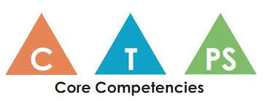
Core Competency Reflection
CRITICAL THINKING
A critical thinker can do the following things:
- experiment with different ways of doing things
- monitor their progress and adjust their actions to make sure they achieve their goal
Explain how you used one or more of these competencies during the Design Thinking project. Give specific examples.
_____________________________________________________________________________________
_____________________________________________________________________________________
_____________________________________________________________________________________
Proficiency Scale
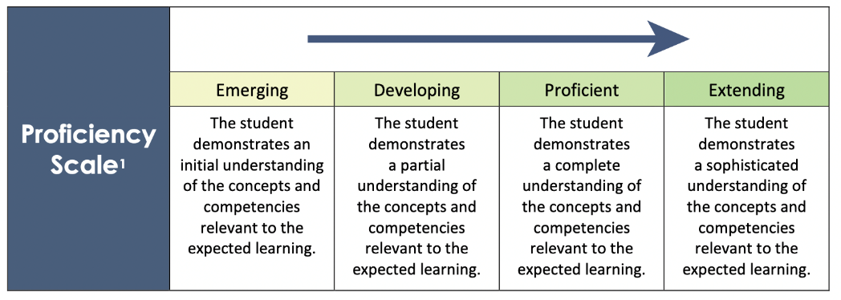
You can use this to help guide your self-reflection above.

