
ELECTRICAL STATION CHEAT SHEET
Installing a plug and receptacle  ( into Framed Walls) | - On your device boxes, have wire sticking out at least 6-8 inches. You will then have to pull out farther for next step  - Use wire ripper tool to remove the sheathing/housing and pull back to expose black, white, bare wires. Once exposed, push wire back in until hit point of exposed wires and tighten at the back so the wire does not move!  - Tighten copper ground wire around the screw at the back of the device box. Loop in direction you are going to tighten so will not come undone. Cut all other wires to be same length as copper wire.  - Use wire stripper to expose ½ inch off end of each wire ( first group only)  - Students will then grab their plug and attach the following wires from your bin to the receptacle/switch:  Black (Hot) wire to Brass screw  White (Neutral) wire to Silver Screw  Bare copper wire (Ground) to the green screw  - Tug to make sure each wire secure and then tighten  - You will now have three wires of each color that you will need to connect by using the yellow Marette ( Yellow = 3 wires and Orange = 2 wires).  - Spread out wires and group same color wires together. Take ends of all black wires and thread together with the yellow Marette. Repeat this process with the copper wires and the white wires.  - Carefully roll up all wires and push into the device box, screwing into place to hold the wires inside.  - remove plug (receptacle) once finished and undo the yellow marettes to be put back in your bin. Separate out the wires that have the RED TAPE, as these ones will be reused and NOT CUT. The wires on the far left ( with NO red tape) will be pulled out 8 inches and cut off where the white housing starts in preparation for next group.
Installing a Switch & Receptacle | - Installing the light switch ( to device box on the right)  - Attach the copper wire piece from your bin onto the green screw on the light switch. Then put three copper wires together and secure with a yellow marette  - the two black (hot) wires go to the switch, the two white wires get connected using a marette (orange)  - The black wire coming from the bottom then gets attached to bottom of the switch. Black wire from top gets attached to top of switch. Black ( hot) wire attaches to brass screw.
Career Connections | Electrician (residential, commercial, industrial), Construction electrician , Maintenance technician (factories, schools, hospitals) , Power line technician (lineman) , HVAC technician (heating/air systems)  - Other careers include Engineering and design, electronics or robotics technician, telecommunications, renewable energy technician ( solar or wind), automotive technician, equipment maintenance specialist, marine electrician, aircraft maintenance, rail systems technician
Job Duties | Electricians typically do the following:  - Read blueprints or technical diagrams  - Install and maintain wiring, control, and lighting systems  - Inspect electrical components, such as transformers and circuit breakers  - Identify electrical problems using a variety of testing devices  - Repair or replace wiring, equipment, or fixtures using hand tools and power tools  - Follow state and local building regulations based on the National Electrical Code  - Direct and train workers to install, maintain, or repair electrical wiring or equipment
Common Electrical Tools | Linesman Pliers Needle Nose Pliers  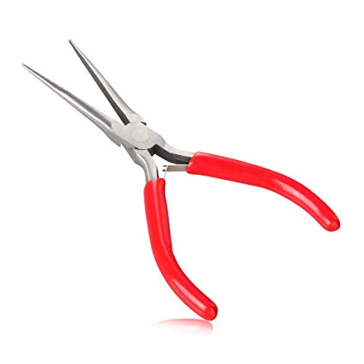  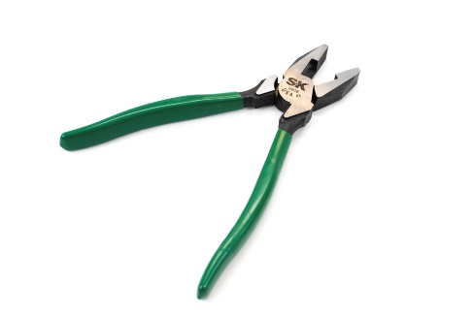  Wire Rippers Screw Driver  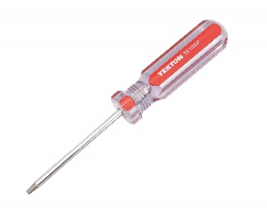  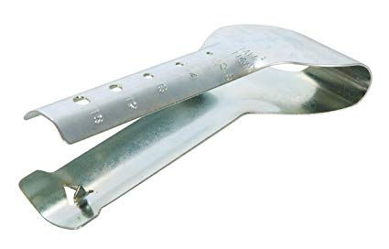  Wire Strippers  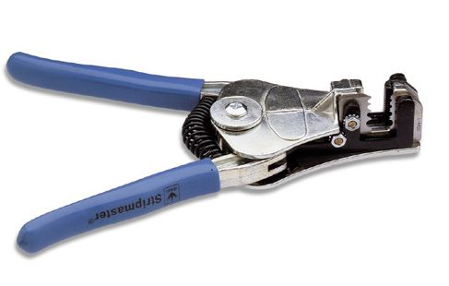  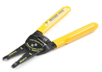  Receptacles Switches Marette  