Orienteering and Survival
Part 1:
Careers using these skills:
Careers | Skills for Life
- Fishing  - Guiding  - Forestry  - Marine Biologist  - Search and rescue  - Coast Guard  - Photographer (Wildlife)  - Land Surveyor  - Geographic Information Systems Technician  - Cartographer  - Park ranger | - Survival  - Back Country exploration and sports  - Adventure racing  - Fishing  - Geocaching

Part 2:
How to use a compass and map
Students do three different tasks in partners

Part 3:
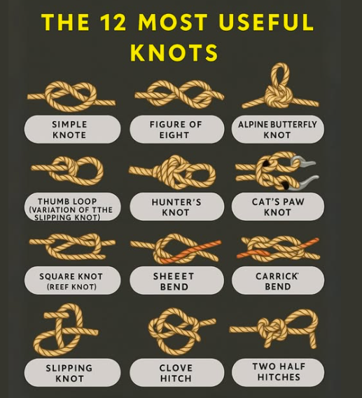
Knot Tying: a few knots, when to use and how to tie.

