
Plumbing Station Cheat Sheet
Career Connections | Careers that use Plumbing skills:  - Plumber  - Pipefitter  - Steamfitter  - Municipal Water and Sewer Technician  - Facilities Maintenance Technician  - Water conservation Technician or Green Energy/Solar Thermal Installer
PEX Pipe | - Prepare station by cutting off ONE SIDE of the completed PEX piping at the corner of the unit and leaving the other side completely intact to follow  - Students measure and then cut PEX pipe to length for path it will follow  - Put rings over pipe THEN insert fittings into pipe  - Use PEX crimping tool to crimp rings in place  - Repeat this process to join each section of the PEX pipe
How to take apart | - Cut PEX as close as possible to the copper elbow using cutters  - Use ring removal tool to cut the copper crimp ring that is over the PEX pipe and the elbow. Then turn 180Degree and cut again so ring can pop off. Remove PEX from the copper elbow. You may need pliers or a knife to remove the PEX if really tight. We will reuse the copper elbow.  - Set up for next group of students to start station over
Tools | 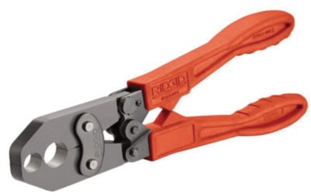  PEX Crimp Tool PEX Ring Removal Tool  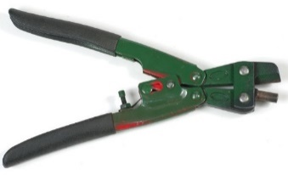  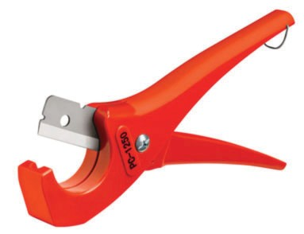  PEX Pipe Cutter  Copper Elbows ( T shape, straight or 90degree)  ADD PHOTOS

