
Soldering Station Cheat Sheet
Safety | - Always wear safety goggles and closed toe shoes when Soldering. Tie long hair back  - Do not touch hot pipe or solder
Soldering Copper | - Use portable vices to clamp soldering pipe  - Using tubing cutter (spin around pipe and turn knob as you go) cut a 1.5 inch piece  - deburr the inside of pipe, sand outside with emery cloth or use pipe cleaners (solder doesn’t flow properly otherwise)  - Sand/clean inside of copper fittings (elbow) as well  - Flux both pieces – only need a tiny bit then join the 2 pieces together  - Roll out solder about 8in then bend the end 1/2inch to 1 inch. The hook will help easier access without getting hands near the heat. Don’t need much solder (kids will keep going and solder will drip – WRONG!!)  - Heat the joint until very warm, when solder flows freely remove the solder and heat. Ideally you only want to heat and add solder once.  - Use a damp wet rag to cool once done and remove drip at the bottom.
Materials Needed | Bucket with water, rags, sharpie, safety glasses, work gloves, pliers, tubing cutter, Solder, Copper Pipe cleaner (inside and out), Bernzomatic automatic torch, clamp/vice to hold copper pipe
Careers Connections | Careers that use Soldering skills:  - Electrician  - HVAC technician  - Pipefitter/ Plumber  - Metal Fabricator  - Automotive /Aerospace Electronics Technician  - Medical device technician  - Artists ( jeweler, metal artist, prototype builder)
Tools | 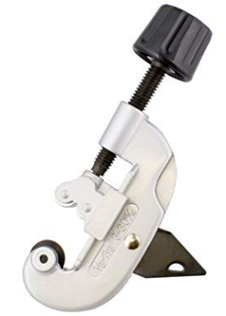  Tubing Cutter Solder  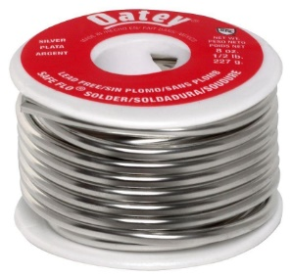  Copper Pipe Cleaner Copper Pipe Cleaner  Outside Inside  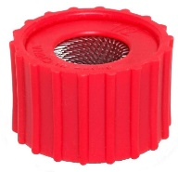  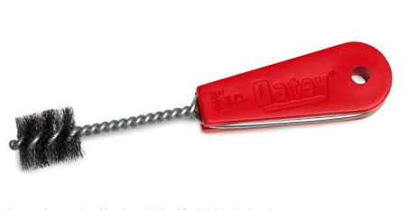  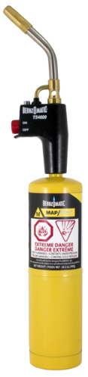  Bernzomatic Automatic Torch  FLUX
Background information | Soldering is the process of joining metal pieces—most commonly electronic components or wires—using a melted filler material (solder). It creates an electrically conductive, strong mechanical bond at relatively low temperatures.  Solder plays a central role in assembling everything from smartphones to industrial controls, forming strong electrical and mechanical connections between components and printed circuit boards  • Soldering: Soldering is the joining of two metal surfaces mechanically and electrically, with the use of metal called solder. Solder secures the connection so it doesn’t break loose due to vibration or other mechanical forces. It also provides electrical continuity, so that the electronic signal can travel through the connection without interruption.  •Solder: Solder is a metal alloy with a relatively low melting point. Typically, it is made from lead and tin, both of which have relatively low melting points. There are many different types of solder, and they can be purchased in rolls of soldering wire.  Flux: It is a chemical cleaning agent ( liquid or paste) used to improve the quality and reliability of the solder joint by helping it flow and stick to the metals. Flux is used to clean and prep the surface, which allows molten solder to flow smoothly and bond effectively with other metals.  Flux removes oxides from metal surfaces and prevents further oxidation during heating by creating a protective barrier.  Compared to welding, soldering requires lower temperatures, making it safer, easier to learn, and ideal for delicate work like electronics and plumbing. It can join dissimilar metals without causing distortion or weakening the base material. However, soldered joints are weaker than welded ones and cannot withstand high stress or extreme temperatures. It is unsuitable for structural applications, and proper adhesion requires clean surfaces and flux.  Jake Thompson  Senior Solutions Engineer

