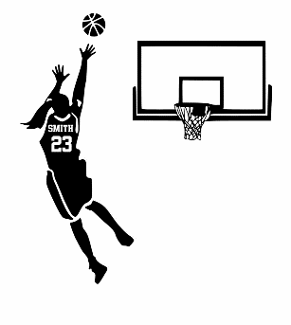
CCS Basketball Practice Schedule

BEAUFORT
 | Monday | Tuesday | Wednesday | Thursday | Friday
AM | Grade 6/7 girls practice | Grade 6/7 boys | 8/9 boys practice | Grade 6/7 boys | 8/9 girls practice
1st Recess |  |  | open gym
2nd Recess | Grade 6/7 boys practice |  | grade 6/7 girls practice | 8/9 shooting practice | grade 6/7 girls practice
After school | Grade 8 Games | 8/9 girls practice | Grade 6/7 Games | Grade 9 Games | 8/9 boys practice
 | Grade 6/7 girls practice

After School Sports
STRATHCONA
 | Monday | Tuesday | Wednesday | Thursday | Friday
AM
1st Recess
2nd Recess
After school | Floor Hockey (CCSS) | Ringette (CCSS) | Floor Hockey (CCSS)

