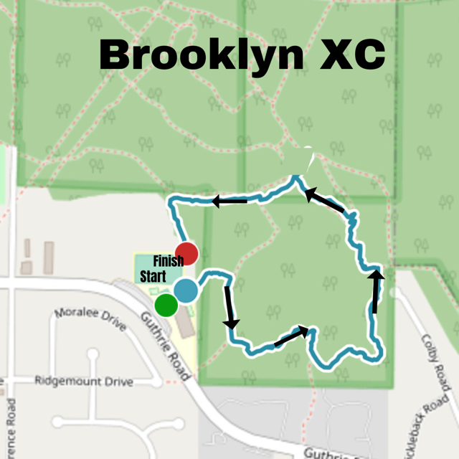

The course is 2 km and will be the same for all grades.
Order:
Grade 7 – girls, boys
Grade 3 – girls, boys (Highland grade 8’s running lead)
Grade 4 – girls, boys
Grade 5 – girls, boys
Grade 6 – girls, boys

