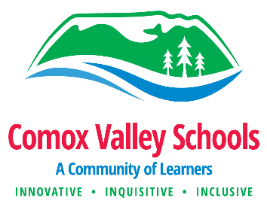

Dear Parents and Guardians,

As part of the B.C. Ministry of Education Physical and Health Education (PHE) curriculum, and the Science curriculum https://curriculum.gov.bc.ca/curriculum, we are required to cover specific content. This includes body science and personal safety in kindergarten and grade 1; Personal safety and abuse prevention in grade 2 and 3; Pubertal changes, hygiene, personal safety, private parts and sexual identities in grade 4 and 5; And pubertal changes, structures and functions of the reproductive systems, personal safety and sexual identities in grades 6 and 7. Because it is so important now to provide children guidance as they navigate the digital world, the grade 6 and 7 lessons will include an age-appropriate discussion about sexually explicit online material and the sending/sharing of intimate images. As reproduction first appears in the grade 6 curriculum, the lessons in younger grades do not include a discussion about sex. As said, these children will be learning about body science (scientific names for private parts) and puberty, depending on their grade level.

There are several overarching principles to consider when these topics are addressed at school, paramount among them is the respectful consideration of the different types of family values that surround these topics. To support our efforts at school to be inclusive to all values (cultural, religious, traditional and liberal), and create a safe learning space for every child, we feel it is very important that you spend time at home discussing your family values with your child. Do consider asking your child about these topics and their PHE lessons and most importantly share your parental guidance and advice with them. Research has shown parents are a primary source of information in this area.

If you would rather deliver this curriculum at home yourself instead of classroom delivery at school, we will excuse your child. If you are requesting the removal of your child from this unit, you are committing to deliver this curriculum yourself during the same time period. The district policy regarding alternate delivery of curriculum is clearly laid out on the school district website under Administrative Procedure 206 “Alternate Delivery of Curriculum” https://www.comoxvalleyschools.ca/wp-content/uploads/2020/11/AP_206_Alternate_Delivery_of_Curriculum.pdf

Yours Sincerely,

S. LeBlanc
Principal

I______________________will be delivering the relevant curriculum myself to my child_________________ at home. Please excuse my child from this unit.

Parent/Guardian signed (Name, date and signature)
_________________________________________________________

