**Bead Time Line Story – 10000 years of History Using Oral Tradition Storytelling**

**By Suzanne Camp, Courtenay BC**

**Introduction:** Use this story to help people visualize and understand how oral tradition storytelling has kept stories, culture, traditions and history of aboriginal people alive for thousands of years. The Bead Timeline story can be adapted with information about any community’s history and territories.

**The Story**

**{Recognition of Territory before the story starts}**

***Action:*** *Hold a small basket which contains the Bead Timeline in the palm of your hand and introduce the story to your audience.*

**The Bead Timeline**

***Action:*** *(Show a single bead fastened to a small card)*

“Each bead on this timeline represents a generation of people. A generation is from the time a baby is born until the time that child grows up and can have a baby of their own. For this timeline a single bead represents 20 years or one generation. There are 500 beads or 500 generations of people represented here on this time line.”

“If you are 6 years old you are part of this single bead, if you are 10 you are half of this bead. All over the world, no matter where your family has come from, every culture and all people have a place on a time line like this.”

***Action:*** *Begin slowly drawing the timeline out of your basket as you start to tell the story.*

“We are going to journey back, back in time. Each time the beads change color we will have gone back 5 generations or 100 years. We are going to go all the way back through time to 10000 years ago.”

“People have lived here along the Pacific Northwest Coast for at least 10000 years. Stone tools and fire pits are some of the few signs we can find of those ancient peoples from so long ago.”

“People’s stories, history, culture and traditions were passed from generation to generation through speaking and listening and remembering and speaking and listening and remembering. *(Point to your mouth, ears and your forehead when you are repeating “speaking and listening and remembering”)* Children in their villages heard their stories many times. When the children were grown they remembered and passed on those stories, the history and the traditions of their communities.”

“And so it was for generation after generation, long before books were written; the stories of the people were told again and again.”

***Action:*** *(By now, you should be near the end of the time line. Your audience will be wondering if it will ever end and then, finally draw out and hold the last bead)*

“Back here *(pointing to the last bead on the timeline*), 10000 years ago, it was the end of the last ice age; a time when much of the land on North America was covered with huge ice fields. So much water was locked up in that ice that sea levels around the world were much lower than they are today.”

“Eventually melting glaciers and rising sea waters covered the shorelines where people might have lived and travelled along the coast. As the ocean levels rose, the traces of ancient habitation disappeared below the waves.”

“Through all that time though, stories continued to be passed from generation to generation: history was remembered and cultural traditions were honored; through speaking and listening and remembering, and speaking and listening and remembering, and speaking and listening and remembering. “ (*Point to your mouth, ears and forehead while you are repeating these words; let your voice fade away softly to end the story.)*

**The End of the Bead Timeline Story**

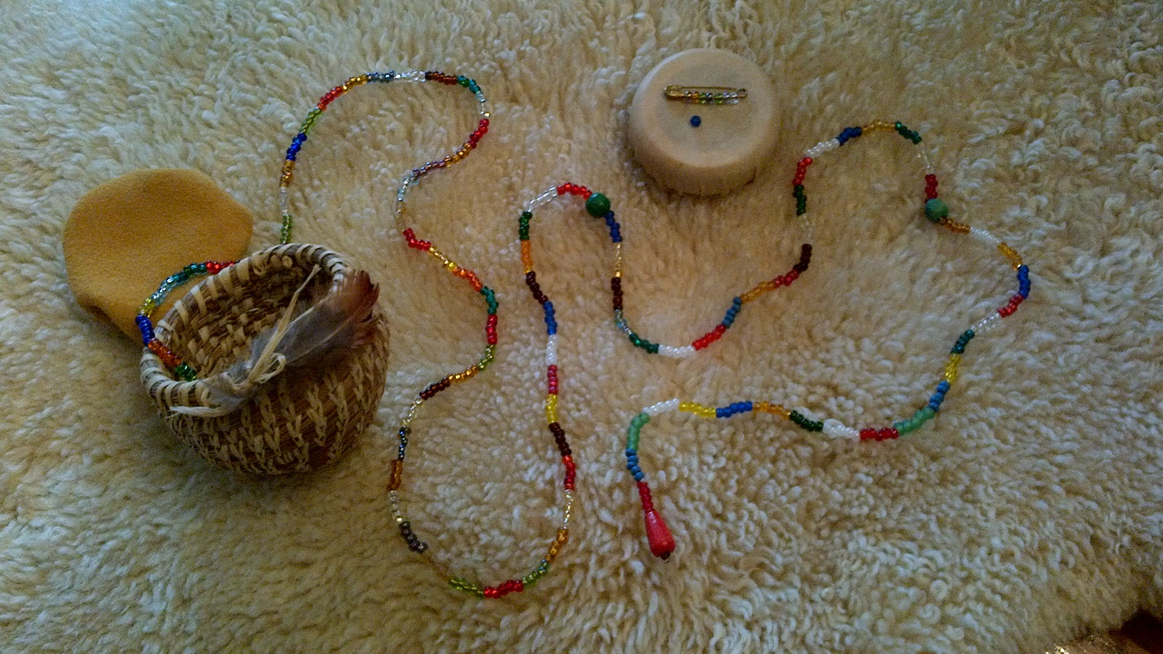

*When the Timeline Story is finished, introduce an oral tradition story or other ideas you want to discuss about traditional aboriginal ecological knowledge, history, culture or contemporary issues.*

**Some suggestions for using this bead timeline:**

**Story telling; Resource Management and Conservation; Cultural Knowledge; Traditional local communities; Contemporary local communities**

1. ‘Set the scene’ for oral tradition storytelling –explaining how stories, culture and tradition were passed along from generation to generation through speaking, listening and remembering and speaking, listening and remembering……down through the generations to the present day
2. Talk about how the First People practiced conservation and caring for their resources in a respectful, thoughtful way – using only what was needed –‘Leaving a light footprint on the land’; in comparison to our present day practices creating a ‘heavy footprint on the land’ where we are carelessly using and discarding/polluting our limited earth resources. (This is usually where I hold up my 7 beads/ generations string to show how quickly we have changed our Comox Valley with our heavy footprint)
3. Talk about the People of the Cedar: About 6000 years ago the world had warmed up enough for cedar trees to begin to grow. *Show that place on the time line.* Cedar became so important that it is still known as the ‘Tree of Life’. For thousands of years Northwest Coast peoples have used cedar for ceremonial regalia, homes, canoes, clothing and household items such as rope and basketry.
4. The bead timeline can be adapted to talk about your traditional local communities, your history and your environment to help children understand how long people have lived on the land of your local territory. For instance, here in the Comox Valley, the remains of a vast network of fish weirs can be found along the Courtenay River estuary. Radio carbon dating has established that the age of a least one of the wooden stakes is over 1300 years old, so it shows that aboriginal people have lived and worked in this area for at least that length of time.
5. Show the 10000 year time line and in comparison, show the tiny contemporary time line of your local community: in the case of the Comox Valley it is only 7 beads/generations since settlers arrived to farm, fish, log, establish coal and copper mines and build homes. Talk about how your community looks today – paved roads, bridges, concrete buildings and landfills; all of which have resulted in a very heavy contemporary ‘footprint’ on the land – a footprint that will last for centuries into the future.