The Dreaded 5 Paragraph Essay
Step 1: Choose your topic
Ask yourself: can I write about this topic for about 2 pages? Will I be able to cover everything I want to in that amount of space?
Step 2: Do some research & reading about your topic
Really spend some time reading about your topic – this will help you determine whether you’ve got a good topic as well as the direction you want to take it
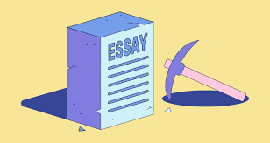
Step 3: WHAT ARE YOUR 3 MAIN POINTS?
You have your topic, you’ve read a bit about it – now you need to decide what your 3 main points are going to be (don’t start writing your essay until we’ve approved your 3 main points)
Step 4: Time to create an outline!
Now you’re going to create an outline for your essay. If you follow all the steps the essay will pretty much write itself once you’ve completed your outline.
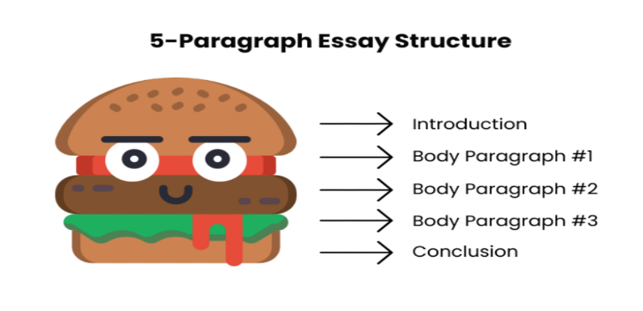
A 5 paragraph essay follows this order:
1: Introduction
2: Body Paragraph 1 (your first main point)
3: Body Paragraph 2 (your second main point)
4: Body Paragraph 3 (your third main point)
5: Conclusion
When you chose your 3 main topic you basically created a blueprint for your essay. Great! Now you know what you’ll be writing about in each body paragraph – this is the substance of your essay. Use the template below to create an outline (we will explain the intro and conclusion paragraphs).
Introduction | Hook:  Thesis statement:
Body Paragraph 1: | Topic:  Point 1:  Point 2:  Point 3:
Body Paragraph 2: | Topic:  Point 1:  Point 2:  Point 3:
Body Paragraph 3: | Topic:  Point 1:  Point 2:  Point 3:
Conclusion: | Restating your main points:  So what? A question or thought to leave your reader with

