- Literacy Outcomes (Foundation Skills Assessment)
Grade 4 Literacy (2024/25)
- A much larger share of Indigenous students are in the Emerging category.
At a glance (proficiency distribution): Indigenous Emerging = 54% vs. 38% non-Indigenous
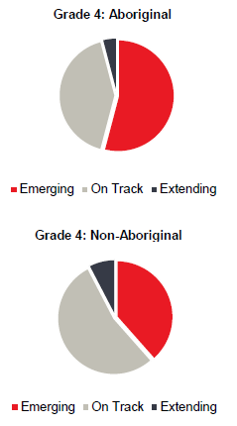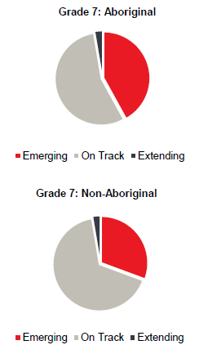
Grade 7 Literacy:
At a glance (proficiency distribution): Indigenous Emerging = 42% vs. 31% non-Indigenous
- The gap persists into middle school.
- Non-Indigenous students are more likely to be On Track or Extending

Secondary Literacy (Graduation Assessments & Courses)
Grade 10 Literacy Assessment (2024/25)
- Indigenous students are less likely to reach Proficient or Extending levels.
At a glance (proficiency distribution): Indigenous Proficient & Extending = 62% vs. 73% non-Indigenous
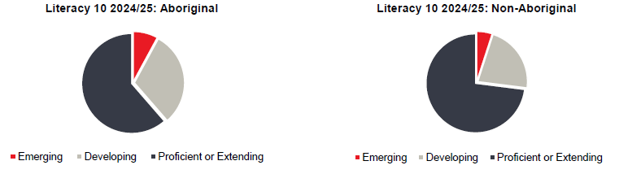
English 10 – C+ or better (2024/25)
- Indigenous: 66%
- Non-Indigenous: 83%
English 12 – C+ or better (2024/25)
- Indigenous: 82%
- Non-Indigenous: 90%
Grade 12 Literacy Assessment (2024/25)
- Indigenous students are less likely to reach Proficient or Extending levels.
At a glance (proficiency distribution): Indigenous Proficient & Extending = 70% vs. 80% non-Indigenous
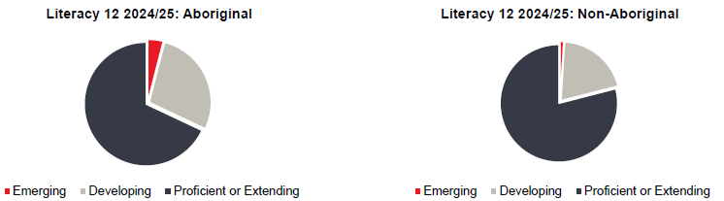

- Numeracy Outcomes (Foundation Skills Assessment)
Grade 4 Numeracy (2024/25)
- A larger share of Indigenous students are in the Emerging category.
At a glance (proficiency distribution): Indigenous Emerging = 41% vs. 36% non-Indigenous
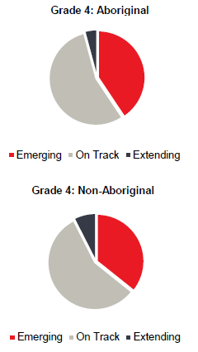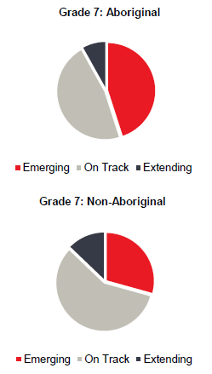
Grade 7 Numeracy (2024/25)
At a glance (proficiency distribution): Indigenous Emerging = 45% vs. 29% non-Indigenous
- Similar gap continues, with fewer Indigenous students reaching On Track or Extending.
Secondary Numeracy
Grade 10 Numeracy Assessment (2024/25)
- Indigenous students are much more likely to fall in Emerging.
- Non-Indigenous students are more often Proficient or Extending.
At a glance (proficiency distribution): Indigenous Proficient & Extending = 37% vs. 57% non-Indigenous
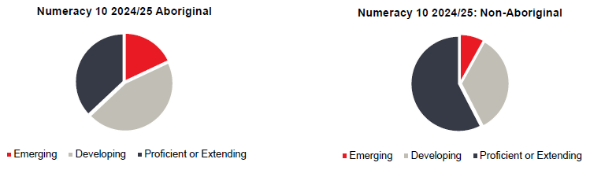
Course Results – C+ or better (2024/25)
- Foundations/Pre-Calc 10: Indigenous 66% | Non-Indigenous 83%
- Workplace Math 10: Indigenous 46% | Non-Indigenous 63%
- Pre-Calculus 11: Indigenous 86% | Non-Indigenous 90%
3. Graduation & Completion Rate Outcomes
Completion Rates (2024/25)
Five-year completion
- Indigenous: ~63%
- Non-Indigenous: ~80%
Six-year completion
- Indigenous: ~72%
- Non-Indigenous: ~81%
Key Takeaways
- Literacy & Numeracy achievement gaps are consistent from elementary through graduation.
- Large persistent gaps appear in early literacy, secondary numeracy, and overall completion rates.
- Some narrowing occurs in senior academic math (e.g., Pre-Calculus 12) however, less Indigenous students take these courses which may skew data.
- Graduation outcomes show the clearest and most persistent disparity over time.

