Name: ________________________ Date: ____________

Part 1: How long do Canadians stay in a job?

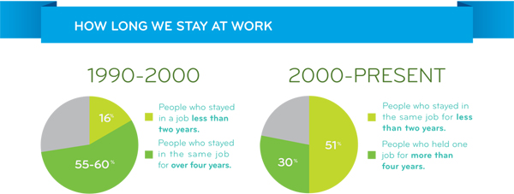
The following infographic was created by Workopolis (a Canadian job advertising and job search website) based on analysis of the millions of resumes uploaded to their website. It compares the length of time that individuals remained in the same job in the decade before the year 2000 with the years from 2000 to 2013.
‘Time’ to Work Infographic
Harris, Peter. (2014). ‘Time” to Work. Workopolis, April 2014. Retrieved from: https://hiring.workopolis.com/article/thinkopolis-time-to-work/

1. Using the data from the infographic above, create a double Bar Graph comparing the two measured values (staying in a job less than two years, and more than four years) for each time period.
Notes:
-The independent axis (x-axis) should list the time periods, each split to show a bar for each measured value.
-The dependent axis (y-axis) should display percent (%) of job seekers.
-The bars should be colour coded, with a legend.
-Include a descriptive title.
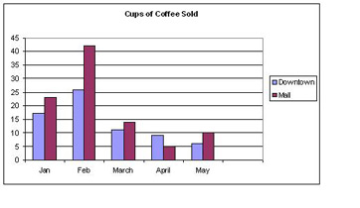
-An unrelated example is shown below:

DRAW/PASTE GRAPH HERE OR ATTACH:

2. Has the length of time that Workopolis users tend to spend working in a particular job changed in the last 30 years? In your own words, describe the observed changes.
______________________________________________________________________________________________________________________________________________________________________________________________________________________________________________________________________________________________________________________________________________________________

3. If the length of time that job seekers continues to change in approximately the same manner, estimate the percent of workers who stayed in a job for more than four years be around the year 2023? How did you come up with your estimate?
______________________________________________________________________________________________________________________________________________________________________________________________________________________________________________________________________________________________________________________________________________________________

Part 2: Changing Industries

The following bar graph illustrates data collected by Statistics Canada on manufacturing jobs as percent share of the Canadian economy:

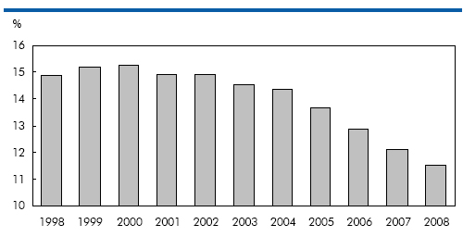
Trends in manufacturing employment
Bernard, André. (2015). Trends in manufacturing employment. Labour Force Survey. Statistics Canada, November, 2015. Retreived from: https://www.statcan.gc.ca/pub/75-001-x/2009102/charts-graphiques/10788/c-g000b-eng.htm

1. Using the data given above, create a Line Graph displaying the percent (%) share of the economy by year 1998 to 2008.
Notes:
-The independent axis (x-axis) should list the years (time).
-The dependent axis (y-axis) should display percent (%) share of economy.
-Include a descriptive title.
-Use the grid on the following page, or a program such as Excel or Google Sheets.

2. Draw a line of best fit connecting the points from the year 2000 to the year 2008. What trend do you observe?
__________________________________________________________________________________________________________________________________________________________________________________________________________________

3. If these changes continue, extrapolate (predict based on the trend in the data) the share of the Canadian economy consisting of manufacturing jobs in the year 2018. How did you use your graph to make your prediction?
__________________________________________________________________________________________________________________________________________________________________________________________________________________

Part 3: The Future and You

How do you prepare for a future that is difficult to imagine? How can you cultivate the skills and flexibility that will allow you to take advantage of new opportunities as they arise? While some industries have remained steady over time, many of you will find work in jobs that don’t exist today. The following infographics were created by Workopolis to illustrate some of the job market trends that their service has observed from 2000-2013, and some they predict for the future:

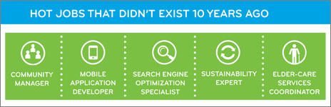

2013 Year in Review Infographic
Harris, Peter. (2013). 2013 Year in Review. Workopolis, November 2013. Retrieved from: https://hiring.workopolis.com/article/2013-year-in-review/

1. Can you think of some other jobs or industries in Canada that will likely show growth and opportunities in the future? Why these jobs?
____________________________________________________________________________________________________________________________________________________________________________________________________________________________________________________________________________________________________________________________________________________________________________________________________________________________________

2. Can you see any areas of need and/or opportunity in your community that might lead to new industries or growth? Explain your ideas.
____________________________________________________________________________________________________________________________________________________________________________________________________________________________________________________________________________________________________________________________________________________________________________________________________________________________________

3. How do you think you and your peers can best prepare yourselves for employment in jobs that may not exist yet?
____________________________________________________________________________________________________________________________________________________________________________________________________________________________________________________________________________________________________________________________________________________________________________________________________________________________________

4. What are some things that you can do now and in the future to ensure you are ready and able to create or take advantage of job opportunities when they arise?
____________________________________________________________________________________________________________________________________________________________________________________________________________________________________________________________________________________________________________________________________________________________________________________________________________________________________

Teaching Notes
The following learning activity was created to help students meet learning goals contained in both Math 9 and Career Education 9. It was designed to be completed in one lesson, and requires only general grade level skills and knowledge.

Goals
-Students will engage with data and create and interpret graphs of different styles.
-Students will observe trends in data and make predictions.
-Students will explore the changing nature of work and reflect on the future of work for themselves and their community.

Continuous linear relationships can be identified and represented in many
connected ways to identify regularities and make generalizations

Big Ideas
Math 9:
-Continuous linear relationships can be identified and represented in many

Analyzing the validity, reliability, and representation of data enables us to compare and interpret
connected ways to identify regularities and make generalizations.
-Analyzing the validity, reliability, and representation of data enables us to compare and interpret.

Math 9 Curricular Competencies/Content Links:
- Use tools and technology to explore and create patterns and relationships, and test conjectures
- Two-variable linear relations, using graphing, interpolation, and extrapolation
- Using reasoning and logic to explore, analyze, and apply mathematical ideas
- Use mathematical arguments to support personal choices
- Statistics in society

Adapting to economic and labour market changes requires flexibility

Career Education 9:
-Adapting to economic and labour market changes requires flexibility.

Career Education 9 Curricular Competencies/Content Links:
- Local and global needs and opportunities
- Factors affecting types of jobs in the community
- Apply decision-making strategies to a life, work, or community problem and adjust the strategies to adapt to new situations.

First Peoples Principles of Learning: Learning ultimately supports the well-being of the self, the family, the community, the land, the spirits, and the ancestors.

Core Competency: Critical Thinking - Analyze and make judgments, explore possibilities.

Lesson Outline
Before the lesson:
-Copy or provide digital access to the student materials (Parts 1-2).
-Provide graph paper or access to a program such as Excel or Google Sheets.
Optional: Introduce or review graphing techniques including Bar and Line Graphs.
Introduce or review continuous linear relationships.

Part 1: How long do Canadians stay in a job? Suggested time: 20 minutes

▢ Guide and support students as they interpret two pie charts and create a double bar graph based on the data. Students are then asked to make and justify a prediction based on the data.

Part 2: Changing Industries Suggested time: 25 minutes

▢ Guide and support students as they interpret a bar graph and create a line graph based on the data. Students identify a line of best fit, and predict (extrapolate) based on the trend.

Part 3: The Future and You Suggested time: 15 minutes or homework

▢ Students reflect on changing employment opportunities in Canada and in their community, and consider employability in a

Assessment Rubric

Goals | 1 | 2 | 3
Creates and interprets a Bar Graph based on ‘Time’ to Work infographic | Not done or minimally done. | Bar graph is done but missing one or two elements listed in column 3. | Bar graph is complete. Includes a title, labelled axes with units, colour-coded bars.
Creates a continuous line graph from numerical data; and describes and interprets trends | Not done or minimally done | Line graph is done but missing one or two elements in column 3. | Line graph is complete. Includes a title, labelled axes with units, and a line of best fit.
Reflects on employment trends and considers future opportunities in Canada and locally | Not done or minimally done. | Makes but does not explain predictions, or predicts only one of: Canada/locally. | Suggests future opportunities in Canada and locally. Explains reasoning behind predictions.
Reflects on the changing nature of work and how this impacts employability | Not done or minimally done. | Lists basic education or training options, does not connect to changing industries. | Considers preparations for an unknown future. Possibly mentions flexibility, transferrable skills.

Total: /

