Math and Careers 9
Teaching Notes

The learning activity was created to help students meet learning goals contained in both Math 9 and Career Education 9 and requires only general grade level skills and knowledge.

Goals

- students will use reasoning and logic to explore, analyze and apply mathematical ideas
- students will estimate reasonably
- students will demonstrate and apply math strategies
- students will engage in problem-solving experiences
- students will represent mathematical ideas in concrete and pictorial forms
- students will understand simple budgets, reading pay stubs and calculating simple interest

Big Ideas

- The principles and processes underlying operations with numbers apply equally to algebraic situations and can be described and analyzed.
- Continuous linear relationships can be identified and represented in many connected ways to identify regularities and make generalizations.

Math 9 Curricular Competencies/Content Links:
- Use tools and technology to explore and create patterns and relationships, and test conjectures
- Two-variable linear relations, using graphing
- Using reasoning and logic to explore, analyze, and apply mathematical ideas
- Use mathematical arguments to support personal choices

Career Education 9:

-Adapting to economic and labour market changes requires flexibility.

First Peoples Principles of Learning:
Learning ultimately supports the well-being of the self, the family, the community,
the land, the spirits, and the ancestors.

Core Competency:
Critical Thinking - Analyze and make judgments, explore possibilities.
Positive Personal and Cultural Identity –Explore personal values and choices

Lesson Outline/Instructions for Teacher

Before the lesson:
- Provide digital access to the student to search for prices of food items or provide grocery store newspaper flyers.
- Provide graph paper or access to a program such as Excel or Google Sheets.
- Provide calculators

Part 1: Planning a Party
- Students may work in groups.
- Brainstorm categories and items needed for planning a birthday party.
- Give instructions on creating circle graphs.
Part 2: Paying for the Party
- Explain the general information contained in a pay stub and deductions.
Part 3: Interest-ing – Paying for the Party
- Explain credit card interest and the formula to calculate interest. (I=PRT)
- Give instructions on creating bar graphs.

After the lesson:
- Submit a class list to the Career Centre of the students who completed meeting the ‘Big Idea’..

Rubric at end of assignment

Math 9 and Career Education 9

Student’s Name: _______________________________________ Date: ________
Math Teacher’s Name:___________________________________

Math: How Will I Ever Use It?

Part 1: Planning a Party

Your friend, Sam will be turning 15 years old and you and your friends would like to plan a party to celebrate this milestone. You need to create a ‘budget’. A budget is an estimate of expenditures.

Instructions: Create a budget for the party.

- What is the theme for the party? ______________________________________
________________________________________________________________
- What is the venue for the party? _____________________________________
Will there be a cost for the venue, if so give what are you going to budget for the cost for the venue? _______________________________________________
3. How many guests will be in attendance? _______________________________
4. Expenditures to consider for the party are: decorations, refreshments
(beverages, food), entertainment, music, clean-up, transportation to buy items,
paper/plastic dishes & cutlery etc.
5. Create a ‘chart’ or spreadsheet with a list of needs and wants for the party.
Organize your items under categories and total the cost for each category. You
can use the attached blank chart. To find the actual costs use store flyers on-line
or newspaper copies, visit the stores or ask parents/guardians.
(Some local stores are: Save-on Foods, Superstore, Fairway Market, Thrifty
Foods, Costco, Quality Foods, Market on Millstream, Walmart, London Drugs,
Dollarama, Bulk Barn, Dollar Tree.

An example of a chart is below.

Category | Estimated Cost | Actual Cost | Unit Cost | Rounding | Amount needed | Total Cost | Add Sales Tax of 12%  (GST 5%  PST 7%)
Beverages
Bottles of water | $20.00 | $10.00 for 48 bottles  (Save-On Foods) | $0.208 | $0.21 | 40 bottles | $8.40 | $9.41
Food
Total Cost

Questions:

- How did you decide what you wanted to buy and where you wanted to buy the items?
________________________________________________________________________________________________________________________________________________________________________________________________
2. What does it mean when someone describes a purchase as a “‘good value”
________________________________________________________________________________________________________________________________________________________________________________________________
3. After totaling the cost of the birthday party. Calculate the percent for each
category.
Category _______________________ Percent ___________________
Category _______________________ Percent ___________________
Category _______________________ Percent ___________________
Category _______________________ Percent ___________________
Category _______________________ Percent ___________________
Category _______________________ Percent ___________________
Category _______________________ Percent ___________________
Category _______________________ Percent ___________________
4. Using the categories and percents from your budget, draw a circle graph showing
the budget for the party. Make sure to label your circle graph (see next page).

5. What category was the most expensive for your party? ________________
Do you agree with paying most of your money on this category? Why or why not? _______________________________________________________________
_______________________________________________________________

6. After looking at the total cost of the birthday party you realized you could only
spend 75% of the total cost.
a. How much money would 75% of your total cost be? _______________
b. What changes would you make to your purchases to keep within your
new budget? How did you make these decisions?
________________________________________________________________________________________________________________________________________________________________________________________________
Part 2: Paying for the Party – Reading a Pay Stub

Now that you have planned the birthday party and created a budget you will need to pay for it.

Instructions: Take a look at the sample pay stub below and answer the following questions.

- What is the wage per hour for this employee? ____________________________
- How many hours did this employee work for this pay period? _________________
- How much money was earned per hour for overtime? _______________________
- What is this employee’s gross pay (current) for this pay period? _______________
- What is this employee’s gross pay for the year to date (YTD)? ________________
- List the deductions made from this employee’s pay
____________________ ____________________
____________________ ____________________
- Calculate the percent for each of the deductions from the gross pay (current).
Income Tax ______________________________
E.I. (Employment Insurance) _________________
CPP (Canada Pension Plan) _________________
Meals ___________________________________
- What is the percent of the total deduction from the gross pay? ______________
- What is the total amount of the pay for this pay period? ________________
- If this employee wants to only spend 30% of her pay, how much money can she spend? ____________________________________
- As of June 1, 2018 the minimum wage in BC increased to $12.65 per hour.
What would be the percent increase for the wage of this employee if she is getting the BC minimum wage? __________________________________

For more information on reading pay stubs go to:
https://www.tpsgc-pwgsc.gc.ca/remuneration-compensation/services-paye-pay-services/paye-information-pay/lire-paye-talon-read-pay-stub-eng.html

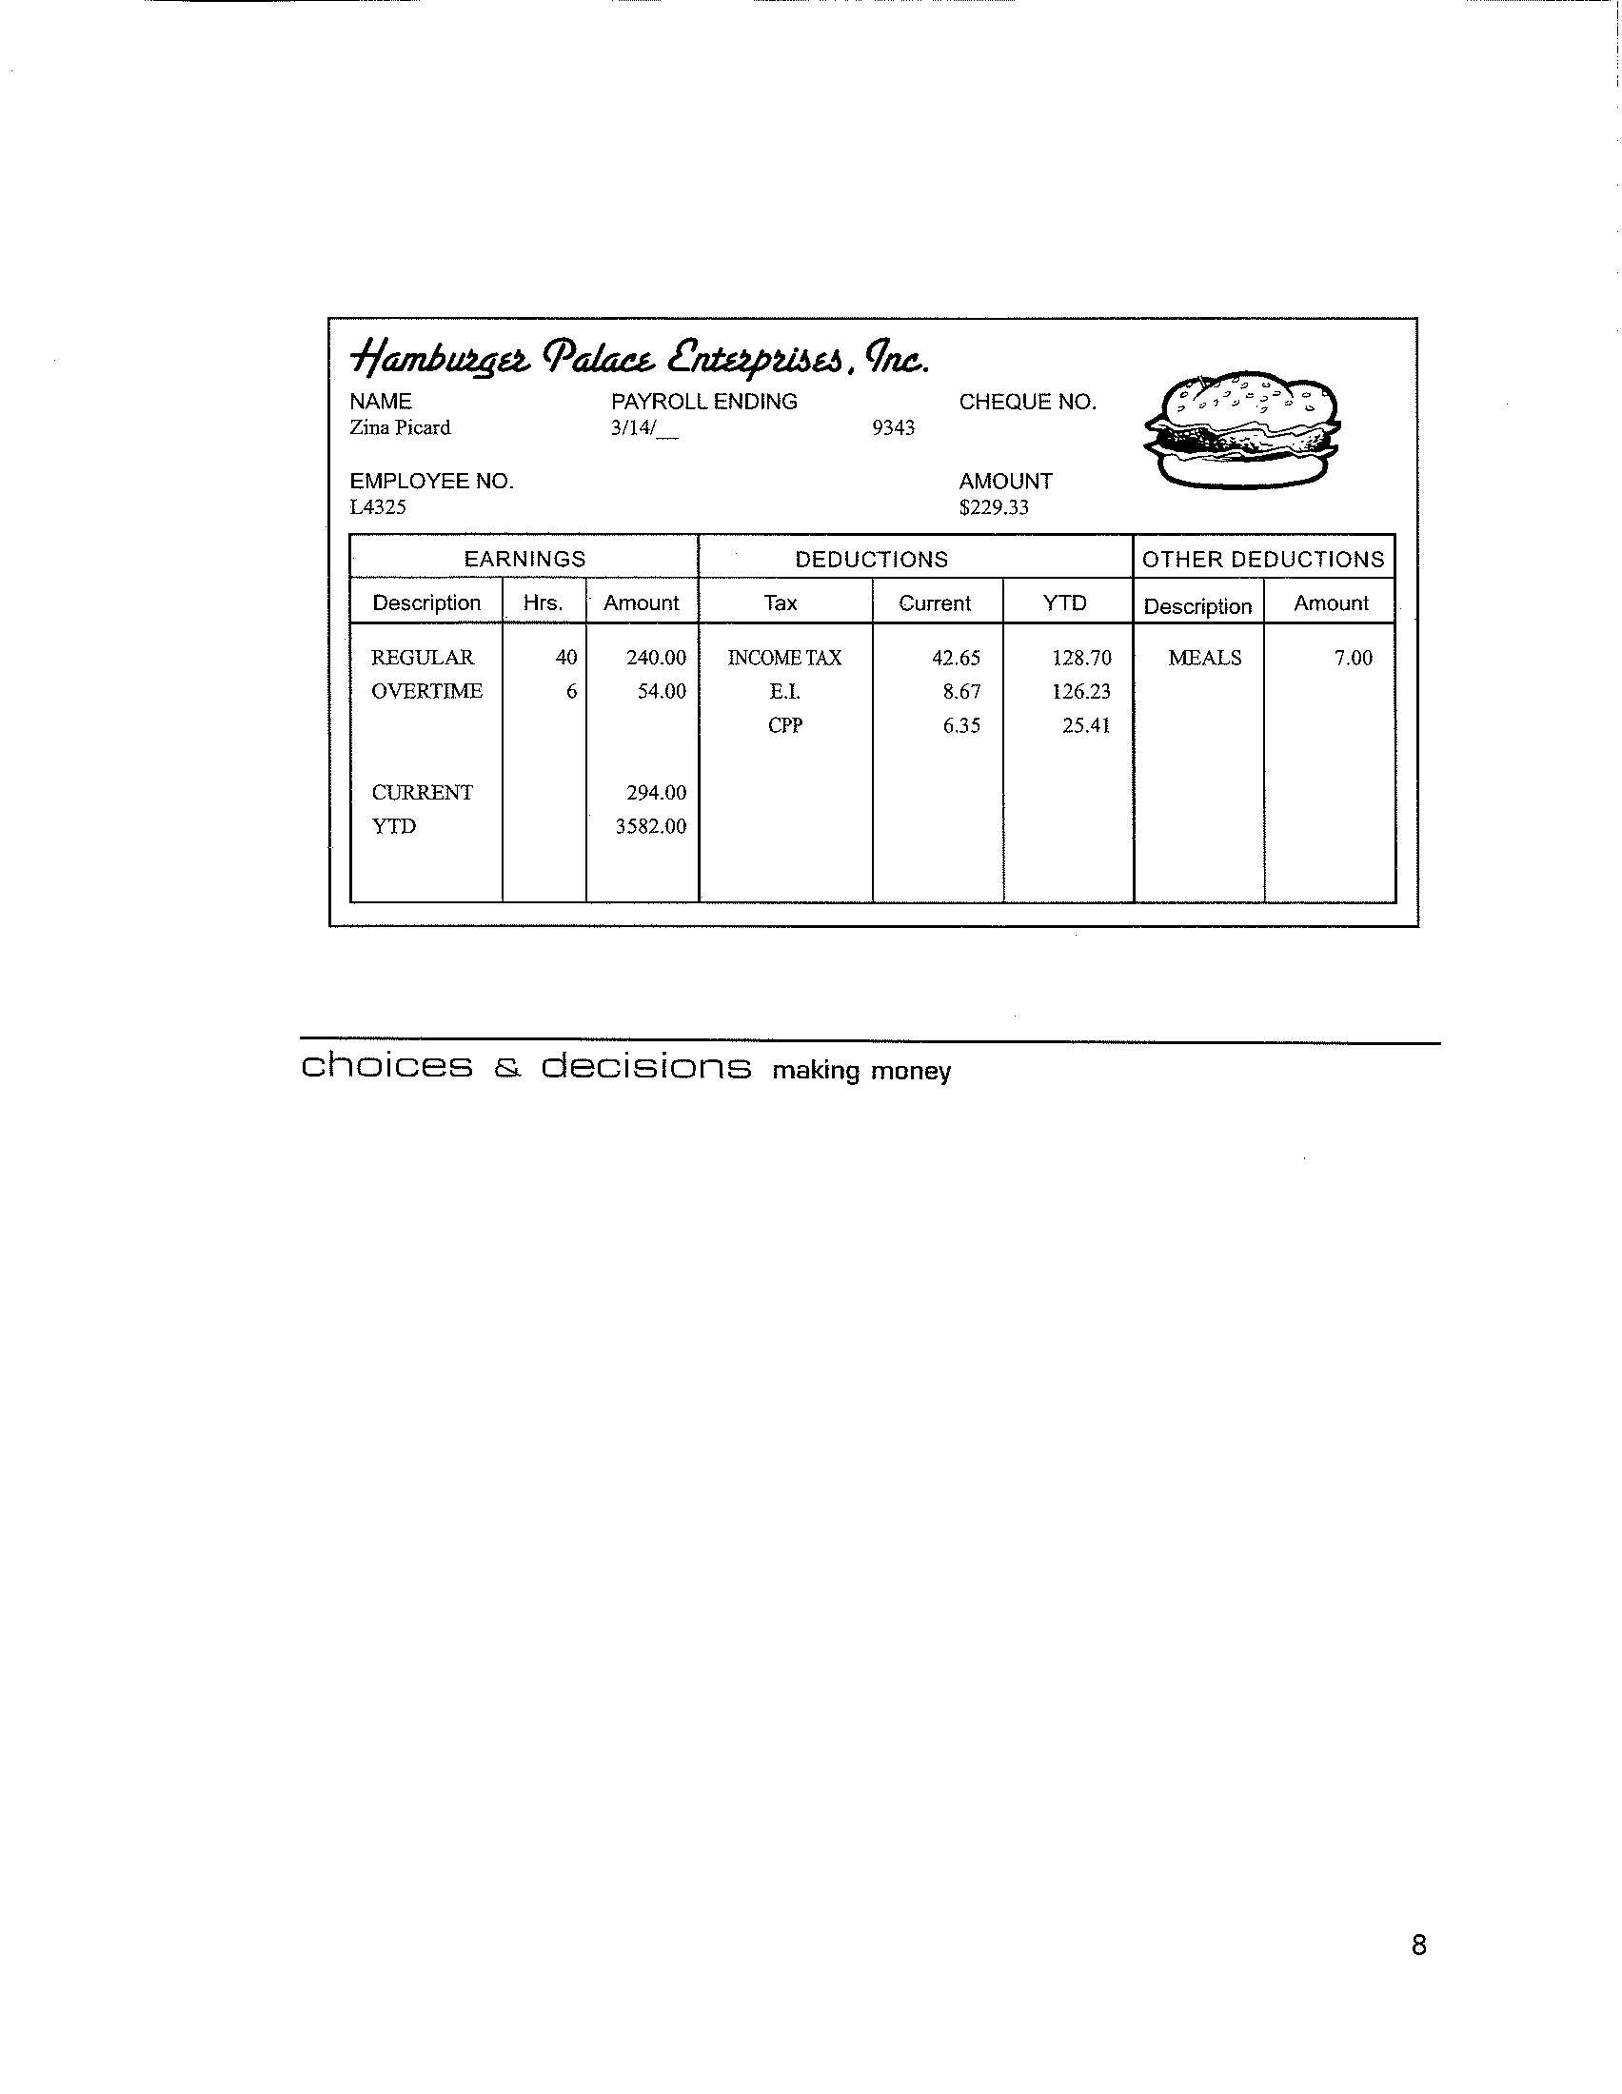

Part 3: Interest-ing – Paying for the Party

Some people use credit cards instead of cash when making purchases. If you cannot pay the amount owing on your credit card you will be charged “interest” on the remaining money owing. Interest is the charge for the privilege of borrowing money. Assume you owe a $1,000 balance on your credit card.

Instructions: Compare the following credit card deals and answer the questions below.

Credit Card A. 20% interest paid over 24 months
Credit Card B 12% interest paid over 36 months
Credit Card C 15% interest paid over 30 months
Credit Card D 18% interest paid over 12 months

The interest for credit cards is called “simple interest” and is calculated using this simple interest formula I=PRT
Interest = principal X rate(decimal) X percent of a year (t)
- Calculate the annual interest on the balance of $1,000 for each of the above credit cards. (How much interest will you be paying per year for each credit card?)
Credit Card A. ___________________________________________
Credit Card B. ___________________________________________
Credit Card C. ___________________________________________
Credit Card D. ___________________________________________
2. Which credit card has the lowest monthly payment? ___________________
3. Which credit card has the lowest total cost (total cost equals the number of
payments times the monthly payment amount)________________________
4. What is the ‘real’ cost of borrowing $1,000 for each of the above credit card deals?
Credit Card A. ___________________________________________
Credit Card B. ___________________________________________
Credit Card C. ___________________________________________
Credit Card D. ___________________________________________

Choose a period of one year for each of the four loans, and display the
information in a bar graph.

Here is an example of a bar graph.
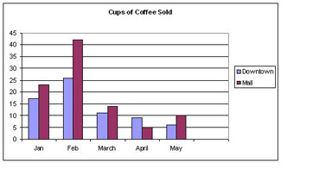

5. What is the value of paying for an item without borrowing the money?
_______________________________________________________________________________________________________________________________________________________________________________________
6. Do you think you can keep within a budget? Why or why not?
_______________________________________________________________________________________________________________________________________________________________________________________
7. What changes in the economy will affect your earning power and personal budget?
_______________________________________________________________________________________________________________________________________________________________________________________

Assessment Rubric

Student Name: ______________________________________ Date: ___________

Topic: _______________________________________________________________

 | Attempted (1) | Meets Expectations (2) | Exceeds Expectations (3)
Budget | Expenses and costs are not realistic. The planning and items on the budget are not realistic and unsupported. | Expenses and costs are somewhat realistic. The planning and items on the budget are somewhat realistic and somewhat supported | Expenses and costs and are very realistic. The planning and items in the budget are very realistic and accurately supported.
Circle and Bar Graphs | The student included a circle and bar graph with many inaccuracies | The student included a fairly accurate circle and graph representing the inquiry | The student included an accurate circle and bar graph representing the inquiry
Math Quality | The math calculations are at least 50% accurate | The math calculations are at least 70% accurate | The math calculations are 95% – 100% accurate
Reflection on labour market and lifestyle changes | The student has not reflected or has minimally reflecting on labour and lifestyle changes | The student makes some effort reflecting on labour and lifestyle changes | The student makes a plausible reflection on labour and lifestyle changes

Total: /12
After the lesson:
- Submit a class list to the Career Centre of the students who completed meeting the ‘Big Idea’.

