Social Studies 9 - Cross Curricular Assignment

Teaching Notes
Big Ideas:

Careers 9: Achieving our learning goals requires effort and perseverance.
Social Studies 9: Disparities in power alter the balance of relationships between individuals and between societies.

First Peoples Principles of Learning:

Learning is embedded in memory, history, and story.
Learning involves generational roles and responsibilities.
Learning is holistic, reflexive, reflective, experiential and relational.
Core Competency: Social Responsibility - Valuing Diversity

Students value diversity, defend human rights, advocate for others, and act with a sense of ethics in interactions, including online.

Assignment:

This assignment can begin by showing the Secret Path film, by Gord Downie, to your students or by reading through the story with the graphic novel and showing the film at the end of the assignment. Either way is fine, depending on your students, and is rounded out nicely with a discussion panel at the end of the film you can further discuss. The journal prompts, for each poem/segment of the film, can be printed and completed independently or watched/read/responded to together slowly over a series of classes. The link for the Secret Path film is https://secretpath.ca/#Film. You can obtain copies of the graphic novel through the Aboriginal Education Department (not the DRC). The rubric for the journal responses follows the assignment.
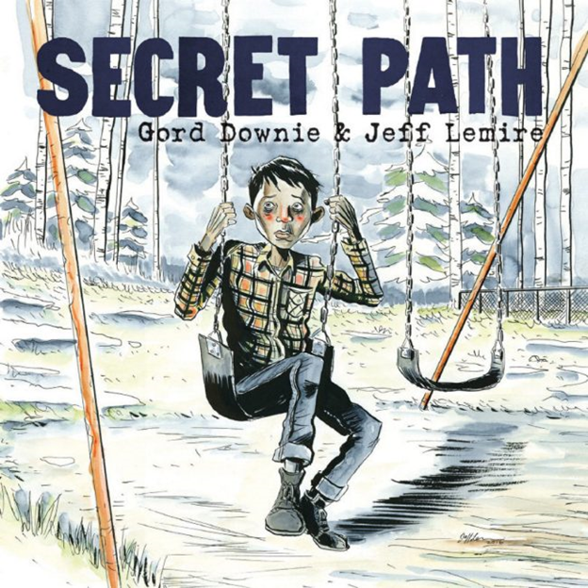

Secret Path Journal Prompts

Each journal response should be in paragraph form, using the conventions of grammar and spelling, answer each of the questions posed for each poem, and should be packed full with vibrant and spicy school and audience appropriate language that expresses why you feel the way you do about each section of Gord Downie’s Secret Path.

The Stranger
Please write a reflection that tells me what “I am the Stranger” means, what and where is the “Secret Path”, who is “not gonna stop”, and what does “Please, just let me catch my breath” mean?

Swing Set
Who was Chanie speaking with, what was he waiting for, why did he look behind him, and what emotions did the image of the swing “dancing wildly where it was” give you?

Seven Matches
How and why did the woman hurt Chanie’s feeling and what is the significance of the countdown of matches he has left? Pick one image from this section and tell me what it’s significance is to Chanie and what emotions it evokes in you.

I Will Not Be Struck
Why does Chanie think back about his father while he is on the run on the Secret Path, what are the meanings behind being struck (literal and figurative), and what is the meaning of,
“I am staring into space
Forever or else
Enter the wilderness
And we only have ourselves”?

Son
What is the significance for Chanie when the song says, “Son, when you dance, I’ll be on your shoulder, And you’ll feel it”? What does it mean “When something occurs in your heart And there isn’t a next sentence”? Pick one image from this section and tell me what it’s significance is to Chanie and what emotions it evokes in you.

Secret Path
Secret Path tells the story of Chanie Wenjack, a 12-year-old Anishinaabe boy who died in 1966 when he tried to run away from the Cecilia Jeffrey Indian Residential School. He was trying to return home, which was 400 kilometres away.

The theme of ‘returning home’, or ‘coming home’, is prevalent throughout the story. Do you have a story about going home? For example, it could be returning home after a vacation, or even after a day of school. What emotions or feelings are involved in coming home? What imagery do you see on the way home? Once arriving home?

You may write a narrative short story, a newspaper-style article, an oral storytelling piece, or a poem of your stylistic choice.

Don’t Let This Touch You
Using a Google Doc, create a collage that fills the page with images and words that express the emotions elicited in this poem.

Haunt Them, Haunt Them, Haunt Them
The raven is prevalent in the Secret Path. You will find him in many of the images following Chanie’s journey until the very end of the Secret Path. Why is the raven telling Chanie to haunt them, why did he wish Chanie a “plain Ordinary death”, and what is Chanie’s ultimate choice about how he wants to end his life? Pick one image from this section and tell me what it’s significance is to Chanie and what emotions it evokes in you.

The Only Place To Be
As Chanie is dying, he says that the wolf, the raven, the sun, and the wind will have him in the end? What does this mean? Tell me what he also means when he says that,
“I’ll just close my eyes
I’ll just catch my breath
This is the only place to be”.
Pick one image from this section and tell me what it’s significance is to Chanie and what emotions it evokes in you.

Secret Path Final Entry
Chanie Wenjack haunts us. His true story is a painful reminder of a very dark part in Canadian history. Chanie’s story, brought to the forefront by Gord Downie, has touched millions of hearts here in Canada and abroad. His story, along with many others, is protected at The National Centre for Truth and Reconciliation (NCTR) at the University of Manitoba. There they work tirelessly to preserve, reveal, and move Canada forward on the path of reconciliation. For your final entry, I would like you to reflect on what you’ve learned about residential schooling, Chanie or another person’s journey, and in what way you can honour the memory of what happened right here at home in Canada.

Careers 9 Final Reflection
Have you or your family ever overcome a loss or hardship that required you and/or your family to persevere, advocate for one another, support a loved one, or stand up for yourself during a troubling time? Please write a short personal response about that hardship.

The Secret Path Rubric
Criteria | Unsatisfactory  Beginning | Developing | Accomplished | Exemplary | Total
Content  Reflection | 1 | 2 | 3 | 4 | /40
 | Reflection lacks critical thinking. Superficial or inadequate connections are made. | Reflection demonstrates limited critical thinking in applying, analyzing, and/or evaluating key concepts and theories. Minimal connections made through explanations, inferences, and/or examples. | Reflection demonstrates some degree of critical thinking in applying, analyzing, and/or evaluating key concepts and theories. Connections made through explanations, inferences, and/or examples. | Reflection demonstrates a high degree of critical thinking in applying, analyzing, and evaluating key concepts and theories. Insightful and relevant connections made through contextual explanations, inferences, and examples.
Personal Growth | 1 | 2 | 3 | 4 | /40
 | Conveys inadequate evidence of reflection on own work in response to the self-assessment questions posed. Personal growth and awareness are not evident and/or demonstrates a neutral experience with negligible personal impact. Lacks enough inferences, examples, personal insights and challenges, and/or future implications are overlooked. | Conveys limited evidence of reflection on own work in response to the self-assessment questions posed. Demonstrates less than adequate personal growth and awareness through few or simplistic inferences made, examples, insights, and/or challenges that are not well developed. Minimal thought of the future implications of current experience. | Conveys evidence of reflection on own work with a personal response to the self-assessment questions posed. Demonstrates satisfactory personal growth and awareness through some inferences made, examples, insights, and challenges. Some thought of the future implications of current experience. | Conveys strong evidence of reflection on own work with a personal response to the self-assessment questions posed. Demonstrates significant personal growth and awareness of deeper meaning through inferences made, examples, well developed insights, and substantial depth in perceptions and challenges. Synthesizes current experience into future implications.
Writing Quality | 1 | 2 | 3 | 4 | /20
 | Poor writing style lacking in standard English, clarity, language used, and/or frequent errors in grammar, punctuation, usage, and spelling. Needs work. | Average and/or casual writing style that is sometimes unclear and/or with some errors in grammar, punctuation, usage, and spelling. | Above average writing style and logically organized using standard English with minor errors in grammar, punctuation, usage, and spelling. | Well written and clearly organized using standard English, characterized by elements of a strong writing style and basically free from grammar, punctuation, usage, and spelling errors.
TOTAL POINTS (sum of 4 Criteria) |  |  |  |  | /100
Careers 9 Summary Paragraph Rubric

 | Exemplary | Accomplished | Developing | Beginning
 | 4 | 3 | 2 | 1
Reflective  Thinking | The reflection explains the student’s own thinking and learning processes, as well as implications for future learning. | The reflection explains the student’s thinking about his/her own learning processes. | The reflection attempts to demonstrate thinking about learning but is vague and/or unclear about the personal learning process. | The reflection does not address the student’s thinking and/or learning.
Analysis | The reflection is an in-depth analysis of the learning experience, the  value of the derived learning to self or others, and the enhancement of the student’s appreciation for the discipline. | The reflection is an analysis of the learning  experience and the  value of the derived learning to self or others. | The reflection attempts to analyze the learning experience but the value of the learning to the student or others is vague and/or unclear. | The reflection does not move beyond a description of the learning experience.
Making  Connections | The reflection articulates multiple connections between this learning experience and past learning, life experiences, and/or future goals. | The reflection articulates connections between this learning experience and past learning  experiences and/or future goals. | The reflection attempts to articulate connections between this learning experience and past learning experiences, or  personal goals, but the connection is vague and/or unclear. | The reflection does not articulate any connection to other learning or experiences.

/12

