Module 2 Lesson 3 Assignment: Researching Career Paths
In the last assignment, you completed a number of surveys in order for myBlueprint to get a better idea of your own personality, interests, motivators, knowledge and learning style to get a sense of potential careers that may interest you. In this assignment, you will further explore some of these career options using myBlueprint.
Instructions:
- Log into your myBlueprint portfolio and click on the "Who Am I" sidebar. Then click on "Match Results" like in the image below and your Occupation Matches should appear underneath.
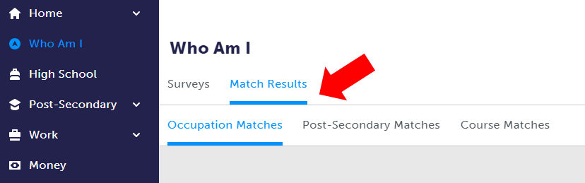
2. Now make a list in your assignment of the careers listed in the order presented before you go to Step 3. This is because the order will likely change as you continue this assignment.
3. Choose "Get Started" button next to the top career listed in your Occupation Match. When you select "Get Started", you will be asked an additional ten questions relating to that specific profession, and a percentage match for that career. Answer the questions for the next four career options as well.
4. Finally, answer the following questions about the career information presented to you in myBlueprint:
- List the careers presented to you before you answered the additional questions. How do they compare to the order that is by percentage match. Did they change a great deal, or very little? Why?
- What are the commonalities or differences between the careers presented to you in your top matches? Do the careers have similar duties or responsibilities? Do they use similar or different skills?
- How useful do you feel career surveys are in determining a career path? If you had a friend who was having a tough time deciding on a career path, would you recommend they take the career compatibility test? What additional resources do you think they could use in your community?
Upload your Career Paths assignment to your Grade 9 myBlueprint portfolio, as well as submitting it here.

