DIGITAL FOOTPRINTS…
A cautionary tale…

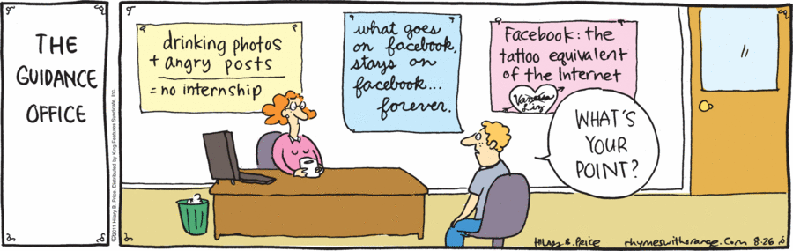

In this assignment, you will develop a comic strip to tell the story of one (or more) characters and how their digital footprint has negatively or positively impacted their life.

Part One: Storyboarding

Your first task is to prepare a storyboarded idea for your comic strip. A storyboard is an expression of everything that will be contained in your comic: what each picture will look like and the text that will accompany the images. A storyboard is literally a rough “story” version of your comic. In the advertising industry, several storyboards of marketing tools (such as commercials) are made for the client to choose from.
Please answer the following questions before proceeding with your storyboard. In your assignment submission, you can upload your storyboard with accompanying questions.

- Describe the basic plot of your comic. Who are your characters and what is the story?

- Who is the target audience for your comic (such as gender, age)? Why do you feel this target audience will connect with your comic?

- What is the specific image/message that you want the audience to be left with after reading your comic?

Design a storyboard of at least 8 drawings to show what will be in the frame of your comic. You do not have to be an artist to be successful at storyboarding! You just have to be able to communicate your story through pictures. Pictures can be simply designed – simplicity and colour are at times very effective! For each drawing, please write the rough dialogue of each character. You are welcome to draw on the storyboard below, or make one of your own.

Use the following checklist to ensure success with your storyboard:

STORYBOARD CHECKLIST
- Main idea of the comic is made clear
- Dialogue is placed where appropriate
- Storyline includes clear references to the concept of digital footprints, a digital identity or digital citizenship
- Sequence of events is clearly illustrated
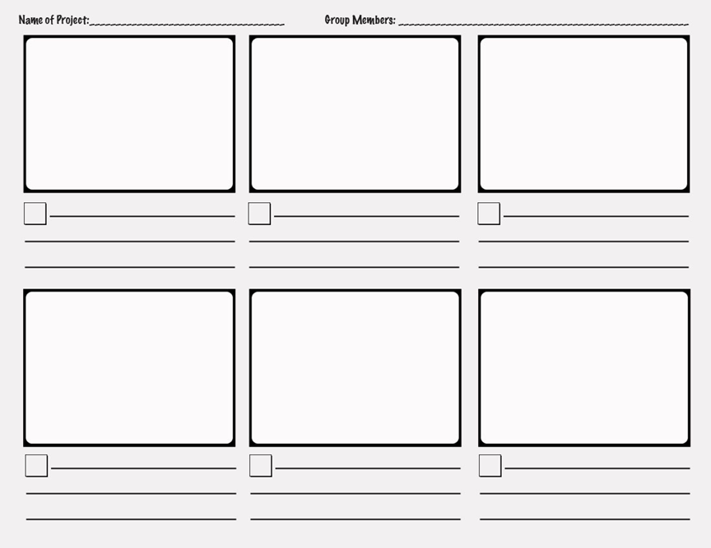
- Comic includes a minimum of three panels (boxes)
Part Two: Using ToonDoo to Create Your Own Comic

You will now use your storyboard to create your comic using the website ToonDoo (www.toondoo.com). Create a new account on the ToonDoo website (choose a user friendly name as it will be printed on your comic) and click on the ToonDoo Maker to start! Select a layout that works for your story, but please make sure that it has at least three panels.

Take some time to explore the options in ToonDoo; there are endless characters, backgrounds, props, and options to add text. Use the shrink or enlarge buttons at the bottom to resize your objects. Use the rotate or flip buttons to change your objects or characters - you can even change your character’s emotions!
Need extra help using ToonDoo? Visit https://ed.ted.com/on/KnXtNOvc and watch the video.

Start building your comic, and make sure to save from time to time (found under the icon “main menu”). When you save your comic, please make sure you 1) DO NOT allow others to ReDoo, 2) Do not allow others to purchase, and 3) under options, make sure to click “keep it private”. This is also the way to print your work.

When you are finished your comic strip, you can either print and upload your document for submission, print it to a .pdf and upload it for submission, or click “email to friends” and send directly to your teacher.

