Career Education 7 - Using Entrepreneurship in Career Education
Core Competencies:
- Communication | - Thinking | - Personal & Social

Big Ideas:

- Leadership represents good planning, goal-setting and collaboration
- New experiences, both within and outside of school, expand our career skills set and options
Curricular Competencies:

- Use entrepreneurial and innovative thinking to solve problems
- Apply project management skills to support career development
- Appreciate the value of new experiences, innovative thinking and risk taking in broadening their career options
- Examine the importance of service learning and the responsibility of individuals to contribute to the community and the world

INTRODUCTION:
This is an integrated assignment, students will use the B.C. Labour Market Outlook information for Vancouver Island in order to think of a business idea that may be in demand in the future. (Original link: https://www.workbc.ca/getmedia/66fd0e7c-734e-4fcb-b1a6-0454862525a6/BC_Labour_Market_Outlook_2017_Edition_Nov_2017.PDF.aspx).

PART ONE:
- Start with a class discussion about employment trends and how they evolve over time. Popular jobs in the 1850s include chimney sweeps, daguerreotypists (the pioneers of photography using the camera obscura), a drover (someone who drives cattle or sheep), hemp dressers (someone who worked in the linen industry separating the coarse parts of hemp) and shoe peg makers. Discuss how these careers have basically become obsolete in current times.

Next brainstorm about jobs that exist today that will likely become extinct in the next 50 years (such as travel agents, bank tellers, postal workers, and telemarketing). Question students about why they think these positions will no longer be available. Discuss why it is important that students consider the labour market outlook when they are choosing a career path.

2. Have students fill in the table “Industry Outlook for Vancouver Island” and brainstorm five positions that are in each industry. They can use the website www.workbc.ca to find positions.
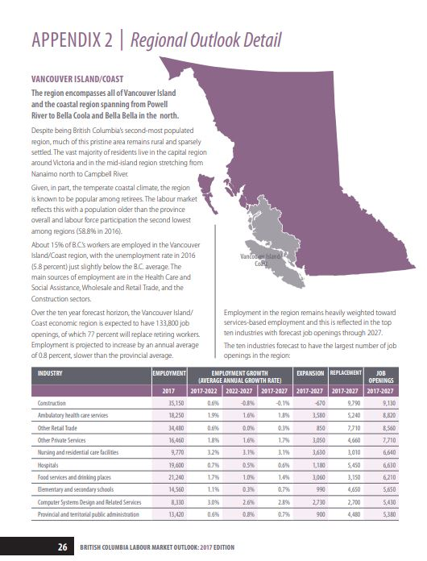

Let’s talk jobs…where will they be?
Industry Outlook for Vancouver Island

Name: _______________________________ Date: __________________________

Using the Regional Outlook Detail for Vancouver Island, list the ten industries that will have the largest number of job openings in the next ten years. Add the number of job openings to the table, and five occupations that can be found in each industry. Need help? Visit www.workbc.ca to explore careers through these occupation categories.

INDUSTRY | # OF JOB OPENINGS? | 5 OCCUPATIONS FOUND IN THIS INDUSTRY
1)
2)
3)
4)
5)
6)
7)
8)
9)
10)

PART TWO:

Now that students have an idea of the industries on Vancouver Island that will be experiencing growth, students will use entrepreneurial and innovative thinking to design a business that caters to one of those industries using a simplified version of the Business Model Canvas (https://strategyzer.com/canvas/business-model-canvas) - a tool used to create business model templates...is has taken over as today’s version of the “business plan”.

A Business Model Canvas is usually quite complex, however I have simplified a simpler version for this assignment. The best way is to have an “Engineering print” printed at Staples (24 x 36) - costs $2.94 each - and then students use post it notes to fill in the different categories. The idea is for students to be able to pivot their business really easily by just moving around the post it notes. If you are not able to make the engineering prints, no worries, just give each group a copy to develop their idea.

The focus of this entrepreneurship project is for students to use the information about industries with growth to solve a pain or create a gain for any group of people in the community. They then need to think about all the resources in the community that they will need for the business, and how they will add value (*create a value proposition*) in the community. Groups of 2 are recommended, or students can work on their own).

(See the file Entrepreneurship Business Model Canvas Student and Teacher Materials for assignment sheet and materials)

