M3 Lesson 2: Setting Goals
Core Competencies:

- Communication | - Thinking | - Personal & Social

Big Ideas:

- Achieving our learning goals requires effort and perseverance
Curricular Competencies:
- Use self-assessment and reflection to develop awareness of their strengths, preferences and skills
- Set and achieve realistic learning goals with perseverance and resilience
Lesson:
Assignment – Part 1
1. Autobiography of Me: yesterday, today and tomorrow:
The intent of this assignment is for you to have a chance to summarize all the information you learned about yourself and what goals / plans / hopes you might have for your future. An autobiography is the story of you. For this assignment you are to write about yourself as a student / learner and the goals and dreams you have for your future. Your story should cover your past, your present and your future. Your future section should describe how you see yourself and your life 15 years from now. It should also include information you learned about yourself in all those self tests you worked through in module 1. If you like you can quote relevant parts of these self test summaries. Be creative - you can include other ways of describing yourself (pictures, movies, sound clips. etc).
To start you thinking along these lines, let's look at things that you love to do already, things you don't enjoy doing at all, things you want to learn and things you think you're good at. A pattern should begin to emerge which will help point you in the direction of your goals.
This assignment should be about 500 words in length.
As well...
2. Now that you have thought about your goals in writing your autobiography, you are going to add five goals to your myBlueprint portfolio:
- Visit www.myBlueprint.ca, and enter your email and password to log in.
- In the left-hand navigation menu, click Home and select Goals.
- Select + Add Goal to create a new Goal for this activity, defining the goal and its timeline.
- Add at least three tasks you need to do in order to accomplish your goal.
- Repeat steps 3 and 4 for four additional goals.
Throughout the course, you should revisit your goals in myBlueprint often and remind yourself of the tasks you need to accomplish each goal. This is a great way to work on your accountability and responsibility!
Take a screenshot of this part of the assignment.
Assignment – Part 2
Achievement of our goals is closely linked to our own personal habits: what our regular tendency or practice something is and are things that are especially hard to give up. Our habits can work for or against achieving our goals, so let's take a critical look at our habits and what we need to work on!
Revisit the five goals that you added to your myBlueprint portfolio. For each goal list two habits that you would like to improve on to help you reach your goal. For example, if my goal were to achieve a mark of at least 90% in Career Life Education 8, two habits I would like to work on are making sure I get at least 8 hours of sleep per night, and ensuring that I spend at least an hour each day on my class assignments. I would then decide what habits I need to change in the short and long term to ensure that this habit is helping me work positively towards my goals.
Being aware of your habits is a great way to think about the core competency of Personal Awareness and Responsibility.
Copy and paste the table below or make your own to complete and submit your assignment.
Goal #1:
Habit | Short -Term:  What I can do in the short term to improve this habit: | Long - Term:  What I can do in the long term to improve this habit:
#1
#2
Goal #2:
Habit | Short -Term:  What I can do in the short term to improve this habit: | Long - Term:  What I can do in the long term to improve this habit:
#1
#2
Goal #3:
Habit | Short -Term:  What I can do in the short term to improve this habit: | Long - Term:  What I can do in the long term to improve this habit:
#1
#2

Goal #4:
Habit | Short -Term:  What I can do in the short term to improve this habit: | Long - Term:  What I can do in the long term to improve this habit:
#1
#2
Goal #5:
Habit | Short -Term:  What I can do in the short term to improve this habit: | Long - Term:  What I can do in the long term to improve this habit:
#1
#2
Assessment – Part 1
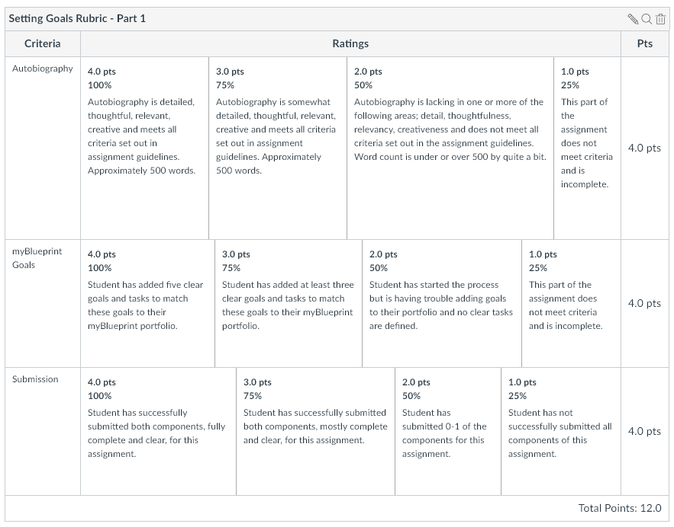
Assessment – Part 2
