Module 3 Lesson 4 Assignment: Thinking Ahead to Graduation
The following assignment has two parts. In the first part, you will use the BC Ministry of Education Graduation Requirements website to start researching what is necessary to obtain a Dogwood Graduation Diploma in BC. In the second part of the assignment, you will use the course planning tool in myBlueprint to come up with one option to fulfill your graduation requirements. Let's get started!
Part 1:
Using the British Columbia Certificate of Graduation website, answer the following questions:
- For students graduating after June 30, 2018, how many credits will be required to graduate? Normally, how many credits do students receive for one course?
- How many credits must be from required courses, and how many credits must be received from elective courses?
- List the courses required for graduation in each of Grades 10, 11 and 12.
- Students need to complete two graduation assessments. Give a brief explanation of each (hint...use https://curriculum.gov.bc.ca/provincial-assessment/graduation. for help!)
- What are the Career Education courses that are required for graduation?
Part 2:
In Part 2 of this assignment, you will use myBlueprint to explore one option for a course plan for Grades 10, 11 and 12. This initial plan will change as your interests and goals change between grades 10-12, but is a useful tool for visualizing one way to complete your graduation requirements.
Instructions:
1. Log into your myBlueprint account and click "High School" on the left hand toolbar.
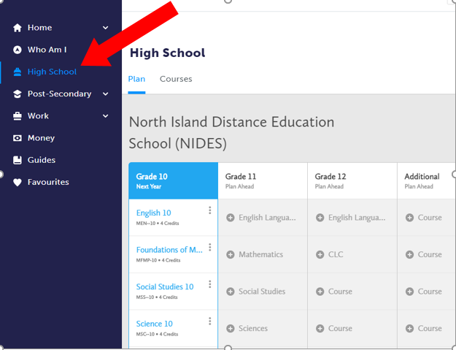
2. Using the graduation requirements you have identified in Part 1 of this assignment, use the High School plan tool to design one graduation option for Grades 10-12. Fill in the courses you could take in each grade to fulfill graduation requirements. In no way is this a commitment to these courses - we are just playing with options, and how to keep track of how those options change while still ensuring we will graduate!
Please ensure that you have the following in your courses for graduation plan:
- A language arts (for example, English) course in each of Grades 10, 11 & 12
- CLE 10 and CLC 12
- P.E. 10
- Science 10 and a Science 11 or 12
- Socials 10 and a Socials 11 or 12
- a Math 10 and a Math 11 or 12
- an Arts Education or Applied Skills, Design and Technologies 10, 11 or 12
- at least 28 credits of electives
- at least 12 credits of Grade 12 courses, not including Language Arts 12
3. In a short journal entry of approximately 400 words, reflect on the graduation plan you outlined in Part 2 of your assignment. Use these guiding questions to help in your response:
- Planning for graduation brings out different feelings in all of us. Some of us are nervous, some anxious, some excited, and some of us would prefer to just put our head in the sand! Explain your feelings as you begin to plan for your graduation.
- How did you come to choose the courses you did in your Grade 10/11/12 plan? Use specific course examples in your reply.
- As we begin to plan out our path, it's important to realize that a lot of changes are going to come our way that will require us to be flexible with our plan. Give some examples of events that could mean a change in your plan, and how you would navigate those changes.
Upload your Graduation Requirements assignment and journal here, and email your teacher to confirm you have finished your Grade 10-11-12 course plan in myBlueprint

