The Johari Window

Beauty and the Beast

Name(s): ____________________ Date: __________________
____________________ Block: __________________

Use the adjectives below to develop a Johari Window that identifies the parts of Beast (before he was turned back into a prince) that are:

- Known to Beast, as well as Belle, Maurice (Belle’s father), and the servants
- Known (or perceived) by Belle, but not to Beast
- Known to Beast, but are kept hidden from Belle, Maurice, and the servants
- Unknown to both Beast and to Belle at this point in time

ADJECTIVES THAT CAN BE USED AS DESCRIPTORS IN A JOHARI WINDOW:
able | energetic | loving | searching
accepting | extroverted | mature | self-assertive
adaptable | friendly | modest | self-conscious
bold | giving | nervous | sensible
brave | happy | observant | sentimental
calm | helpful | organized | shy
caring | idealistic | patient | silly
cheerful | independent | powerful | spontaneous
clever | ingenious | proud | sympathetic
complex | intelligent | quiet | tense
confident | introverted | reflective | trustworthy
dependable | kind | relaxed | warm
dignified | knowledgeable | religious | wise
empathetic | logical | responsive | witty
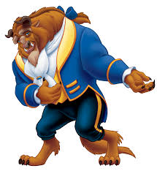

The Johari Window for Beast

Known to Beast Not Known to Beast

Known to
Others

Not Known
to Others

In what ways do you think that Beast would have changed his decisions and behaviour if he had all the information given in the Johari Window?
____________________________________________________________________________________________________________________________________________________________________________________________________________________________________________________________________________________________________________

