The Johari Window
Using the adjectives below, interview a family member that know you well to develop a Johari Window that identify the parts of you that are:
Arena (known to self AND known to others):
- Adjectives that both you and your family member would use to describe yourself. These are the traits that both you and your family member perceive to be true about yourself.

Façade (known to self but NOT known to others):
- Adjectives selected by you, but not by your family member, go in this quadrant. These are things the family member may be either unaware of (such as being self-conscious), or that are perhaps untrue however you feel they are true.

Blind Spot (known to others but NOT known to self):
- Adjectives not selected by you, but only by your family member. These represent what others perceive but you do not.

Unknown (not known to self AND not known to others):
- Adjectives that neither you nor your family member feel are representative of your personality go here. This represents your behaviors or motives that no one recognizes—either because they do not apply, or because both you and your family member are ignorant of these traits. This is the unconscious part of you that neither you nor your family member see. A good way to start this is with “I wonder…” - use the adjectives that you are unsure of, or haven’t had the opportunity to demonstrate.

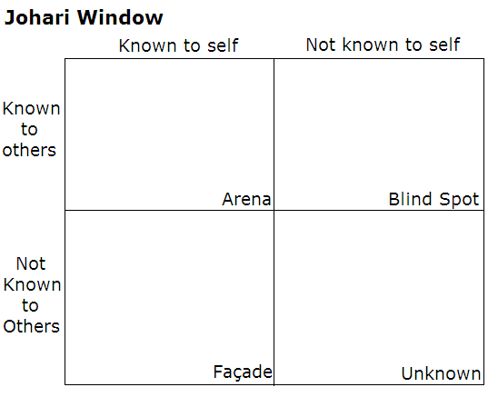

ADJECTIVES THAT CAN BE USED AS DESCRIPTORS IN A JOHARI WINDOW:
able | energetic | loving | searching
accepting | extroverted | mature | self-assertive
adaptable | friendly | modest | self-conscious
bold | giving | nervous | sensible
brave | happy | observant | sentimental
calm | helpful | organized | shy
caring | idealistic | patient | silly
cheerful | independent | powerful | spontaneous
clever | ingenious | proud | sympathetic
complex | intelligent | quiet | tense
confident | introverted | reflective | trustworthy
dependable | kind | relaxed | warm
dignified | knowledgeable | religious | wise
empathetic | logical | responsive | witty

Instructions:
- Draw a template for a Johari Window either on your computer or on a piece of paper.

- Using the list of adjectives, choose 6 that you think describes your own personality.

- Choose a family member who you feel knows you well. Give your family member the same list of adjectives and ask them to choose 6 that they think describes your personality.

- Arrange the adjectives on a Johari Window based on where they belong (arena, blind spot or façade).

- Complete the “unknown” part of your Johari Window using either adjectives that were not chosen by neither you nor your family member, or personality traits that you have not yet had the opportunity to demonstrate.

- Lastly, complete the following questions about your Johari Window in a journal entry:

  - What information surprised you in how your family member described or perceive you?
  - How could knowing all of the information in a Johari Window assist someone in determining how they could best contribute to their community through volunteerism or making career choices?

