M1 Lesson 2: What is my Learning Style?
Core Competencies:

- Communication | - Thinking | - Personal & Social

Big Ideas:

- Career life choices are made in a recurring cycle of planning, reflecting, adapting and deciding.
Curricular Competencies:

- Communicate with the intent to highlight personal strengths, talents, accomplishments and abilities
- Explore and connect experiential learning both inside and outside of school with possible and preferred career-life pathways
- Explore and reflect on career-life roles, personal growth, and initial planning for preferred career-life pathways

For students
What do you want to be when you grow up? The fact that we start asking you that question as early as age 4 shows how much value our society places on careers. While dreaming about future careers is exciting for some, it can cause anxiety and stress in others. Most people figure it out slowly over time through experience as they learn what type of work best suits them.
The process of choosing a career often begins with self-assessment. The answer to the question "Where do you see yourself in 10 years?" depends on your individual characteristics. In this part of the course you will be using MyBlueprint to complete a series of personal assessments to explore your personal strengths, interests, and values. Your results will help guide your learning through the rest of the course, particularly the work and career section.
Keep in mind that no single test can tell you "what you should be" and that successful career planning is an ongoing and evolving process. Keep an open mind about the results because they might surprise you!
Login to your MyBlueprint Account
On the left side column you will see the following:
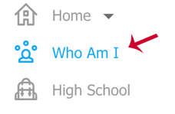

Go to Who Am I.
Complete the following surveys:
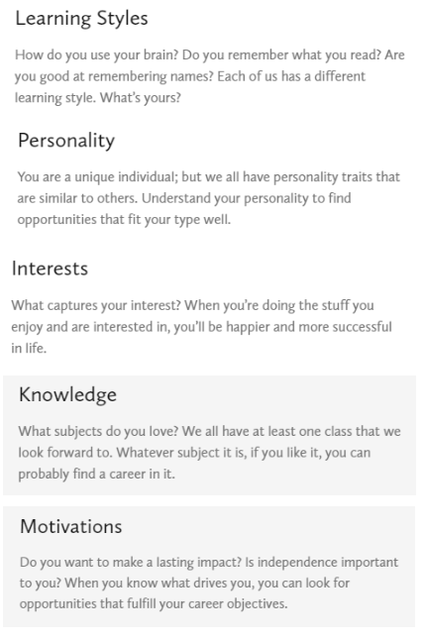
Assignment:
For this self-reflection, you will need to submit the results of each survey you completed in myBlueprint on Learning Styles.
In addition to your survey results, you will need to answer the self-reflection questions below about Learning Styles and include them in your presentation. Please be creative in your submission. You can create a small presentation using a tool of your choice (think prezi, photo journal, social media tools, etc.)
1. Which survey in myBlueprint did you find the most interesting and useful? Why?
2. Did you learn anything about your personal learning style through completion of any of the surveys?
3. How does your personal learning style impact the way you learn in and out of the classroom? Do you think your learning style has an impact of the career paths you might be interested in?
Use the "Learning Styles Rubric" to help guide you in what you will be assessed on for this assignment.
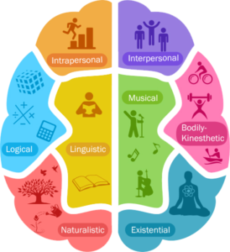

Assessment:
(see next page)
