M1 Lesson 3: Employability Skills
Core Competencies:

- Communication | - Thinking | - Personal & Social

Big Ideas:

- Career life choices are made in a recurring cycle of planning, reflecting, adapting and deciding.
Curricular Competencies:

- Communicate with the intent to highlight personal strengths, talents, accomplishments and abilities
- Explore and connect experiential learning both inside and outside of school with possible and preferred career-life pathways
- Explore and reflect on career-life roles, personal growth, and initial planning for preferred career-life pathways

For students:

Why is Change Inevitable?

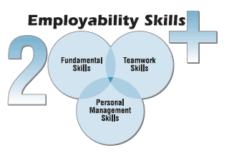

Employability Skills & Self Reflection
Let's see where you stand. Do you have any employability skills? What can you improve on?
Take the Service Canada Fundamental Skills Test
You will see these three quiz options when you open the link:
1. Numeracy
2. Document Use
3. Reading
There are a few options listed for each quiz, please take all the quizzes -starting with the most basic and working towards the more advanced. When complete, copy (a screenshot is a good option) your results into a document for you to submit here with your self reflection.
Upon completion of each quiz, make sure you submit the results by clicking found at the end of the quiz.
Once the answers have been submitted, you will be able to view your strengths and what you must work on.
Visit the following site: Skills You Need
The above site talks about "soft" and "hard" skills. Please give a brief description and summary of both soft and hard skills (3-4 sentences for each).
Assignment:
After completing all of the surveys listed above, do the following -
1. Provide your results for the "Service Canada Fundamental Skills Test. This could be screenshots or copying and pasting (make sure you add titles so your teacher can easily understand what you are submitting) each of your quiz results.
2. Include a brief description and summary of both soft and hard skills. This should be about 3-4 sentences for soft skills and 3-4 sentences for hard skills.
3. Do you agree with the results? Explain why or why not? It is important to provide evidence supporting answers in the survey.
Assessment:

(see next page)
