M1 Lesson 4: Career Exploration
Core Competencies:

- Communication | - Thinking | - Personal & Social

Big Ideas:

- Career life choices are made in a recurring cycle of planning, reflecting, adapting and deciding.
Curricular Competencies:

- Communicate with the intent to highlight personal strengths, talents, accomplishments and abilities
- Explore and connect experiential learning both inside and outside of school with possible and preferred career-life pathways
- Explore and reflect on career-life roles, personal growth, and initial planning for preferred career-life pathways

In this lesson, students will begin exploring some career options for after high school, looking at the career itself, as well as post secondary education and training required.

For students:
In this section, we will explore your life after high school, the career options that are of interest to you and how you would get there through post-secondary education and training.
In myBlueprint, go to the 'Guides' on the left-hand side. Please review the following guides:
- Apprenticeship
- College & University
- Job Search
- Occupations
- Paying for Post Secondary
- Workplace
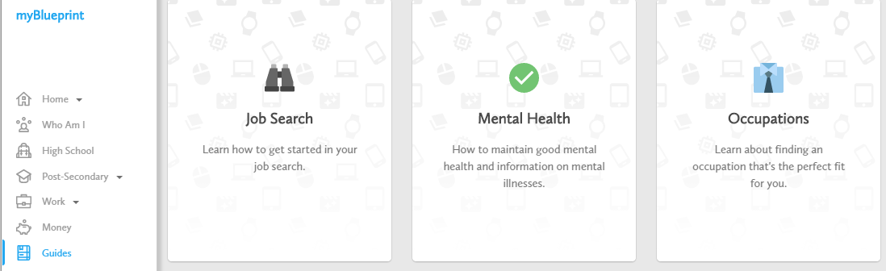

Once you have explored the 'Guides', please visit the 'Work' tab on the left-hand side and click 'Occupations'. This is where you will begin your 'Career Cruising'.

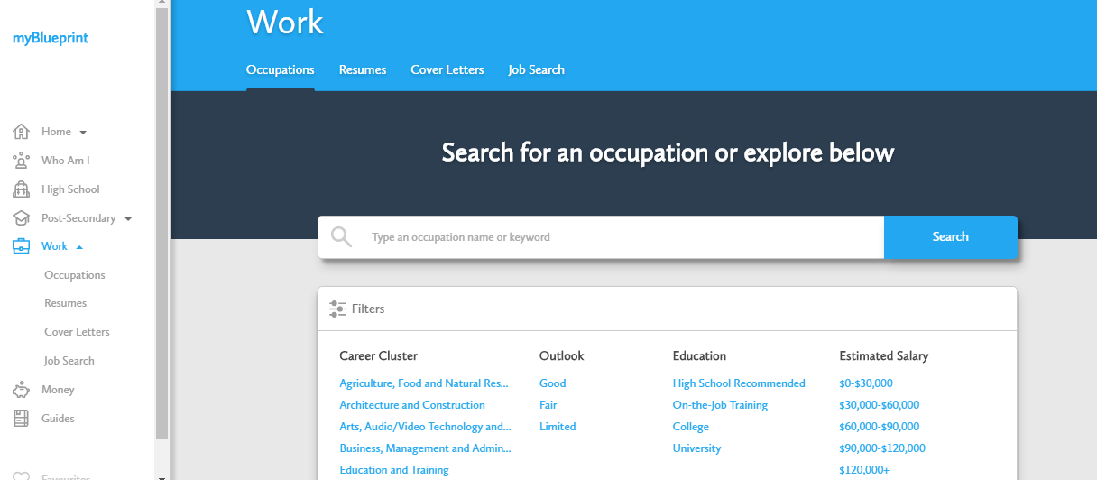

Assignment:
Using myBlueprint, please complete the Career Project assignment on two careers that you are interested in.
Use the career project attachment in the portal.

