M1 Lesson 5: Forming a Grad Plan
Core Competencies:

- Communication | - Thinking | - Personal & Social

Big Ideas:

- Career life choices are made in a recurring cycle of planning, reflecting, adapting and deciding.
Curricular Competencies:

- Communicate with the intent to highlight personal strengths, talents, accomplishments and abilities
- Explore and connect experiential learning both inside and outside of school with possible and preferred career-life pathways
- Explore and reflect on career-life roles, personal growth, and initial planning for preferred career-life pathways

In this lesson, students will begin to navigate the requirements to graduate in British Columbia with a Dogwood diploma, forming an initial plan to complete their graduation requirements.
Assignment
For this assignment, please log in to your myBlueprint account and click the "High School" tab on the left-hand side. From there, choose the "Plan" option under the "High School" header.
You will need to create a new plan and call it "Your Name: Graduation Plan". If you click each course you will be given options to choose from for that course (ex: different math course options available). The description and prerequisites for each course are also found when clicking on each course. You will need to add the required courses (see the previous page for more information of the current graduation plan in British Columbia) - make sure you add all core courses and elective courses. You need 80 credits to graduate but more are encouraged! Getting as much free information and knowledge as possible while in school is always a good idea!
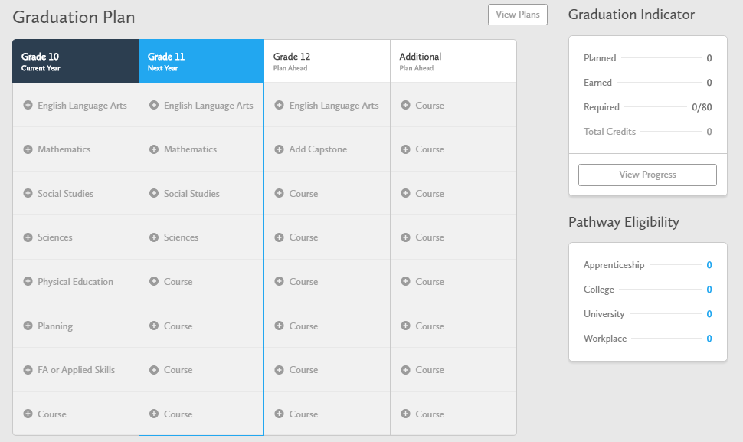
If you are taking this course in grade 10, grade 11 or grade 12, you will still need to fill out all columns (hopefully you are taking the course in grade 10 but that may not be the case!) For each course added, you will need to choose an appropriate course status. The three different status options are listed below.
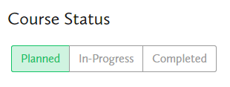
When finished, please save your graduation plan to your ePortfolio and submit a screen shot of your graduation plan here for feedback and grading. Please review the rubric before completing this assignment.
Assessment:
