M1 Lesson 5: Forming a Grad Plan
Core Competencies:

- Communication | - Thinking | - Personal & Social

Big Ideas:

- Career life choices are made in a recurring cycle of planning, reflecting, adapting and deciding.
Curricular Competencies:

- Communicate with the intent to highlight personal strengths, talents, accomplishments and abilities
- Explore and connect experiential learning both inside and outside of school with possible and preferred career-life pathways
- Explore and reflect on career-life roles, personal growth, and initial planning for preferred career-life pathways

In this lesson, students will begin to navigate the requirements to graduate in British Columbia with a Dogwood diploma, forming an initial plan to complete their graduation requirements.

BC Graduation Requirements

How Do I Get Credit To Graduate?
To get started, check out the following links above and have a look through the British Columbia Graduation Requirements. Read through the information below and then use the BC grad planner document to start to plan your high school years for a successful graduation.
Grad Planner
The B.C. Certificate of Graduation or "Dogwood Diploma" is awarded to students who successfully complete the provincial graduation requirements.
Students graduating after June 30, 2018 are on the new Graduation Program. To graduate, they require at least 80 credits total.
Of these 80 credits:
- At least 16 credits must be at the Grade 12 level, including a required Language Arts 12
- At least 28 credits must be elective course credits
- 52 credits are required from the following:
  - Two Career Education courses (8 credits total)
  - Physical and Health Education 10 (4 credits)
  - Science 10 (4 credits), and a Science 11 or 12 (4 credits)
  - Social Studies 10 (4 credits), and a Social Studies 11 or 12 (4 credits)
  - A Math 10 (4 credits), and a Math 11 or 12 (4 credits)
  - A Language Arts 10, 11 & 12 (12 credits total)
  - An Arts Education 10, 11, or 12 and/or an Applied Design, Skills, and Technologies 10, 11, or 12 (4 credits total)
In addition, students on the new Graduation Program must also complete two new graduation assessments aligned with the redesigned curriculum – one in literacy and one in numeracy:
- Graduation Numeracy Assessment
  - The Graduation Numeracy Assessment was introduced in 2018
    - January 2018 - managed implementation with small subset of students
    - June and August 2018 - full provincial implementation
  - Students who have already taken the Math 10 provincial exam may use it to satisfy the Graduation Numeracy Assessment requirement
- Graduation Literacy Assessment
  - The Graduation Literacy Assessment will be introduced in January 2020
  - Students who have already taken a Language Arts 12 exam may use it to satisfy the Graduation Literacy Assessment requirement
    - All students graduating in the 2018/19 school year will take a Language Arts 12 course and associated provincial exam to satisfy this graduation requirement
Note on Career Life Education: For 2018/19, the following career education courses will be used in all BC schools:
- Career Life Education
- Graduation Transitions
For 2019/20 and beyond, the following career education courses will be used in all BC schools:
- Career Life Education
- Career Life Connections
Students on the new Graduation Program will be able to meet the career education graduation requirement with any of the following combinations:
- Planning 10/Graduation Transitions
- Planning 10/Career Life Connections
- Career Life Education/Graduation Transitions
- Career Life Education/Career Life Connections
Note on Social Studies: The Social Studies 11/12 graduation requirement for students on the new Graduation Program is flexible; any of the current or new Ministry Social Studies 11 or 12 courses will meet the requirement.
Current:
- Social Studies 11
- Civic Studies 11
- BC First Nations Studies 12
- Comparative Civilizations 12
- Geography 12
- History 12
- Law 12
- Social Justice 12
New: (i.e., those that will be used in all BC schools in 2019/20):
- Explorations in Social Studies 11
- Francophone History 11
- 20th Century World History 12
- Asian Studies 12
- B.C. First Peoples 12
- Comparative Cultures 12
- Comparative World Religions 12
- Contemporary Indigenous Studies 12
- Economics 12
- Genocide Studies 12
- Human Geography 12
- Law Studies 12
- Philosophy 12
- Political Studies 12
- Physical Geography 12
- Social Justice 12
- Urban Studies 12
Assignment
For this assignment, please log in to your myBlueprint account and click the "High School" tab on the left-hand side. From there, choose the "Plan" option under the "High School" header.
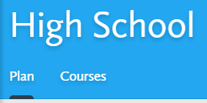
You will need to create a new plan and call it "Your Name: Graduation Plan". If you click each course you will be given options to choose from for that course (ex: different math course options available). The description and prerequisites for each course are also found when clicking on each course. You will need to add the required courses (see the previous page for more information of the current graduation plan in British Columbia) - make sure you add all core courses and elective courses. You need 80 credits to graduate but more are encouraged! Getting as much free information and knowledge as possible while in school is always a good idea!
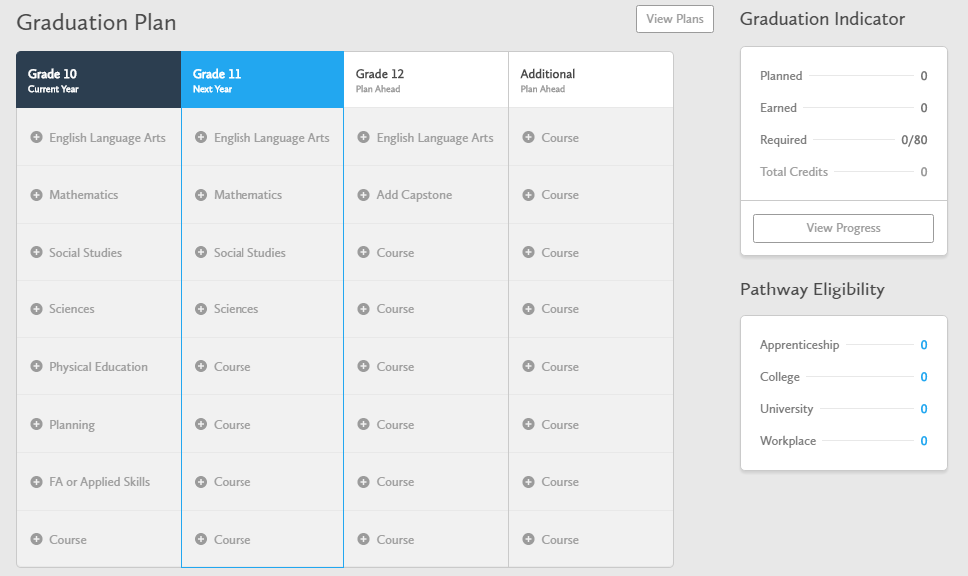
If you are taking this course in grade 10, grade 11 or grade 12, you will still need to fill out all columns (hopefully you are taking the course in grade 10 but that may not be the case!) For each course added, you will need to choose an appropriate course status. The three different status options are listed below.
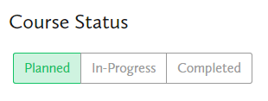
When finished, please save your graduation plan to your ePortfolio and submit a screen shot of your graduation plan here for feedback and grading. Please review the rubric before completing this assignment.
Assessment:
