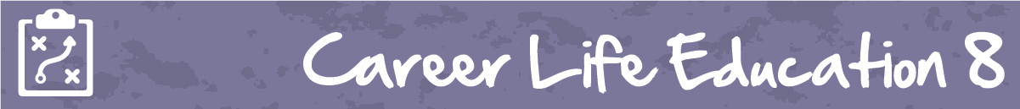

M1 Lesson 1: Multiple Intelligences Lesson & Assignment
Core Competencies:

- Communication | - Thinking | - Personal & Social

Big Ideas:

- Reflecting on our preferences and skills helps us identify the steps we need to take to achieve our career goals
Curricular Competencies:

- Use self-assessment and reflection to develop awareness of their strengths, preferences and skills
- Set and achieve realistic learning goals with perseverance and resilience
- Question self and others about how individual purposes and passions can support the needs of the local and global community when considering career choices
Lesson:
Multiple Intelligences
Nobody is good at everything. Albert Einstein didn't know how to drive a car. Leonardo Da Vinci was terrible at spelling words. But everybody is good at something, and we can all consider ourselves skilled and smart in lots different ways. As proof, have a look at this video where celebrities reveal some of their hidden talents:
Video: Celebrities with weird or hidden talents: https://www.youtube.com/watch?time_continue=1&v=eivn-6ayGT4
Students often associated intelligence with grades and/or test scores. But according to the multiple intelligences theory, we are all intelligent in different ways. The multiple intelligences theory was developed by Howard Gardner, a professor of education at Harvard University.
Gardner's ground-breaking research in psychology and human cognition helped him develop this theory suggesting we each have distinct intellectual abilities that we demonstrate in unique ways.
As students, you often combine intelligences when you do activities or assignments, such as working in a group to create a map based on information given (picture smarts), or writing a reflective essay about how to solve a problem in the world (logic smarts).
Here are seven intelligences that you might use to tackle different tasks and challenges in your daily life:
Musical Smarts - People who have this intelligence enjoy rhythm, beat, singing, and playing instruments.
Body Smarts - This intelligence is about how much control you have over body movements, balance, agility and grace.
People Smarts - This intelligence is about person-to-person relationships: talking and working with others, understanding them and how they behave. It is also about sensing people’s moods and what they are thinking or feeling.
Self-Smarts - This intelligence is about how well you understand yourself: who you are, what you feel, and why you are the way you are. This helps you have high self-esteem, and to solve personal problems.
Picture Smarts - This intelligence is about how well you use the sense of sight and create pictures in your head.
Word Smarts - This intelligence is about the use of words and language, written and spoken. It also relates to how well you write, your vocabulary, and if you can speak more than one language.
Logic Smarts - This intelligence is the ability to solve logical problems and equations mentally.
Assignment
People are born with different abilities and different ways to be smart. These are called Multiple Intelligences. Take the quiz* below to discover your multiple intelligences.
Download and complete the Multiple Intelligences Assignment you will find in the portal under “attachments”
This assignment will be marked using the rubric below.
Assessment
(see next page)
