M1 Lesson 2: Turning Dreams Into Reality
Core Competencies:
• Communication | • Thinking | • Personal & Social

Big Ideas:

- Reflecting on our preferences and skills helps us identify the steps we need to take to achieve our career goals.
Curricular Competencies:

- Use self-assessment and reflection to develop awareness of their strengths, preferences and skills.
- Question self and others about how individual purposes and passions can support the needs of the local and global community when considering career choices.
- Set and achieve learning goals with perseverance and resilience.

Lesson:
In this lesson, students will start by learning about job postings, and the information that needs to be given in a job posting for an organization to attract an employee that is a good fit for the position and the company. They will then use the concept of a job posting to start thinking about their own perfect job posting, and write a description for their perfect position, taking into account their ideal working conditions, interests and skills.
For students:
Job seekers use a wide variety of different ways to find work. They can ask family and friends for word of mouth referrals, visit businesses that they're interested in and ask about openings, and or seek help from community career service agents or recruiters. They can even stay in their pajamas for the day to seek out opportunities by reviewing online job postings.
But what is a job posting? A job posting is an advertisement created by an employer, a member of their human resources staff, or a recruiter (someone who finds employees on behalf of the company) that alerts job seekers of a job opening with a company. The posting might appear on a company’s bulletin board, website, or in the newspaper. Job postings might also appear on career, job board, classified ad and social networking sites.
What information is included in a job posting? Every job posting is different, and depends on the type of company and job for which they are hiring. For example, a posting on a company or career site might include a job title, duties and responsibilities, education and experience requirements, hours, wages, benefits, application instructions and contact information. It would also be useful to give some background information about the company and some information about corporate culture - making sure there is a good fit between the employee and employer is extremely important!
Just compare these two job postings in terms of the information given:
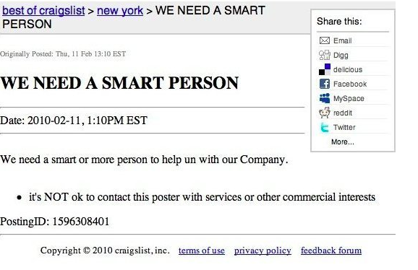
and
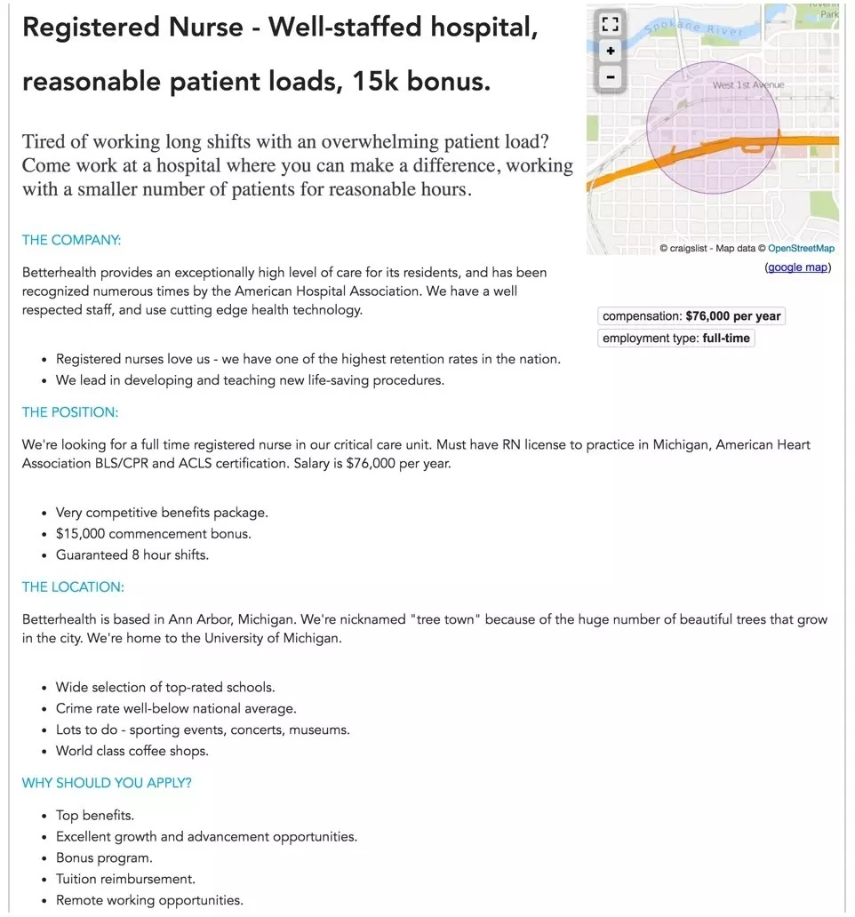
By having a thorough job posting, companies are more likely to get applicants better suited for the company! There are many more interesting postings you can look up for research in the classroom.
Activity:
As a starting point in Career Life Education, let’s get a sense of what your ideal job would be in the future if you were able to design it yourself. In this assignment, you will create a job posting for your ideal job! Employers would be able to look at your posting and hire you based on your job requirements!
In the first part of this assignment, students will make a description of their ideal job or career. You will then use the information to write their own job posting. Beginning with the end in mind is a good way to think about Career Life Education!
Encourage students to think about what would make a job or career a good fit for them and have fun!
Download and complete the Ideal Job Posting Assignment
Assessment:

