M1 Lesson 4: The Importance of First Impressions
Core Competencies:

- Communication | - Thinking | - Personal & Social

Big Ideas:

- Reflecting on our preferences and skills helps us identify the steps we need to take to achieve our career goals.
Curricular Competencies:

- Use self-assessment and reflection to develop awareness of their strengths, preferences and skills.
- Apply decision-making strategies to a life, work or community problem and adjust the strategies to adapt to new situations.

In this lesson and activities, students will consider the importance of first impressions when moving forward in career and life by learning about how quickly first impressions are formed and how the first impressions of others have influenced their own perceptions.
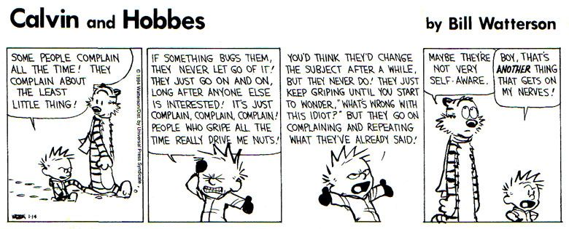
For students:
Have you ever heard the saying “You never get a second chance to make a first impression?” Similar to Calvin in the above cartoon, many of us are not self-aware of the impression we make on others. Being more self aware and reflective on our own first impressions and communication skills will enable us to further develop awareness of our own strengths and skills, as well as being able to better work with others in order to solve problems.
Consider the following:
- It takes 30 seconds to make a first impression
- It takes approximately 20 more meetings to change or undo a bad first impression
- 55% of our message is through our body language
- 38% of our message is through our tone
- 7% of our message is though our words
Activity:
Brainstorm what factors contribute to positive and negative first impressions.
Watch the following video about how to avoid making a bad first impression:
https://www.youtube.com/watch?v=JrbnTZPjg0k
After the video, recap the examples of the wrong way to make a right first impression:
- A weak handshake | - Keeping hands in the wrong position
- Chewing gum | - Avoiding eye contact
- Playing with your hair | - Choosing the wrong conversation topics
- Invading someone's personal space | - Making distracting noises
- Constantly checking your phone | - Forgetting people's names
- Being late | - Wearing the wrong attire
Questions:
- Think back to a situation where you encountered someone new in your life who left a negative first impression. Describe the situation and what specifically happened to make it negative. Alternatively, think back to a situation where you felt you left a negative first impression on someone you had just met. What happened in the situation, and what would you do differently next time?
- The above list of ways to make a negative first impression is by no means complete. List at least three things that people could do to create a negative first impression to add to the list above.
- In 300-400 words, write a story between two people where a negative first impression is created. This could be a story about two people at a party, in a business meeting, someone receiving customer service in a coffee shop, or whatever scenario you can think of. Include at least five examples of how a negative first impression can be created within your story. Next, recreate the same story using positive examples of first impressions.
Extension:
- Many television shows or movies show characters meeting for the first time. Show snippets of different programs to determine what the likely first impression would be.
- Role play different first impression scenarios and decide as a class what the first impression is of each character.
Assessment:
